Biology Course Description
Zannie Dallara  ZDallara@themarinschool.org  http://zanniedallara.weebly.com  Wing 1 – Classroom 4 | 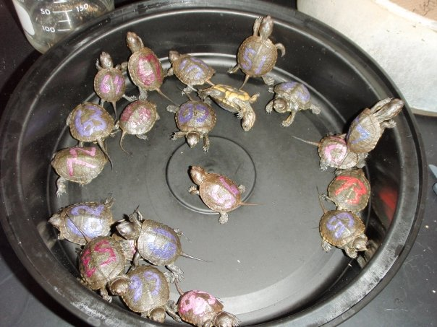
This class is a laboratory based science class that focuses on four major units to teach skills and concepts in biology. You will apply scientific processes to solve problems through the use of data analysis and drawing conclusions. You should be able to make connections between scientific disciplines while forming knowledge and opinions about topics and issues we discuss this year.
- GRADING: Your semester grade is figured like this:
Section | % | Expected School-Wide Learning Results (ESLR)
Participation | 10% | Promote self-directed learners  Promote effective communicators  Promote creative and critical thinkers
Written Assignments | 10% | Promote critical and creative thinkers  Promote effective communicators
Labs & Projects | 30% | Promote effective communicators  Promote responsible members of society  Promote creative and critical thinkers
Notebook | 10% | This is weighted heavily because I carefully grade homework and labs, checking for completeness and accuracy here, while also checking for organization.  Promote self-reliant learners – Organization
Current Events | 5% | Promote responsible members of society  Promote self-directed learners
Tests | 25% | Promote effective communicators
Final exam | 10% | Promote effective communicators  Promote self-directed learners – study skills & academic achievement

- WEBPAGE: http://zanniedallara.weebly.com - Promote self-directed individuals
- Course material, table of contents, study tools, links to helpful videos will all be available on my webpage, updated weekly.
- CLASS RULES: Promote self-directed individuals who strive to act with integrity
- Respect yourself and those around you.
  - No preaching of your values, and no put downs of other people's values.
  - All points of view are worthy of being discussed.
  - Right to pass
  - Confidentiality
  - Ask questions! - There is no such thing as a "dumb question".
- No cell phone use (not even if it is your parents), music or gum in class. – I will confiscate cell phones.
- Work for other courses is not to be done in class.
- BEHAVIOR: If you disrupt the learning environment for others in the class with behavior or tardy problems, you will be penalized by losing their class participation/attitude/cooperation points
- EXTRA HELP: Promote self-reliant learners
- Science is challenging. If you feel overwhelmed or want extra help at any time, come see me. Feel free to come see me or contact me by email if you have any questions or need help.
- I will be available for extra help: Lunch (by arrangement), tutorial and via email
- ATTENDANCE: Promote self-reliant learners
- You are responsible for material presented in class. Exams, quizzes, and homework often include questions on material presented only in class. If you have an excused absence, it is your responsibility to find out what you missed and how to make it up. Check the TOC online at http://zanniedallara.weebly.com to find out what you missed.
- HOMEWORK: Promote critical and creative thinkers & Effective communicators
- It will be assigned at the beginning of each class period on a daily basis. Homework will be posted on Thinkwave through the TMS webpage.
- Helpful links and material can be found at http://zanniedallara.weebly.com. Late work will be worth 50% credit for the first week and 0% credit after that, unless your child’s absence is excused.
- MAKE-UP WORK/GRADES: Promote self-reliant learners
- Make-up work will be accepted if the absence is excused. Late homework assignments may be turned in for half credit. Projects, labs, and papers will lose 10 percentage points for every day late in addition to being considered incomplete.
- BINDERS: Promote self-reliant learners – Organization
- These will be set up in the following manner. All handouts, homework, assignments, labs, tests, quizzes and projects will be filed into your notebook in order as they are assigned. All of these items will be placed after the Table of Contents in order. Each item needs your name, the block and the assignment # in the top right hand corner. Binders will be checked throughout each semester.
- SCIENCE SECTION
  - This section has its own table of contents and stays in your binder all year
- UNIT TABLE OF CONTENTS SHEET
  - For the current unit, only one unit needs to be kept in the binder at a time
  - All work will be numbered and in order according to the table of contents and order assigned.
- Paper: We use an online textbook and printed sections are available on request.

Syllabus (Not necessarily in this order)
- Introduction  Characteristics of Living Things  Osmosis and Diffusion  Cell Structure & Function  Cell Membrane Structure & Function  Using a microscope  - Plant Evolution  Photosynthesis & Respiration  Energy Flow in an Ecosystem  History of Life on Earth  - Body Systems  Connection between organ systems  Synergism  - Immune System | - Genetics  DNA (Purpose and Replication)  Gene Expression and Regulation  Cellular Reproduction  Genetics (Mendelian)  Biotechnology and Bio Ethics  - Sex Ed  Unit taught with a focus on the Evolution of Organs  Health  Healthy Relationships  Personal Care  - Key Concepts:  Structure and Function  Surface to Volume Ratio  Levels of Organization  Scientific Method/ Experimental Design  - On-going sand crab monitoring project
Extra Credit: Promote self-directed individuals
- May be offered to students who have completed all their regular work but may not exceed 3% of the total points possible in any given semester. If you can maintain an A- average in the class (after two tests), the completion requirement for some assignments may become optional. You will still be responsible for the material.
- - - - - - - - - - - - - - - - - - - - - - - - - - - - - - - - - - - - - - - - - - - - - - - - - - - - - - - - - - - - - - - - - - - - - - - - - - -
Student Name: ___________________________________
Student Signature: _____________________________ Date:___________
Guardian Signature: ____________________________ Date: ___________

