Zoology Course Description
Zannie Dallara  ZDallara@themarinschool.org  http://zanniedallara.weebly.com  Building 4 – Science Room B  Ext 130 | 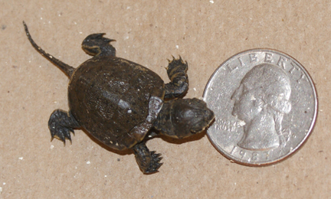
This course is intended as an overview of the science of zoology, the study of animals. Virtually every topic we explore would be a one or two semester self-contained course at the university level. When you have completed this course you will have a foundational understanding of animal life on earth spans from the molecular and genetic, through the development of an embryo to an adult, the anatomy and physiology of that adult, the major groups of animal life and how they interact with the world and each other. Interspersed over both semesters with be actual and virtual field trips so that the natural history of animals will be interwoven with the unfolding course content. We will have hands on labs that respectfully focus on life, avoiding harm if possible.
Grading: Your semester grade is figured like this:
Tests = 30%
Labs = 15%
Projects = 15%
Notebook = 5%
Written Assignments = 10%
Participation = 10%
Final exam = 15%

Syllabus (not necessarily in this order)
- Ecosystems
- Evolution
- Levels of Organization
- Histology: Cells and Tissues
- Classification
- Introduction to Animals
- Comparative Animal Physiology
- Animal Phyla:

Invertebrates
Porifera
Cnidaria
Flatworms
Roundworms
Mollusks
Segmented Worms
Arthropods
Echinoderms
Vertebrates
Fish
Amphibians
Reptiles
Birds
Mammals
Class Requirements: Arrive on time and prepared for class.

"Prepared" means that you have:

* notes + handouts (in a folder/binder or laptop)
(divide into four sections titled "notes", "assignments", "labs", and "tests")
* paper
* something to write with

Since some of the class will revolve around the discussion of certain controversial biosocial issues, certain ground rules have been established:

- Respect – For each other, the teacher, and any speakers.
One person talks at a time. Please raise your hand.
2. No Put Downs -
No preaching of your values, and no put downs of other’s values.
All points of view are worthy of being discussed.
3. Right to pass
4. Confidentiality
5. Ask questions! - There is no such thing as a "dumb question".

Class Presence: Basic classroom discipline will operate on the "Three strikes and you're out" principle - if you have to be addressed for behavioral issues more than twice during a class, you will be asked to leave. Each day you will receive a grade on a four-point scale:
4 pts. = Prepared, positive participation
3 pts. = Prepared, no participation
2 pts. = Not prepared, positive participation
1 pts. = Not prepared, no participation
Points will be subtracted due to negative behavior and unexcused tardies.
Remember classroom etiquette.

Assignments: Your assignments should be completed the night before they are due. Assignments are graded on your initial effort on a 10-point scale:
Content = 4 points
Completely done = 4 points
Neatness + formatting= 2 points.

Special Projects and Incentives: For extra credit, you may choose to do a Science Fair Project, due near the end of first semester. Extra credit points will be determined by your grade on the project. In addition, a student whose course grade is at least 80% and whose project earns a 1st place in the Marin County Science Fair will receive an automatic “A” in the second semester – as long as you maintain atleast a C average. Other extra credit opportunities may be offered. See the teacher before starting any independent extra credit work.

