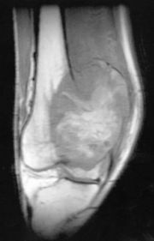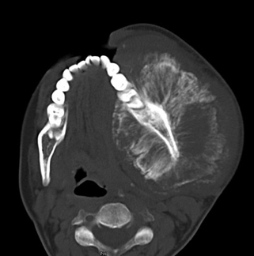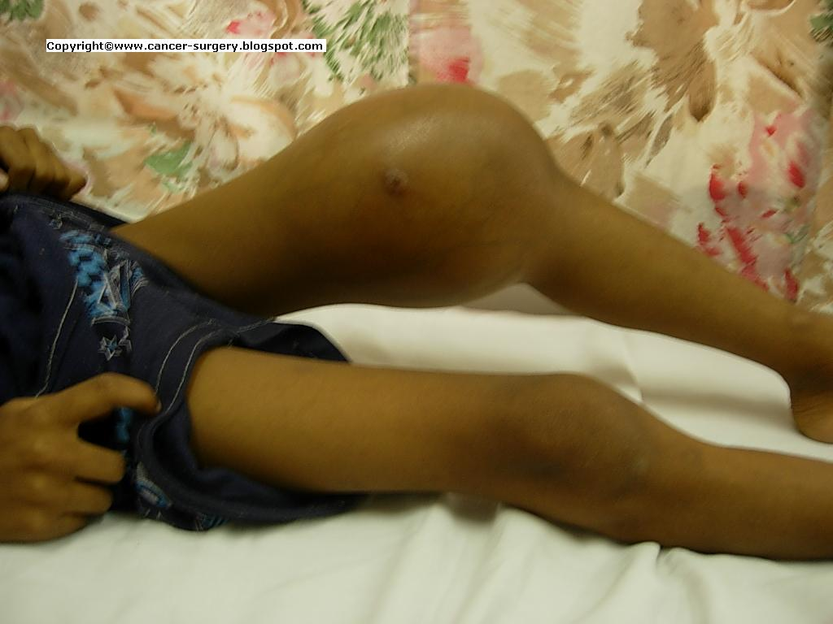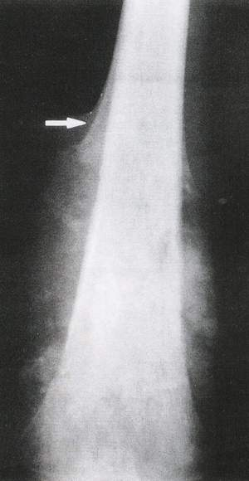

For more info, contact Dr. Logan Spector at spect012@umn.edu

Or visit http://www.cancer.org/cancer/osteosarcoma

**American Cancer Center: 1(800) 515 1214**

**OS Hotline**

* Anywhere from 4.6 to 6.8 cases/million people (in U.S.)
* Slightly more common in males
* Rumors persist that water fluoridation is a factor in OS and deaths resulting from OS – investigative research into these rumors is, as yet, inconclusive

# Interesting Facts

Osteosarcoma

Jared Harband

Doctors will often combine these methods for more effective treatment

**Treatments**

* Chemotherapy
* Surgery
* Amputation
  + Common treatment

**Symptoms**

* Limb/tissue swelling
* Bone breaks easily
* Codman’s Triangle (right)
  + Used in OS diagnosis

A combination of chemotherapy and surgery gives 60-70% survival rate for extremely localized, non-metastasized OS patients

Current standing for metastasized OS prognosis: **possible, but unlikely, survival**

**Current Research**

🙞 🙜

The most promising cure for already-metastasized OS is a combination of amputation and chemotherapy

Cure?

Usually children & young adults

- most common during periods of rapid growth (puberty, growth spurts)

**Who?**

**Description**

* Osteo – bone
* Sarcoma – cancer
* 8th-most common child cancer

Manifests itself in bone tissue, causing tissue necrosis

Mortality rate: 1/3