Ecology Course Description
Zannie Dallara  ZDallara@themarinschool.org  http://zanniedallara.weebly.com  Wing 1 – Classroom 4  Phone Ext 130 | 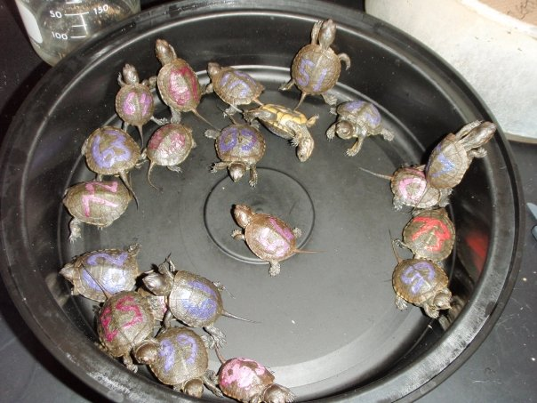
This class is a field based science class that focuses on four major units to teach skills and concepts in ecology. You will apply scientific processes to solve problems through the use of data analysis and drawing conclusions. You should be able to make connections between scientific disciplines while forming knowledge and opinions about topics and issues we discuss this year.
- WEBPAGE: http://zanniedallara.weebly.com
- Course material, table of contents, study tools, links to helpful videos will all be available on my webpage, updated weekly.
- CLASS RULES:
- Respect yourself and those around you.
  - No preaching of your values, and no put downs of other people's values.
  - All points of view are worthy of being discussed.
  - Right to pass
  - Confidentiality
  - Ask questions! - There is no such thing as a "dumb question".
- No cell phone use (not even if it is your parents), music or gum in class. – I will confiscate cell phones.
- Work for other courses is not to be done in class.
- BEHAVIOR: If you disrupt the learning environment for others in the class with behavior or tardy problems, you will be penalized by losing their class participation/attitude/cooperation points
- EXTRA HELP: Science is challenging. If you feel overwhelmed or want extra help at any time, come see me. Feel free to come see me or contact me by email if you have any questions or need help. - I will be available for extra help: Lunch (By arrangement), tutorial and via email
- HOMEWORK: It will be assigned at the beginning of each class period on a daily basis. Homework will be posted on Billmodo through the TMS webpage. Helpful links and material can be found at http://zanniedallara.weebly.com. Late work will be worth 50% credit for the first week and 0% credit after that, unless your child’s absence is excused. Homework will be checked daily, given a stamp for completion credit and discussed in class. Homework and organization of the binder according to the Table Of Contents (TOC) will be graded more completely during a binder check nearing the end of every unit.
- ATTENDANCE: You are responsible for material presented in class. Exams, quizzes, and homework often include questions on material presented only in class. If you have an excused absence, it is your responsibility to find out what you missed and how to make it up. Check the TOC online at http://zanniedallara.weebly.com to find out what you missed.
- MAKE-UP WORK/GRADES: Make-up work will be accepted if the absence is excused. Late homework assignments may be turned in for half credit. Projects, labs, and papers will lose 10 percentage points for every day late in addition to being considered incomplete.
- BINDERS: These will be set up in the following manner. All handouts, homework, assignments, labs, tests, quizzes and projects will be filed into your notebook in order as they are assigned. All of these items will be placed after the Table of Contents in order. Each item needs your name, the block and the assignment # in the top right hand corner. Binders will be checked throughout each semester.
WARM-UPS | SCIENCE SECTION  - This section has its own table of contents and stays in your binder all year | TABLE OF CONTENTS  - Only the current unit needs to be kept in the binder  - All work will be numbered and kept in order of the TOC | TEXTBOOK  We use an online textbook and printed sections are available on request.

- GRADING: Your semester grade is figured like this:
Participation – 10%
Written Assignments= 10%
Labs & Projects = 30%
Notebook – 5%
Tests = 30%
Final exam = 15%

Syllabus (not necessarily in this order)
- The Nature of Science/ Experimentation  - Bay Area Geology & Geography  Topography  Earthquakes  - Bay Area Climate  El Nino/La Nina  Fog  - Ecosystem Concepts  Matter is recycled  Nutrient and mineral cycles Energy flow  Food chains and food webs  Trophic structure  Climate Change  Organisms’ roles (niches)  Symbiotic relationships  Carrying capacity  - Conservation and Stewardship | - Stability of ecosystems  Polycultures vs. monocultures  Succession  Biological Diversity  Introduced Species  Habitat Fragmentation  - The Estuary – San Francisco Bay:  The Estuarine Environment  The Origin, Size and Structure  Population and Land Use  Dredging, Pollution, and Dams  - Watersheds of Marin County  - Bay Area Ecosystems of focus:  Redwood Community – Muir Woods  Rocky Shoreline – Duxbury Reef/Agate Beach  Sandy Beach – Muir Beach  The Ocean – Gulf of Farallones Marine Sanctuary

Extra Credit may be offered to students who have completed all their regular work but may not exceed 3% of the total points possible in any given semester. If you can maintain an A- average in the class (after two tests), the completion requirement for some assignments may become optional. You will still be responsible for the material. Seniors with an “A” going into the final exam in the second semester are excused from taking the exam.
- - - - - - - - - - - - - - - - - - - - - - - - - - - - - - - - - - - - - - - - - - - - - - - - - - - - - - - - - - - - - - - - - - - - - - - - - - -
Student Name: ______________________
Student Signature: __________________________ Date: ____________
Guardian Signature: __________________________ Date: ___________

