Kidney Paper:
Important Dates Date:
- Due Dates:
  - Rough Draft Fri Dec 7th (if your paper is not in today you cannot get the rough draft points) – 15points
  - Final Draft: Monday Dec 10th – 85points
- Work Date:
  - Dec 5th or 6th
Paragraph1: Introduction:
- Explain homeostasis:

- Explain water balance in terms of homeostasis:

- Introduce the Kidneys role in water balance:

- Where is it located

- What organisms have it?

Evolution of Water Balance:
- Paramecium:

- PlanariaP

- Insects

- Fish
  - Fresh:

  - Salt:

- Amphibian:

- Reptiles:

- Birds:

- Mammals:

Vertebrate Kidney Form
- Discuss function of each piece

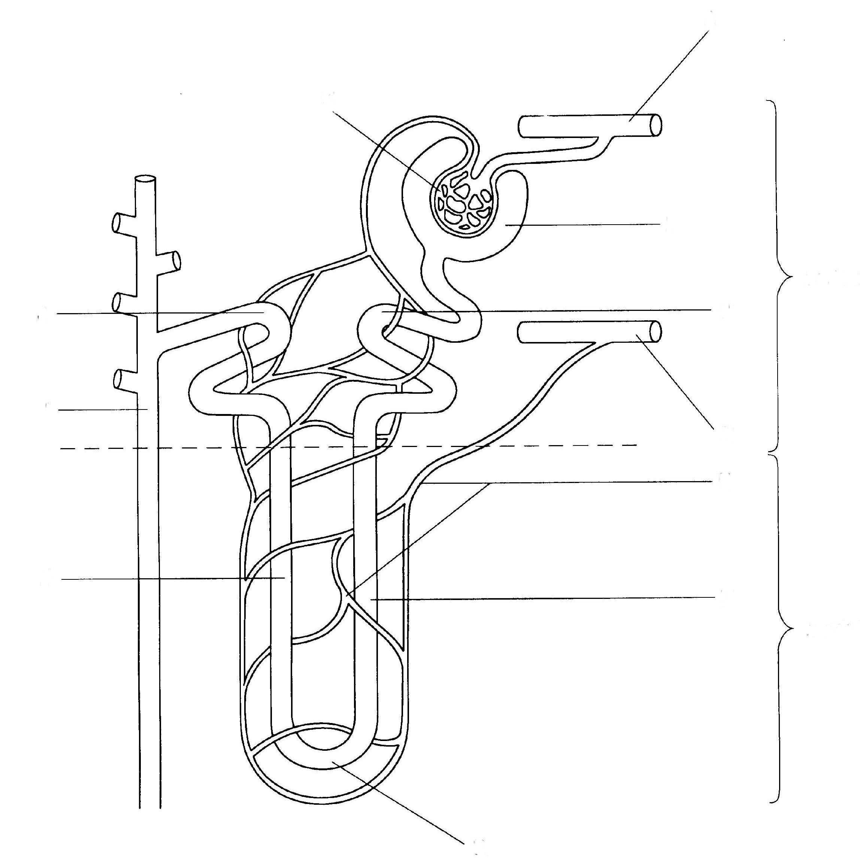
Final:
- Implications if a kidney fails

- Why would it be better to drink pee than let your kidney stop having something to filter?

Use:
- 1 figure
  - Reference in text
  - Example: the intricate form of the vertebrate kidney uses loops of henle (see figure 1).
References
- Minimum of 3
- Sited at the end in APA/MLA format
- Sited in Text (consider using a # at the end of the sentence that corresponds to number of the reference in the bibliography) ¹.

