Worm Comparison
http://www.mcwdn.org/Animals
- The type:
Organism | Platyhelmenthes  (flatworms) | Nematodes  (round worms) | Annelida  (Segmented worms)
Complexity: | Less More
Body cavity (coelom): | Flatworms are acoelomate - they have three germ layers, but no coelom. | Pseudocoelomate - they have a cavity that forms between the mesoderm and the endoderm. | Segmented worms are coelomate - they have a true coelom which forms within the mesoderm
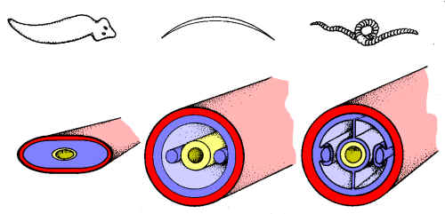
Nervous System: | Have Cephalization:  Most worms have sense receptors and nerves concentrated at their anterior end. This is known as "cephalization" or formation of the head.  Very simple nervous system with two nerve cords running down either side. It has two simple brains called ganglia, which are simple bundles of nerves. It has two eyespots that help it sense light. Two nerve cords that transmit impulses in the roundworm. A earthworm has a nervous system with a simple brain and nerve cord.
Digestive System | - 1 Way Vs 2 Way Guts:  - 1 Way = flow through gut (2 separate openings = Mouth & Anus seperate)  - 2 way gut = Does a loop (1 opening = manus)  2 way 1 way Many are parasites and live off other animals and plants. 1 way

Excretion | A flatworm gets rid of wastes through the same opening it takes in food. A roundworm has an anus at its rear end and a series of excretory tubes that end in an excretory pore. A earthworm’s wastes help to fertilize the soil. It gets rid of its wastes through tubes called nephridin that lead to pores that allow the wastes out.
Respiratory System | A flatworm takes in oxygen, but has no formal respiratory system. A roundworm has no heart or formal blood vessels A earthworm has no respiratory organ. It takes in oxygen directly through its skin and gives off carbon dioxide. Its skin is always moist.
Circulatory System | A flatworm has a gastrovascular cavity with one opening. It eats small worms, insects and microscopic matter. A roundworm has no formal respiratory system. A earthworm has blood and blood vessels with multiple (5) hearts.

Reproductive system | Asexual: A flatworm reproduces by splitting in two. When a flatworm is split up it immediately forms a new flatworm. Sexual: The female has an ovary, holds eggs in an oviduct and then passes them to the uterus, where they are fertilized. The male has sperm cells are made in the testis and stored in the vas deferens. When it is time to reproduce, the sperm cells pass through the spicule. - 200,000 Eggs! Sexual: Has both sperm and eggs within its body and reproduces sexually. However, the eggs must be fertilized by the sperm of another worm. An earthworm lays a batch of eggs at one time. They do not spend time raising their young once they are hatched.
Muscualar/Skeletal | No skeleton. It has tiny bristles called cilia that help it move as well as two layers of muscles under its skin. A roundworm has no skeleton. A earthworm does not have a skeleton. It has bristles on each segment called setae that help the earthworm move.
Symmetry | Bilateral Bilateral Bilateral

