Dinosaur Project: Decorate and Elaborate

You get to be a paleontologist!
Goal: Decorate your dino and make a presentation to include: (please go in order of this sheet in your presentation)
Basic
Name the Dino:
- Common name
- Scientific name (Genus species)
What is its closest extant (living) relative?
- How do you know?
What is its closest extinct (non-living) relative?
- This is where you include some research on the real Dino that you modified.
Habitat
Explain where you are likely to find them?
Why do they look the way they do?
Adaptations:
- Size, feet, scales/skin/feathers neck, tail,
- Unique feature
Why do they look the way they do?
- Sexual selection (because the ladies like it)
- Camo
Life History
Social?  - Social or solitary?  Reproduction  - How do they signal to mates?  - Development? Direct, indirect... Elaborate  - Maternal instinct? Maternal/paternal care: | Diet  - Eating habits  - Tooth morphology  - Predator or prey?  - Greatest threats to Dino?  Sounds:  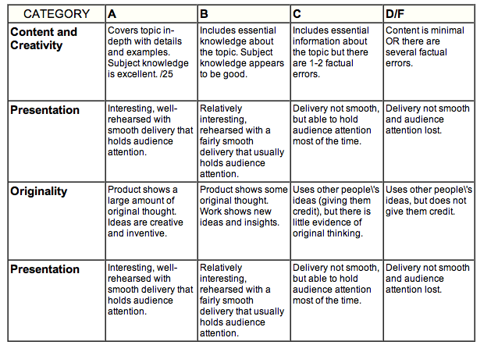  - When does it vocalize?

/10

/12

/10

/10
Category | Points | A | B | C | D/F
Content and Creativity/Originality
Basic
A = Creative and Correct
Name the Dino:  - Common name  - Scientific name (Genus species) | /4
What is its closest extant (living) relative?  - How do you know? | /3
What is its closest extinct (non-living) relative?  - This is where you include some research on the real Dino that you modified. | /3
Habitat
Explain where you are likely to find them? | /2
Why do they look the way they do?  Adaptations:  - Size, feet, scales/skin/feathers neck, tail,  - Unique featur | /6
Why do they look the way they do?  - Sexual selection (because the ladies like it)  - Camo | /2
Life History
Social?  - Social or solitary? | /2
Reproduction  - How do they signal to mates?  - Development? Direct, indirect... Elaborate  - Maternal instinct? Maternal/paternal care: | /5
Diet  - Eating habits  - Tooth morphology  - Predator or prey?  - Greatest threats to Dino? | /3
Sounds:  - When does it vocalize? | /2
Presentation
Oral Presentation | /5
Visual  - Did you use pictures to support your claims? | /5
Your beautifully Dino
Creativity of decorations/”adaptations” | /8
Notes/Comments:

Total____________/50

/8

