Brain Structure
Pic | Section |  |  | Function
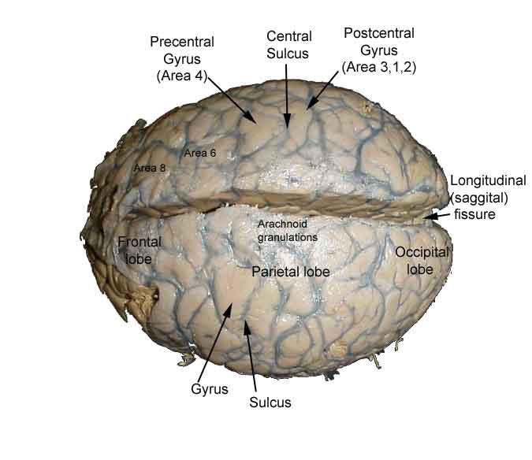  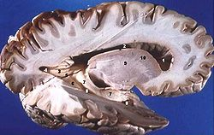 | A. The Cerebrum | •Parts:  –Divided into ____________ and __________cerebral hemispheres  –The cerebral cortex is divided into _____________ which control various functions  •Structure:  –Covered by:  •Folds called _____________  •grooves called _____________ (little groves)  •_____________ (big grooves)  –It has a cortex: an outer covering  about 2 mm thick  –Gray matter vs. white matter  •_____________ : Myelinated Axon is white (insulation on the nerve)  –Function: Tissue through which messages pass between different areas of gray matter within the nervous system  •_____________ : absence of Mylin.  –Function: muscle control, sensory perception such as seeing and hearing, memory, emotions, speech, decision making, and self-control.  –While 20% of all oxygen taken in by the body goes to the brain, 95% of that goes specifically into the grey matter  •Connected by the corpus callosum
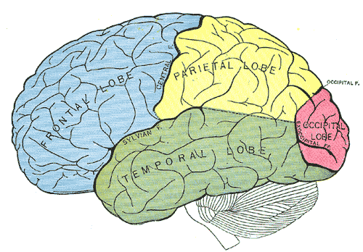 |  | Lobes:  1. _____________ Lobe  –Control of voluntary muscles in the body  –Motor speech (Broca’s area)  –Voluntary eye movement  –Concentration, planning, problem solving  –Rational thought, intelligence  2. _____________ Area (frontal)  movement of skeletal muscles  3. _____________ _____________ Area (frontal)  learned motor skills  4. _____________ _____________ Area (Broca’s) (frontal)  controls mouth movement for speech
5. _____________ Lobe
– touch, taste and other sensory info
–understanding speech, using words (Wernicke’s
6. _____________ Area (frontal/parietal)
• conscious awareness of sensations
•interpretation of sensory experiences
 | A. The Cerebrum | 7. _____________ Lobe  –smell and hearing  –interpretation of sensory experiences  8. Auditory Area (temporal)  •Hearing is processed
9. _____________ Lobe
– visual senses
10. _____________ Area (occipital)
–Processes input from optic nerves
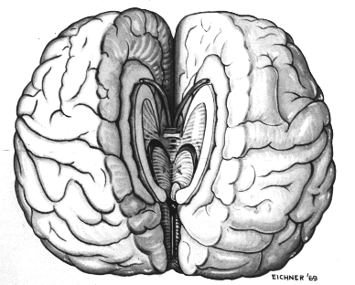 |  | Cerebral __________________________ (11)  •Hemisphere = half of sphere (brain)  •The right side of the brain controls the left side of the body and vice versa  •Hemispheres connected by the Corpus callosum
Right Vs Left – Creativity
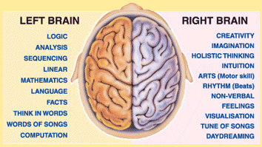 http://blogs.scientificamerican.com/beautiful-minds/2013/08/19/the-real-neuroscience-of-creativity/
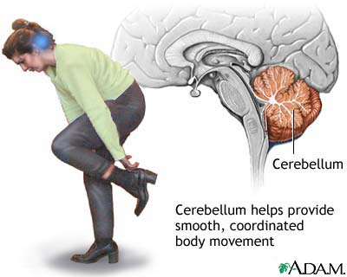 | B. Cerebellum #13 |  | •Processes sensory information about limbs, joints, and other body parts to determine desired positions.  •Balance, coordination of skeletal muscle, posture
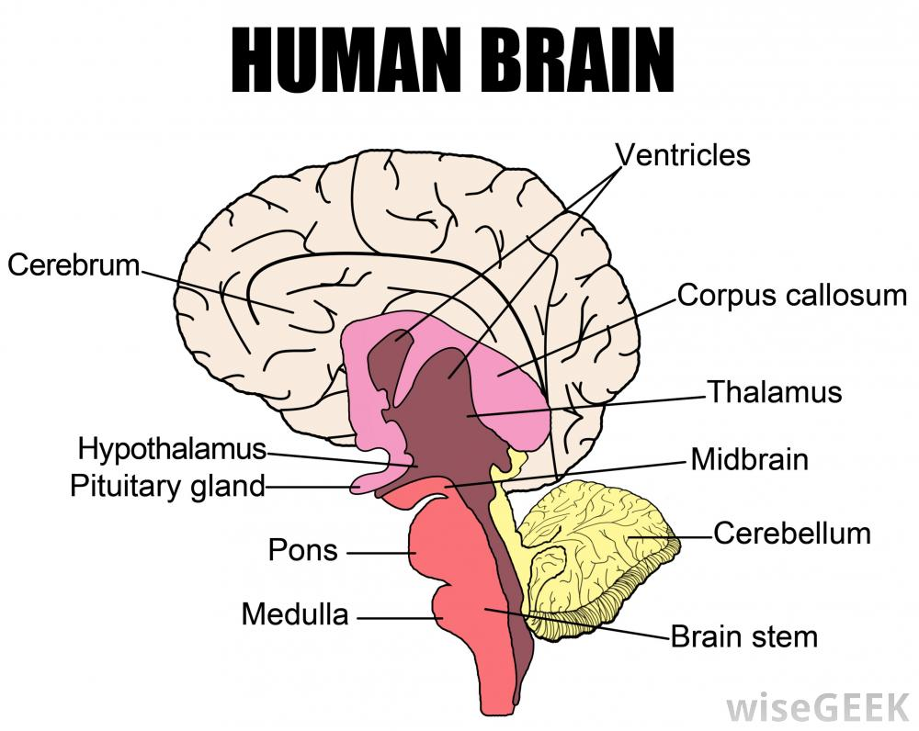 | C. Brainstem (14) |  | •Brainstem: Connects the cerebrum to the spinal cord  –_____________ (15): visual and auditory reflex center  –_____________ :(#16) transfers nerve impulses from cerebrum to cerebellum  –_____________ _____________ : (#17) controls heart and breathing rates, controls blood pressure, vessel changes
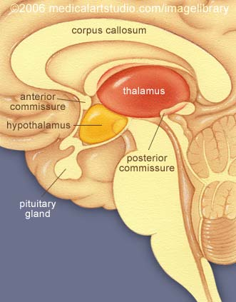 | D. Diencephalon (18) |  | •_____________ -(#19)  -Receives all sensory impulses and relays them to the appropriate region of the cerebral cortex  -Produces awareness of sensation  • _________________________ – (#20)  –Links the nervous system to the endocrine system  –Regulates heart rate, blood pressure, body temp, hunger, gland secretions, sleep etc.  –Maintains homeostasis-links nervous to endocrine system
Summary:

