Brain Structure
Pic | Section |  |  | Function
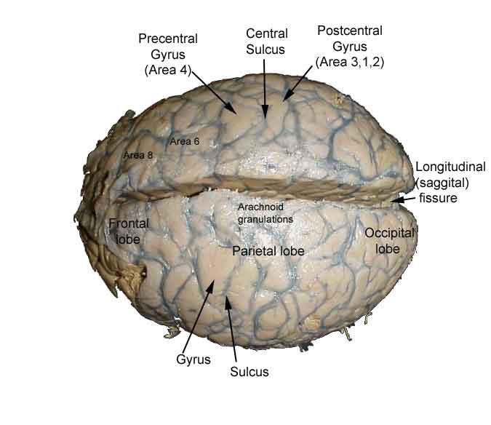  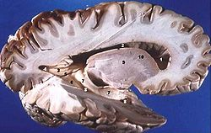 | A. The Cerebrum | •Parts:  –Divided into right and left cerebral hemispheres  –The cerebral cortex is divided into LOBES which control various functions  •Structure:  –Covered by:  •Folds called convolutions  •grooves called sulci (little groves)  •Fissures (big grooves)  –It has a cortex: an outer covering  about 2 mm thick  –Gray matter vs. white matter  •White: Myelinated Axon is white (insulation on the nerve)  –Function: Tissue through which messages pass between different areas of gray matter within the nervous system  •Grey: absence of Mylin.  –Function: muscle control, sensory perception such as seeing and hearing, memory, emotions, speech, decision making, and self-control.  –While 20% of all oxygen taken in by the body goes to the brain, 95% of that goes specifically into the grey matter  •Connected by the corpus callosum
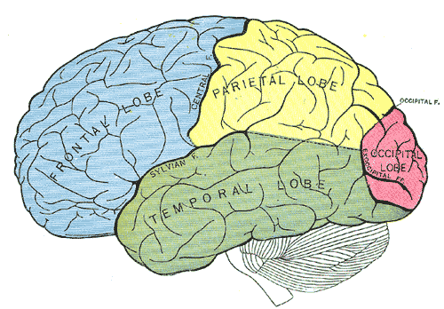 |  | Lobes:  1. Frontal Lobe  –Control of voluntary muscles in the body  –Motor speech (Broca’s area)  –Voluntary eye movement  –Concentration, planning, problem solving  –Rational thought, intelligence  2. Motor Area (frontal)  movement of skeletal muscles  3. Pre-Motor Area (frontal)  learned motor skills  4. Motor Speech Area (Broca’s) (frontal)  controls mouth movement for speech
5. Parietal Lobe
– touch, taste and other sensory info
–understanding speech, using words (Wernicke’s
6. Sensory Area (frontal/parietal)
• conscious awareness of sensations
•interpretation of sensory experiences
 | A. The Cerebrum | 7. Temporal Lobe  –smell and hearing  –interpretation of sensory experiences  8. Auditory Area (temporal)  •Hearing is processed
9. Occipital Lobe
– visual senses
10. Visual Area (occipital)
–Processes input from optic nerves
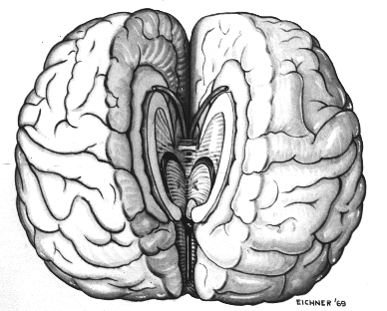 |  | Cerebral Hemispheres (11)  •Hemisphere = half of sphere (brain)  •The right side of the brain controls the left side of the body and vice versa  •Hemispheres connected by the Corpus callosum
Right Vs Left – Creativity
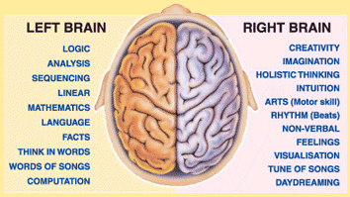 http://blogs.scientificamerican.com/beautiful-minds/2013/08/19/the-real-neuroscience-of-creativity/
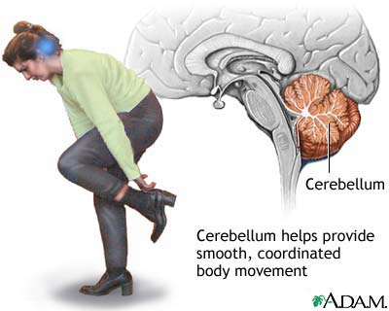 | B. Cerebellum #13 |  | •Processes sensory information about limbs, joints, and other body parts to determine desired positions.  •Balance, coordination of skeletal muscle, posture
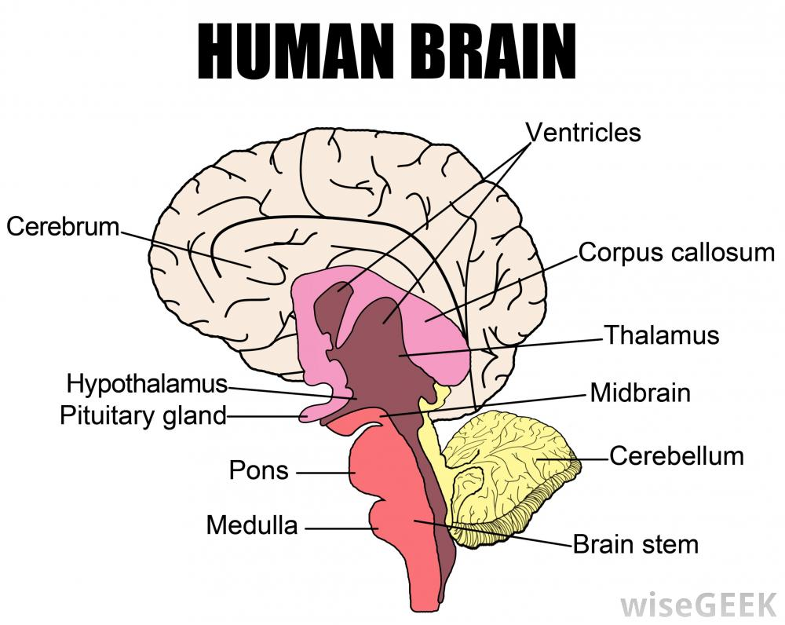 | C. Brainstem (14) |  | •Brainstem: Connects the cerebrum to the spinal cord  –Midbrain (15): visual and auditory reflex center  –Pons:(#16) transfers nerve impulses from cerebrum to cerebellum  –Medulla Oblongata: (#17) controls heart and breathing rates, controls blood pressure, vessel changes
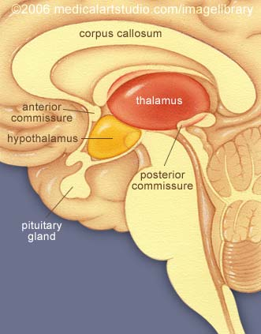 | D. Diencephalon (18) |  | •Thalamus-(#19)  -Receives all sensory impulses and relays them to the appropriate region of the cerebral cortex  -Produces awareness of sensation  • Hypothalamus – (#20)  –Links the nervous system to the endocrine system  –Regulates heart rate, blood pressure, body temp, hunger, gland secretions, sleep etc.  –Maintains homeostasis-links nervous to endocrine system
Summary:

