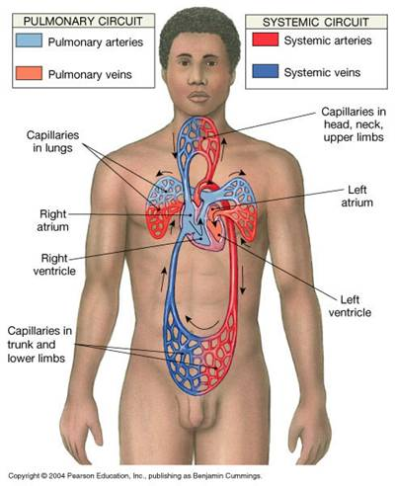
Cardiovascular System Notes
Main Function:

Parts (2):
Pulmonary circuit | Systemic Circuit
Layers of the heart
Pericardium

- Functions:
1)
2)
3)
4)
Epicardium

Myocardium

Endocardium

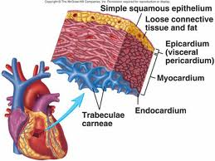
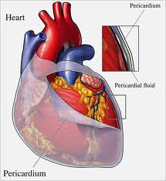
Chambers of the heart
Left Atrium-

Right Atrium-

Left Ventricle-

Right Ventricle-
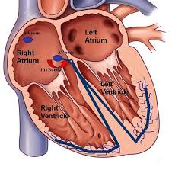

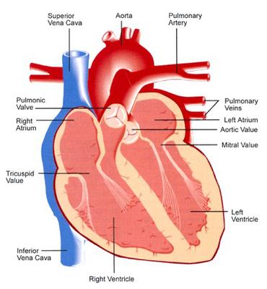
Valves of the heart
1.
2.
3.
4.
Heart Actions

Heart Actions
The Cardiac Cycle
- Atrial systole-

- Ventricular systole-

- Daistole-
Heart Sounds-

- First sound (lubb)

- Second sound (dupp)

Blood Pressure-
•Blood pressure

•Pulse-

•Systolic pressure-

•Diastolic pressure-

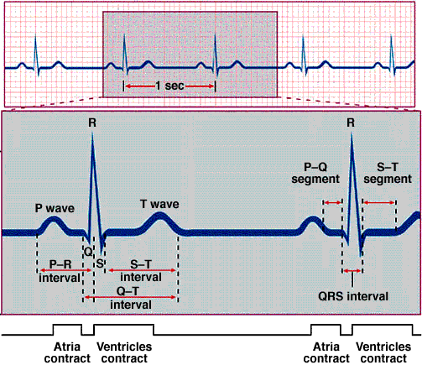
Electrocardiogram

Essential Questions
•What role does the heart play in maintaining homeostasis? | •What does blood pressure and heart rate indicate?
•How do changes in the cardiac cycle effect delivery of oxygen to cells? | •How do we determine if the cardiovascular system is functioning properly?

