Ninja Species Project: Decorate and Elaborate

You get to be an expert on a species!
Goal: Take a known Ninja Species, a species with crazy awesome adaptations, and evolve that. You can create any life history characteristics you want, you just need to justify them scientifically.
- Basically decorate your Species and make a presentation to include: (please go in order of this sheet in your presentation)
Basic
Name the species:
- Common name
- Scientific name (Genus species)
What is its closest extant (living) relative?
- How do you know?
What is its closest extinct (non-living) relative?
- This is where you include some research on the real species that you modified.
Habitat
Explain where you are likely to find them? – Be specific to biome
Why do they look the way they do?
Adaptations: To their biome
- Size, feet, scales/skin/feathers neck, tail,
- Sensory structures/features?
- Unique feature
Why do they look the way they do?
- Sexual selection (because the ladies like it)
- Camouflage
- Predator avoidance method
Life History
Social?  - Social or solitary?  - What is a group of them called?  Reproduction  - How do they signal to mates?  - Do they have any courtship rituals?  - Development? Direct, indirect... Elaborate  - Maternal instinct? Maternal/paternal care | Diet  - Eating habits  - Tooth morphology  - Predator or prey?  - Greatest threats to species?  Sounds:  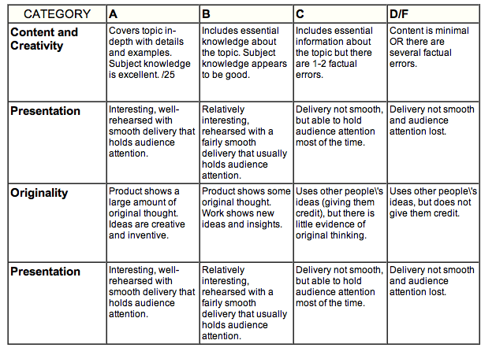  - When does it vocalize?

Category | Points
Content and Creativity/Originality
Basic
A = Creative and Correct
Name the species:  - Common name  - Scientific name (Genus species) | /4
What is its closest extant (living) relative?  - How do you know? | /3
What is its closest extinct (non-living) relative?  - This is where you include some research on the real species that you modified. | /3
Habitat
Explain where you are likely to find them? – biome | /2
Why do they look the way they do?  Adaptations:  - Size, feet, scales/skin/feathers neck, tail,  - Sensory structures/features? | /4
Unique feature | /2
Why do they look the way they do?  - Sexual selection (because the ladies like it)  - Camouflage\  - Predator avoidance method | /2
Life History
Social?  - Social or solitary?  - What is a group of them called? | /2
Reproduction  - How do they signal to mates?  - Do they have any courtship rituals?  - Development? Direct, indirect... Elaborate  - Maternal instinct? Maternal/paternal care: | /5
Diet  - Eating habits  - Tooth morphology  - Predator or prey?  - Greatest threats to your species? | /3
Sounds:  - When does it vocalize? | /2
Presentation
Oral Presentation  - Figure out what each was responsible for before hand  - Don’t read | /5
Visual  - Did you use pictures to support your claims? | /5
Your Beautifully Decorated Species
Creativity of decorations/”adaptations” | /8
Notes/Comments:

Total____________/50

/12

/8

/10

/10

/10

