Lab: Moss
Examination of the First Plants to Make it to Land
Background:
Bryophytes include the familiar mosses (Phylum Bryophyta) plus two other phyla: the liverworts (P. Hepatophyta) and hornworts (P. Anthocerophyta).
- These plants lack any clearly differentiated tissues to transport water, nutrients and metabolites around the plant body. Although this severely limits their size, nonvascular plants still dominate some habitats, particularly moist temperate or cold environments. Root-like rhizoids provide anchorage but do not conduct water. Mosses absorb water like sponges, but can also dry out and become dormant.

Pre-Lab:
- Define
Rhizoids: __________________________________________

Similar to: ________________ in other plants
Phyllids: __________________________________________

Similar to: ________________ in other plants
Seta: _____________________________________________

Similar to: ________________ in other plants
Sporangium capsule: ________________________________

Similar to: ________________ in other plants
- Question:
Why can we not just call them roots, leaves, and stems?

Lab:
Station 1: Water storage in Sphagnum, a moss
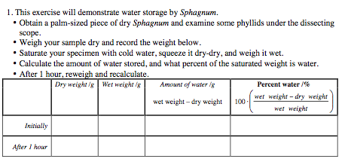
Conclusion about moss’s ability to hold water over time__________________________________________
_______________________________________________________________________________________
►Station 2: Draw a single piece of moss
Draw at 1X

1. Obtain a clump of moss, isolate a single individual from the clump using forceps, and examine it under the dissecting scope.
2. Carefully draw the plant, labeling the following structures: rhizoids, phyllids, seta and sporangium capsule.

► Post Lab Questions
Bryophyta:
What are these commonly known as?

Where do they live?

What adaptations allow them to have advanced to this environment?

How can they get away with not being vascular?
Where they live | Shape
How do they hold water?

How do they reproduce and why does it rely on water?

