Salmon Life Cycle
Freshwater Salt Water Freshwater!

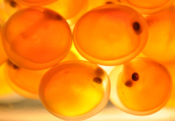
Eggs
- Salmon eggs stay in the _______for 2-3 months before hatching.
- During this time they develop into embryos, and the baby salmon’s eyes can be clearly seen.
- Average number of eggs deposited per hen (Female) is around 3,000 eggs.
Why is Erosion so bad for Salmon?

Alevin
- After hatching from the egg, young salmon, known as alevin
- Remain in the gravel and feed off the _____________still attached to their bodies.
- Alevins remain in the gravel for another 1-2 months before swimming up from the gravel to live in the stream.
Fry
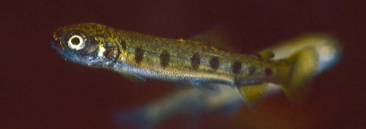
- Young ________________ salmon that recently left the gravel are known as fry.
- Fry are typically 1-2 inches in length.
- When they emerge from the gravel they are called “Sac Fry” as a small amount of the yolk sack continues to nourish them until they learn to feed.
- Pink and Chum salmon out-migrate to the ocean as fry while other species may stay in freshwater for many months or years.
Parr
- Young salmon typically between 2-5 inches that are not yet smolts are known as parr (or fingerlings) due to the __________ _____________(parr marks) along their bodies.
- As salmon mature into a smolt, the parr marks disappear.
- Different species can be distinguished by the pattern of parr marks.
Smolt
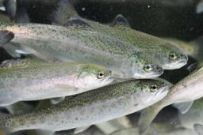
- When salmon prepare to migrate from freshwater to the ocean, they become smolts.
- To manage the _________________ between ______________and _________________, salmon fry must go through a physical change known as smolting.
- Smolting begins in freshwater and sees the young salmon through the ____________________ and into the ocean when it is time.
- Smolts loose their parr marks
Why are estuaries important to the development of salmon, specifically to which life stage?

How do salmon learn where to return? (From the ocean, they go back to their birthplace to spawn)
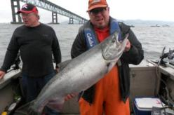
Adult
- Most salmon spend more than 80% of their lives in the ________ where they grow big on the prey species available in the ocean.
- Salmon spend 1-5 years in the ocean, depending on species and environmental conditions.
- Salmon travel vast distances to Alaska and even Russia or Japan, yet still return home.
- Commercial and sport fishing for salmon provides millions of dollars to CALIFORNIAS economy.
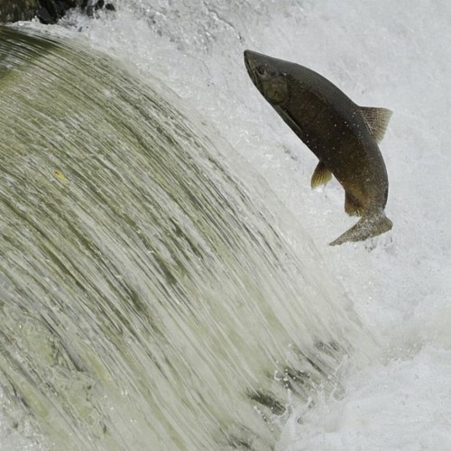
Spawn
- After spending 1-5 years in the ocean, adult salmon _________to the stream (or hatchery) they were ________in to spawn.
- They remember the _____________ and can find it again.
- Adults change significantly once they enter freshwater. They change color, stop eating, males develop a kype (hooked jaw), and they stop drinking.
- Adults overcome many ____________during their return migration. Dams, waterfalls, culverts, low water, pollution, sediment, and predators can impact their success.
What is an example of a man made obstacle that they encounter while spawning? What does it look like?
Die
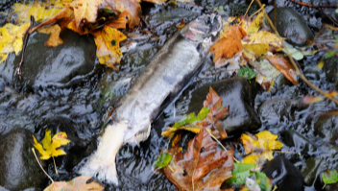
- After making their return journey and going through the hurdles and physical changes all salmon and many steelhead adults will ______after spawning.
- Fortunately this death will bring life.
- The carcasses play an important role in the food web.
- The carcasses feed many organisms including __________ some of which in turn provide food for the young salmon.
- The carcasses bring nutrients from the ocean that benefit the stream and riparian vegetation.
Redd
- Adult salmon create _______ ______ known as redds to deposit fertilized eggs in the gravel.
- Salmon species spawn in the fall or winter, regardless of when they enter the river.
- Redds are typically constructed in clean ______ with good flow of clean water, otherwise the eggs would suffocate (____) and die.
- The eggs are deposited and then covered with rocks that are on average 2-4 inches in size. The eggs are hidden and incubate in the spaces between the rocks.

