http://www.whitman.edu/content/virtualpig
Physiology
Dissection: Fetal Pig Anatomy
Introduction:
The specimens you will dissect and study are fetal (unborn) pigs. The fetal pig is an excellent representative of the class of mammals since it illustrates the basic anatomy of the adult mammal as well as providing information about certain features and structures present in the fetal body. In other words, what you learn by dissection of the fetal pig is broadly applicable to most other mammals. Even if your primary interest is human anatomy, the pig is very similar in construction, and most of the names that you will learn apply to human structures as well.
Fetal pigs are obtained from pregnant sows in the process of being slaughtered at abattoirs or slaughterhouses. The period of gestation or development within the uterus of the female is 112 to 115 days and there are, on the average, 7 to 12 offspring in a litter.

The age of the fetus can be approximated by measuring the length of the body from snout to base of tail:
1.2 cm specimen is about 21 days old
2.8 cm specimen is about 48 days old
4.0 cm specimen is about 56 days old
22 cm specimen is about 100 days old
30 cm specimen is about full term. (112-115 days old)

The pig, Sus scrofa, is a member of the group of mammals know as even-toed ungulates, the artiodactyla, to which deer, cows and whales (!) belong. Artiodactyla possess two toes, the third and fourth. The first toe is lost and the second and fifth are reduced in size or lost. (Try to find these on a whale). Taxonomically, the pig belongs to the phylum Chordata, class Mammalia, order Artiodactyla, genus Sus, species scrofa. Pigs, unlike most other herbivorous artiodactyla, are omnivores, and they can live 15-20 years in captivity, but they are usually slaughtered much earlier.

→ Please note that one very important requirement for this lab is respectful treatment of your lab specimen. Your fetal pig has been a living creature and that should be recognized through your treatment of the specimen throughout the duration of the lab.

General Lab Instructions

Materials: You will use the same materials for the entire lab. Your group is responsible for the well being and cleanliness of these materials, as well as work area and sink/drainage board/storage cart. At the end of each lab period yo must show all your cleaned and dried materials to me in order to earn a stamp for the lab each day.
- Dissecting tray  - Dissecting tools  - Scalpel  - Scissors  - 2 Wooden needles  - Forceps  - Metal Probe | - Preserved fetal pig  - Goggles for each person  - Gloves for each person  - Aprons  - 2 lengths of string  - meter stick (for first use only)  - Plastic bag | - Binder paper  - Colored pencils  - Pen/Pencil  - Handouts  - Anatomy Textbook and Guides, Color-Ins  - White paper  - Tracing paper

Beginning of each dissection day:
- Read and note specific dissection instructions given for the section.
- One person obtains the fetal pig and gloves, goggles, aprons, materials.

During each dissection:
- Follow specific instructions for each dissection section
- Read and understand all directions before you begin to dissect.
- Cut as little as possible!! The more you cut, the more you alter the original structural relationships. Keep in mind that you are dissecting not butchering.
- Dissection is to be undertaken with great care as it is intended as a procedure to help you locate, expose and learn the anatomy of an animal. You should always know what you are cutting and why.
- Don’t rush! Don’t dig around or randomly snip, poke, or probe.
- Locate and draw the underlined terms as you go along, and reflect how their structure is related to their function.

Drawings/Illustrations
- You must produce scientific line drawings from your own pig, not from the book or hand-outs, not from your team member!!!!!! Drawings are graded.
- Draw the structures you can see with whole lines and the ones hidden below with dotted lines. Use stipples to show roundings. Study how commercial drawings in your package do scientific illustrations.
- Label structures, using a ruler and straight lines, with the names on the outside of the drawing.

End of each dissection day:
- Wrap the pig in its skin and return to plastic bag; save all the dissecting fluid.
- Clean and dry lab tray, tools and work area, clean out the sink at your lab station.
- Store piggy on your period’s tray. c
- Complete normal lab clean up.
- Replace goggles, aprons and wash hands

Safety:
- Goggles and gloves must be worn at all times
- Caution: preserving fluid will squirt out when the first incision is made.
- Dissection tools are extremely sharp! Handle with care. The scalpel should never leave the table.
- If preserving fluid should get in the eyes they must be washed with the eyewash.
- Do not put any dissecting tools in your mouth EVER!
- Any accident must be reported to Mrs. Berry IMMEDIATELY.

Groups:
- 2 dissectors
- Reader/Materials Person
- Drawings/Observations
- Entire Group- Responsible for write up/Question completion. Final lab product.

Lab Procedures
- Make a title page for this piggy lab. (See instructions under Assignments/Questions to Section 1).
- Title and keep each section in the order covered in class. At the top of the page, identify your group by its letter or name.
- For underlined or bolded terms do the following:
- Identify them on your pig. Check them off with a on your handout. Look up all terms you are not familiar with.
- Draw and label accurately and precisely on your diagram what is seen for each term. Reminder: DO NOT copy diagrams from handouts or from partners. Use the scientific drawing and labeling method.
- If appropriate, make detailed side - drawings of specific features, such as umbilical cord, villi, etc. This is particularly important in “scrunchy” situations and where labeling arrows could interfere with the drawing.
- Reflect as you investigate different organs how function and structure might be related
- Color as many as possible of the color in handouts given to you.
- Answer the analysis questions* for each section, using anatomical terms (dorsal, medial ..)

4. I will sign off your drawings in class as you complete them. The questions will be due the following period.

* These questions can and will usually be done for homework and not in class unless the rest of the dissection assignment for that day is complete. Please, no “off-the-top-of –your-head answers. There is exploring and learning to do! Sources must be cited (author, page #, date) and referenced.

Individual Sections - Terms and Questions

Section 1: External Anatomy

Directions: When fully dressed up, collect your pig and place it in the dissection tray. Locate and identify and check off the external features. Touch the different parts to discover their texture and hardness.. Discuss differences to humans. At the conclusion of your first investigation and drawing/labeling, name your fetal pig and make a name tag visible on its storage bag.

Descriptions:

A mammal’s body consists of an axial part – the main axis, consisting of its body, and an appendicular part – consisting of the appendages or limbs. The axial part is then dividable into four different regions; head, neck, trunk, and tail.

The Head
1. The ears – The external flap is known as the pinna and the short passage leading to the eardrum is the external acoustic meatus. In most mammals these parts of the ear help gather and concentrate sound waves.
2. The eye – The eye is protected by the upper and lower eyelids and also by the nictitating membrane, which covers the anterior portion of the eyeball. This membrane can move across the eyeball, helping it to keep clean. Man has a vestige of this membrane in the median corner of the eye.
3. The mouth – bounded by fleshy lips and cheeks that enable the young to suckle.
4. The tongue – protruding beyond the mouth, its tip wraps around the teats for suckling
5. Open the mouth and determine whether your pig has teeth.
6. Nostrils – also called nares on the end of the snout.

The Trunk
The trunk of mammals can be divided into a cranial (superior) portion, the thorax, encased by the ribs, and a caudal (inferior) portion, the abdomen.
1. Note the umbilical cord. Here blood vessels carried nutrients, oxygen and waste material from the circulatory system of the embryo to that of the placenta, where they were exchanged across the cell membranes, by diffusion. Make a fresh clean cut through the last section of the cord to note the number of veins and arteries.
2. Locate the small nipples. These are the external openings from the mammary glands, a distinctive feature of mammals.
3. Determine the sex of your specimen.
The males are identified by the presence of two baggy scrotal sacs situated at the caudal end of the body, and, ventrally, by the presence of the urogenital opening, with its long hair or two, just caudally to the umbilical cord. The penis a long muscular tube, to be felt under the skin, runs from the opening to the area between the back legs. Due to the age of the specimen, the testes may not yet have descended from the abdominal cavity.
In females, the genital papilla, with a long hair or two, is the opening that serves both genital and urinary systems, hence is also a urogenital opening, is found caudally, lies just ventral to the anus, which is the caudal opening of the digestive tract.
4. Check another team’s pig’s with the opposite sex so that you may be able to identify and recognize its structural gender differences.

The appendages:
Pigs are quadrupeds.
1. Examine the legs and note that the pig is ungulate (hoofed) and that is walks on the tip of its toes. Determine and label the parts of the limbs that correspond to your elbow, knee, heel, and wrist, hip, shoulder.

The Integumentary System : The Integumentary System, consisting of the skin and associated features, such as hair, sweat glands, etc, covers the whole pig. It feels quite different, almost ropey, compared to our skin. Notice the bristles or body hairs and label the areas where groups of hairs are found, such as on the chin (the vibrissae), eyelids, urogenital openings, etc. What might be their specific functions?

Individual Name: ________________________
Fetal Pig’s Name: _______________________
Group Members: __________________________________________________________________
Group Name: ___________________________

Section 1: External Anatomy

Assignments/Questions to Section 1:

I. Determine your pig’s name and make a creative title page for its dissection that also includes its, length, girth, weight, sex, and age. Add also the group members’ names, starting with yours, and your lab group letter or name.

II . Answer the following questions due the next period .

- How is the pig taxonomically classified?

- Count the number of mammary papillae on your specimen and compare them with two other teams. How are they different and how do they compare to human’s. Explain why they might be different in number.

- Describe how the external genitalia of the two sexes are different.

- Make a new clean transverse cut through the umbilical cord: describe its structure and list how many veins and arteries the cord contains.

- What is the function of the umbilical cord?

- How do the body hairs/bristles on a fetal pig and hair on a human serve similar purposes? How are they different in function and location?

- What might be the specific function of these groups of hair : vibrissae, eyelashes, hairs associated with the urogenital openings?

- There are six functions of the Integumentary system. List them. Chose two and describe them thoroughly in your own words.

- Return to your drawing and add the following six terms with arrows: cranial (superior) , caudal (inferior) , dorsal (posterior) l, ventral (anterior), lateral, medial, without interfering with the anatomical drawing.

Section 2: The Digestive System

The Digestive System: Mammals are examples of heterotrophic organism and thus are incapable of synthesizing their own organic compounds from simple inorganic nutrients. They must instead rely upon prefabricated organic molecules. Since the majority of these are too large and insoluble to pass through semipermeable membranes, they must be broken down to their smaller, absorbable subunits. This is the primary function of the digestive system.

UPPER DIGESTIVE SYSTEM DISSECTION

Directions:
Place the pig, dorsal side down, in the dissecting pan. Tie a cord around the lower end of the forelimbs and another around the hindlimbs on one side of the body, bring the cords under the pan to the opposite side, and tie them to the forelimbs and hindlimbs on that side. Make sure that the pig’s legs are well stretched.

Descriptions:
1. Open the jaws as widely as you can and identify the oral cavity with the tongue attached on its ventral surface and the hard palate forming its dorsal surface. The hard and inferior soft palate separates the oral cavity from the nasal cavities.

2. With scissors, cut through the corners !! of the mouth posteriorly so that the lower jaw can be dropped to a 180 º angle and the interior of the mouth examined. Look at the pig skull to determine how to do the cut to separate the mandible from the rest of the skull. Examine the tongue and hard palate in more detail. Posterior to the hard palate, is the soft palate which contains no bone.

3. Locate the upper and lower gums and the few teeth that have probably erupted. The first ones to come through are usually the incisors and the canines. If your specimen has no teeth in evidence, cut into the gum to observe the embryonic teeth.

4. The most posterior part of the oral cavity is known as the pharynx. It is the common passageway for the food, drink, and air.

5. Identify the epiglottis, a flap at the base of the tongue. It partially covers an opening, the glottis which is the entrance into the trachea, a passageway leading to the lungs. The epiglottis helps to prevent food from entering the trachea. Posterior and dorsal to the glottis, find the opening into the esophagus, the soft, muscular digestive tract tube which connects the oral cavity with the stomach.

6. Close the mouth of the pig temporarily. Remove a 3” square section of skin from the region of the throat (see Diagram ). You MAY BE able to see a pair of large thymus glands lying among the muscles. These glands are not part of the digestive system but function in the young pig to produce antibodies as a defense against disease. Later, they shrink in size considerably.

7. Medially, beneath several strips of muscle, lies the hard-walled larynx (voicebox) and trachea, parts of the respiratory passage. Dorsal to the trachea lies the esophagus. Be certain that you understand the relationships of the food and air passages in the head and neck.
LOWER DIGESTIVE SYSTEM DISSECTION (IN ABDOMEN)

Directions: Carefully open up the abdominal region, making your first cut medially at the point where the sternum ends and you feel the soft abdomen. Cut in a straight line up to the umbilical cord. Your cuts will be different for a male or a female pig, as indicated in the figures below. Then do the two side cuts – the first right by the sternum, at a right angle to the medial cut. You will cut through some ribs and you will stop as you come to the back. Your cut is close to the diaphragm that separates thoracic from abdominal cavity. The second cut is at the posterior end of the dorsal cavity – see the figure below. Open up the flaps laterally.

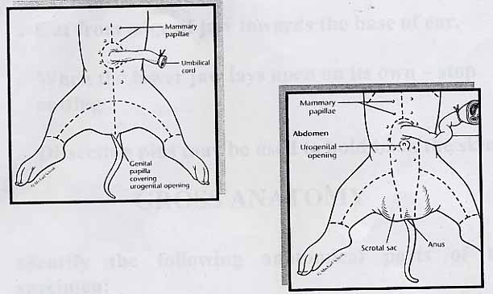
Figure X: Dissection cut lines for Females and Males.

Descriptions:
8. The abdominal cavity is lined with a shiny membrane, the peritoneum, and contains such viscera as the stomach, large and small intestine, major blood vessel, and urinary and internal genital organs. ALL the viscera, except where otherwise specifically directed, are to be left intact in the body.

9.The liver is the largest organ in the abdomen. Note how it fits into the concavity of the diaphragm, a muscular partition that separates the thoracic and abdominal cavities. Note also the small gall bladder that lies on the dorsal side of the large liver flap.

10. Push the liver aside and identify the stomach. This is the organ in which food is stored and where protein digestion is initiated. Locate the point at the anterior end of the stomach where the esophagus penetrates the diaphragm and then almost immediately joins the stomach. The constriction/sphincter between the stomach and the small intestine is known as the pylorus. Attached to the stomach by a mesentery is a long, flat, smooth, reddish organ, the spleen, an organ concerned with the production, storage and elimination of red blood cells.

11. The anterior end of the small intestine is called the duodenum. The liver and duodenum are connected by the bile duct which gives off a branch to the gall bladder, a small greenish sac embedded in the liver.

12. Lift the stomach and locate the pancreas, a light-colored diffuse granular gland. This has a duct which empties digestive enzymes into the small intestine. As is the case with most organs, it also has other functions. (remember?)

13. From the pyloric region, the small intestine runs posteriorly progressing from the duodenum to the jejunum and finally the ileum, until it joins the large intestine. Cut out a small segment of the small intestine, open it and examine it under water (float it in water). Observe how the internal lining is composed of numerous finger-like projections, the villi. These serve to increase the surface area to facilitate absorption.

14. A blind sac, the caecum, projects from the large intestine at the point of juncture.

15. Follow the large intestine (also called the colon) until it becomes the rectum in the pelvic region. Posteriorly the digestive tract opens to the outside through the anus.
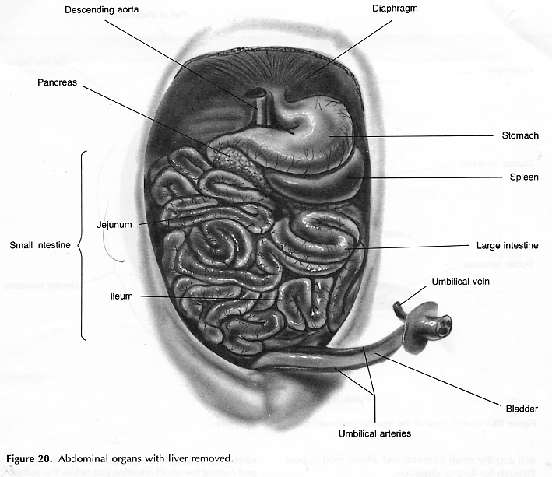

Phillips, Roger E. Jr., Dissection of the Fetal Pig, REX Educational Resources Company: Burlington, North Carolina, 1985
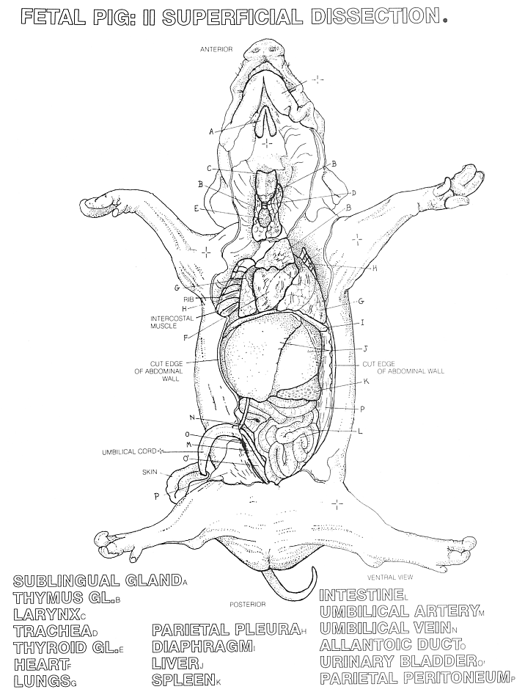

Elson, Lawrence M., The Zoology Coloring Book, Barnes and Noble Books: New York, New York, 1982

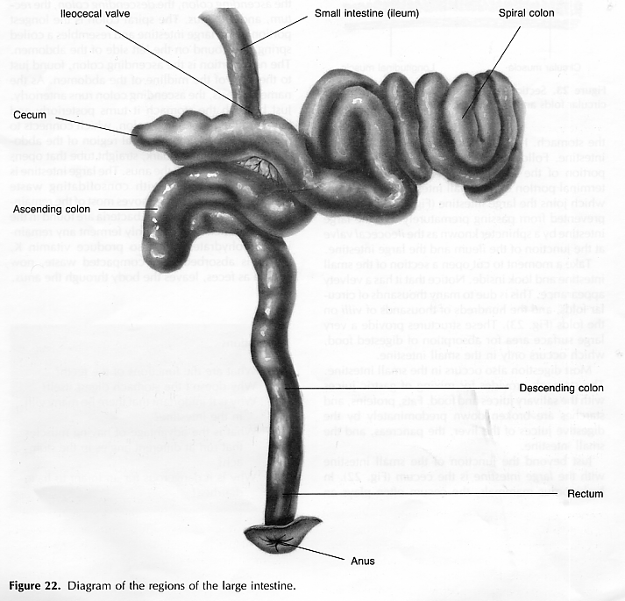

Phillips, Roger E. Jr., Dissection of the Fetal Pig, REX Educational Resources Company: Burlington, North Carolina, 1985

Individual Name: ______________________
Fetal Pig’s Name: _______________________
Group Members: __________________________________________________________________
Group Name: ___________________________

(end of description to Digestive System)

16. Once you have finished your drawings and I signed off, you may, if there is time, FIRST guess the total length of the intestines (do it in inches AND in centimeters) guesstimate _______in. _______cm, then remove, unfold, and measure the length of both the small and large intestines and record on the digestive system diagram.
(actual length: _____in. ______cm ).

Section 2: The Digestive System

Assignments/Questions:

- Identify the function of the digestive system.

- What body systems share the pharynx?

- What is the role of the epiglottis?

- What structures have you cut through to expose the internal organs (viscera)?

- What two cavities does the diaphragm separate?

What body system does the diaphragm belong to and what is its function?

- Why doesn’t the stomach digest itself? How does the stomach actually produce the chyme?

- What are the functions of the two valves or sphincters which are at the beginning and end of the stomach?

- What is the function of the gall bladder, and why does one always remove it before cooking the liver? (You may have to ask a butcher!!)

- What are the functions of the pancreas?

- The spleen is not a part of the digestive system. What system does it belong to and what is its function?

- The liver is an extremely important organ of the body with very complex function. Explain and support this statement using specific examples to support your statements.

- Choose two organs from the abdominal cavity and explain how the structure of each organ complements its function.

→ Don’t forget to cite and reference!

Section 3: The Respiratory-Circulatory System
Due to the intricate connections between these two body systems, it is impossible to view each totally separately. Therefore, be aware that your dissections and investigations need to continuously go back and forth between these body structures. The dissection of blood vessels is delicate where curiosity, dexterity and patience will greatly pay off with clear understanding the circulatory system. Clean dissections are an art, and they will greatly impress your teacher!
Instead of presenting this section with dissecting directions and descriptions separated into two parts, they are intermingled. Team members will need to read out loud to each other and follow line by line the text below.

3a: The Respiratory System
In order for cells to glean the largest amount of energy (ATP) from the organic molecules which have been digested, it is necessary for these compounds to undergo complete cellular respiration and for this to occur, oxygen is usually necessary. Cells must therefore have a continuous supply of oxygen and a means of releasing carbon dioxide. The critical process in gas exchange is diffusion of the gases in and out of individual cells. Such diffusion is possible only across a moist membrane. Such membranes are very delicate and must be protected from drying out and from mechanical injury. Another requirement is that the respiratory surface be large. You will see how these requirements are met as you study the respiratory system of the fetal pig.

- Make a cross section about 2cm in from the snout, remove the piece, and make an additional 3 cm long sagittal cut so that you can examine the nasal passages more carefully. They are separated from one another by a bony partition called the nasal septum. The lateral walls of the passages contain large folds, partially attached to cartilage, to increase the surface area. Check the skull of the adult pig and peer into its nasal passage to cartilaginous nasal conchae.
- Review the location of the pharynx, glottis, epiglottis. Locate the nasal passage leading into the pharynx.
- With your scissors, cut into the larynx and find two small membranes, the vocal cords.
- Posteriorly, the larynx connects to the trachea. Notice the rings of cartilage. Do they extend all the way around the trachea?
- Now cut open the thoracic cavity along the sternum and make a transverse cut posterior to the front legs, folding back the chest wall flaps so that the thoracic cavity is exposed.
- The thoracic cavity is divided into three compartments, the right and left pleural cavities containing the lungs, and the pericardial cavity, delineated by the tough pericardium, containing the heart. Posteriorly it is separated from the abdominal cavity by the diaphragm..
- Note the position of the lungs in the thoracic cavity. You may find a very thin membrane adhering to the lung tissue. This is the internal layer of the pleura. When the lungs are inflated there is no space between this layer and the external pleura, a shiny membrane hugging the ribs and diaphragm. As the lungs move, the pleura protect them from chafing against hard connective tissues or muscle and bones.
- In order to see the effect of inflation, cut a hole into the trachea at least one centimeter posterior to the laryx and insert a straw. Blow through the straw to simulate inhalation. Neat!

Make a rough schematic overview sketch of the cavities described and the membranes delineating them before moving on.

- Note the number of the lungs’ lobes on the right and on the left side. Notice how the lungs appear to cradle the heart.
- Note the large flat gland, the thymus, that lies on the cranial side of the heart.
- You might be able to follow the division of the trachea into right and left bronchi (singular- bronchus) by carefully snipping away lung tissue, but retaining the blood vessels. As they enter the lungs, these tubes continue to subdivide until they lead to the functional units of the lung, the air sac. An air sac contains several microscopic outpocketings called alveoli. These tiny structures have thin (one cell thick) moist endothelial cells and are surrounded by pulmonary capillaries’ network. The exchange of gases between the external air and the blood occurs here.
- Carefully follow the main arteries and veins from the lungs to the heart to see the pulmonaray circulation.
- Toward the posterior end of the trachea you will find the thyroid, an endocrine gland, framed by the carotid arteries.

Section 3b: The Circulatory System
The circulatory system can be considered an integrating mechanism. It not only carries raw materials and by-products of metabolism between sites of exchange with the environment and other parts of the body, but also serves as the medium in which a variety of chemical messages (hormones) are circulated.

In mammals, the heart is divided into four chambers to better separate the oxygenated blood (coming from the lungs) from the deoxygenated blood (coming from the tissues and cells of the body).
- Carefully clear away the pericardium (the membrane surrounding the heart) to expose the heart fully to view.
The left and right ventricles compose the major portion of the heart. with the darker atria sitting cranially atop the ventricles.
- Locate the following arteries.
  - pulmonary trunk- a light colored structure, leaves the right ventricle and branches into the pulmonary arteries which carry blood which needs oxygen (deoxygenated) to the lungs.
  - ductus arteriosus- it is a short stout vessel that continues directly from the pulmonary trunk to the aorta. It carries blood in the fetus only and serves to shunt blood away from the pulmonary circulation which is not functional before birth. A few weeks after birth it atrophies into a sold cord called the ligamentum arteriosum and remains there for life.
  - aorta – aortic arch - leaves the left ventricle and will carry the newly oxygenated blood to the body.
  - Following the aorta, anteriorly, the first branches are the pair of coronary arteries whose main function is to supply the walls of the heart itself with blood. You may find it easier to follow them by locating them along the neck and then following the posteriorly to the heart. You may need to sever the coronary veins in order to do that.
  - Locate and follow posteriorly the thick descending aorta (abdominal aorta) in the middorsal line. It gives off several branches as you follow it posteriorly.
- Locate the following veins: carotid veins, superior and inferior vena cava, hepatic, renal, umbilical veins.
- Fetal Circulation
Read this text carefully, as you will be asked a question or two during your dissection and Q&A section.
In the fetal pig, the placenta, rather than the digestive tract, lungs and kidneys, provides food, oxygen and removes carbon dioxide and nitrogenous wastes. Accordingly the pattern of fetal circulation differs in several ways from that of the adult.
Blood rich in oxygen and food materials and low in waste products leaves the placenta and enters the embryo via the umbilical vein. This empties into the caudal vena cava which transports it to the right atrium. In adults the right and left atria are separated from each other by a septum but in the fetus there is an opening in this septum called the foramen ovale. Most of the rich umbilical blood entering the fetal heart can pass from the right to the left side directly via the foramen ovule, thus bypassing the nonfunctional lungs. From there it is distributed to the head and the body.
Most of the blood returning from the head in the cranial vena cava goes from the right atrium to the right ventricle and in the adult this deoxygenated blood is then pumped to the lungs via the pulmonary trunk. During fetal life, the lungs are not sufficiently developed to handle all this blood and consequently only a small volume goes through them and returns to the heart in the pulmonary veins. Most of it bypasses the lungs traveling through the ductus arteriosus to the rest of the body and by the umbilical arteries to the placenta, thus completing the circuit.
A fetus has a temporary opening, the foramen ovale, between the right and left atria. That permits most of the oxygen rich blood from the right atrium (!!!!) to pass to the left atrium and ventricle to be pumped throughout the body of the fetus in the systemic circulation. Later in the fetal life the ductus arteriosus becomes smaller in diameter resulting in some blood flow to the fetal lungs and getting them ready for external respiration and intake of oxygen.

Now draw and label the respiro-circulatory system.

- Heart
Make a frontal cut through the heart and identify or re-identify as many of the following structures: left ventricle and atrium, right ventricle and atrium, aortic arch, semilunar valves, tricuspid and bicuspid valves, superior and inferior vena cava, coronary arteries, pulmonary trunk and artery. Remove the heart and check where the bronchi enter the lungs.

Fetal Blood Circulation

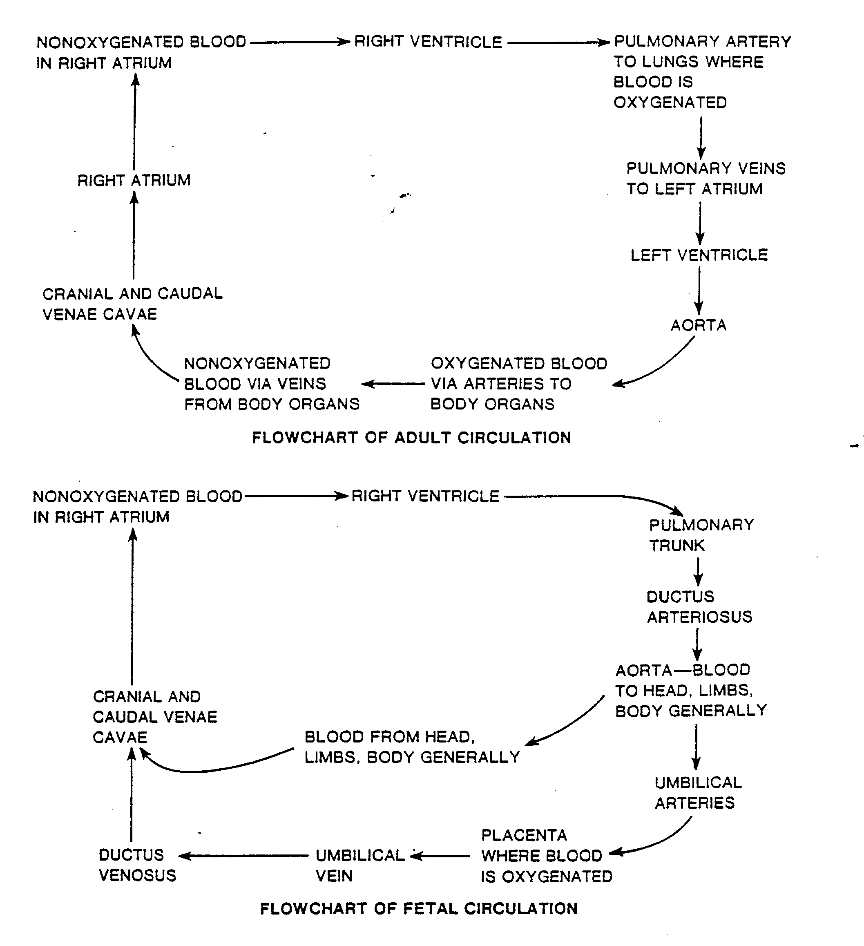
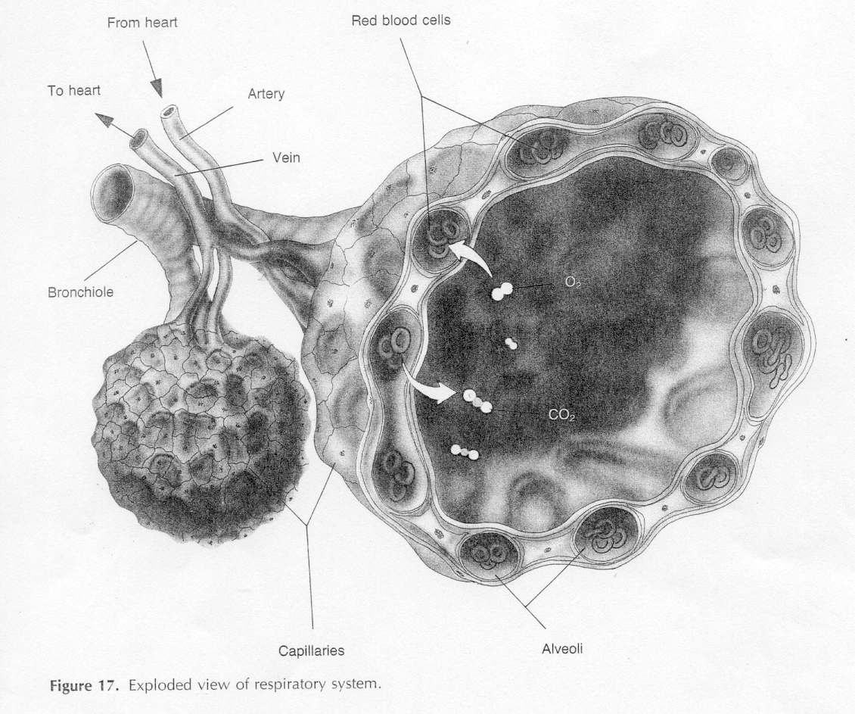
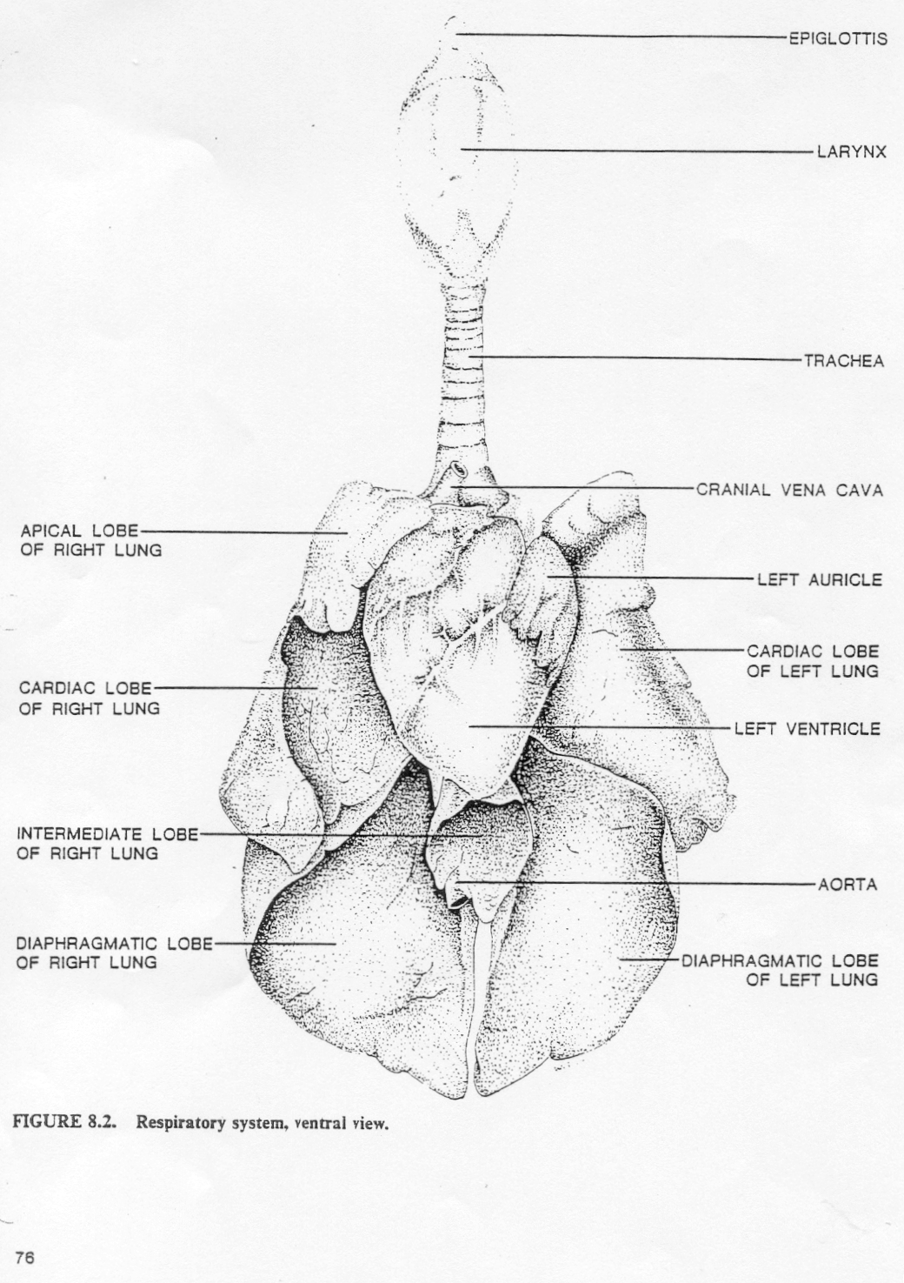
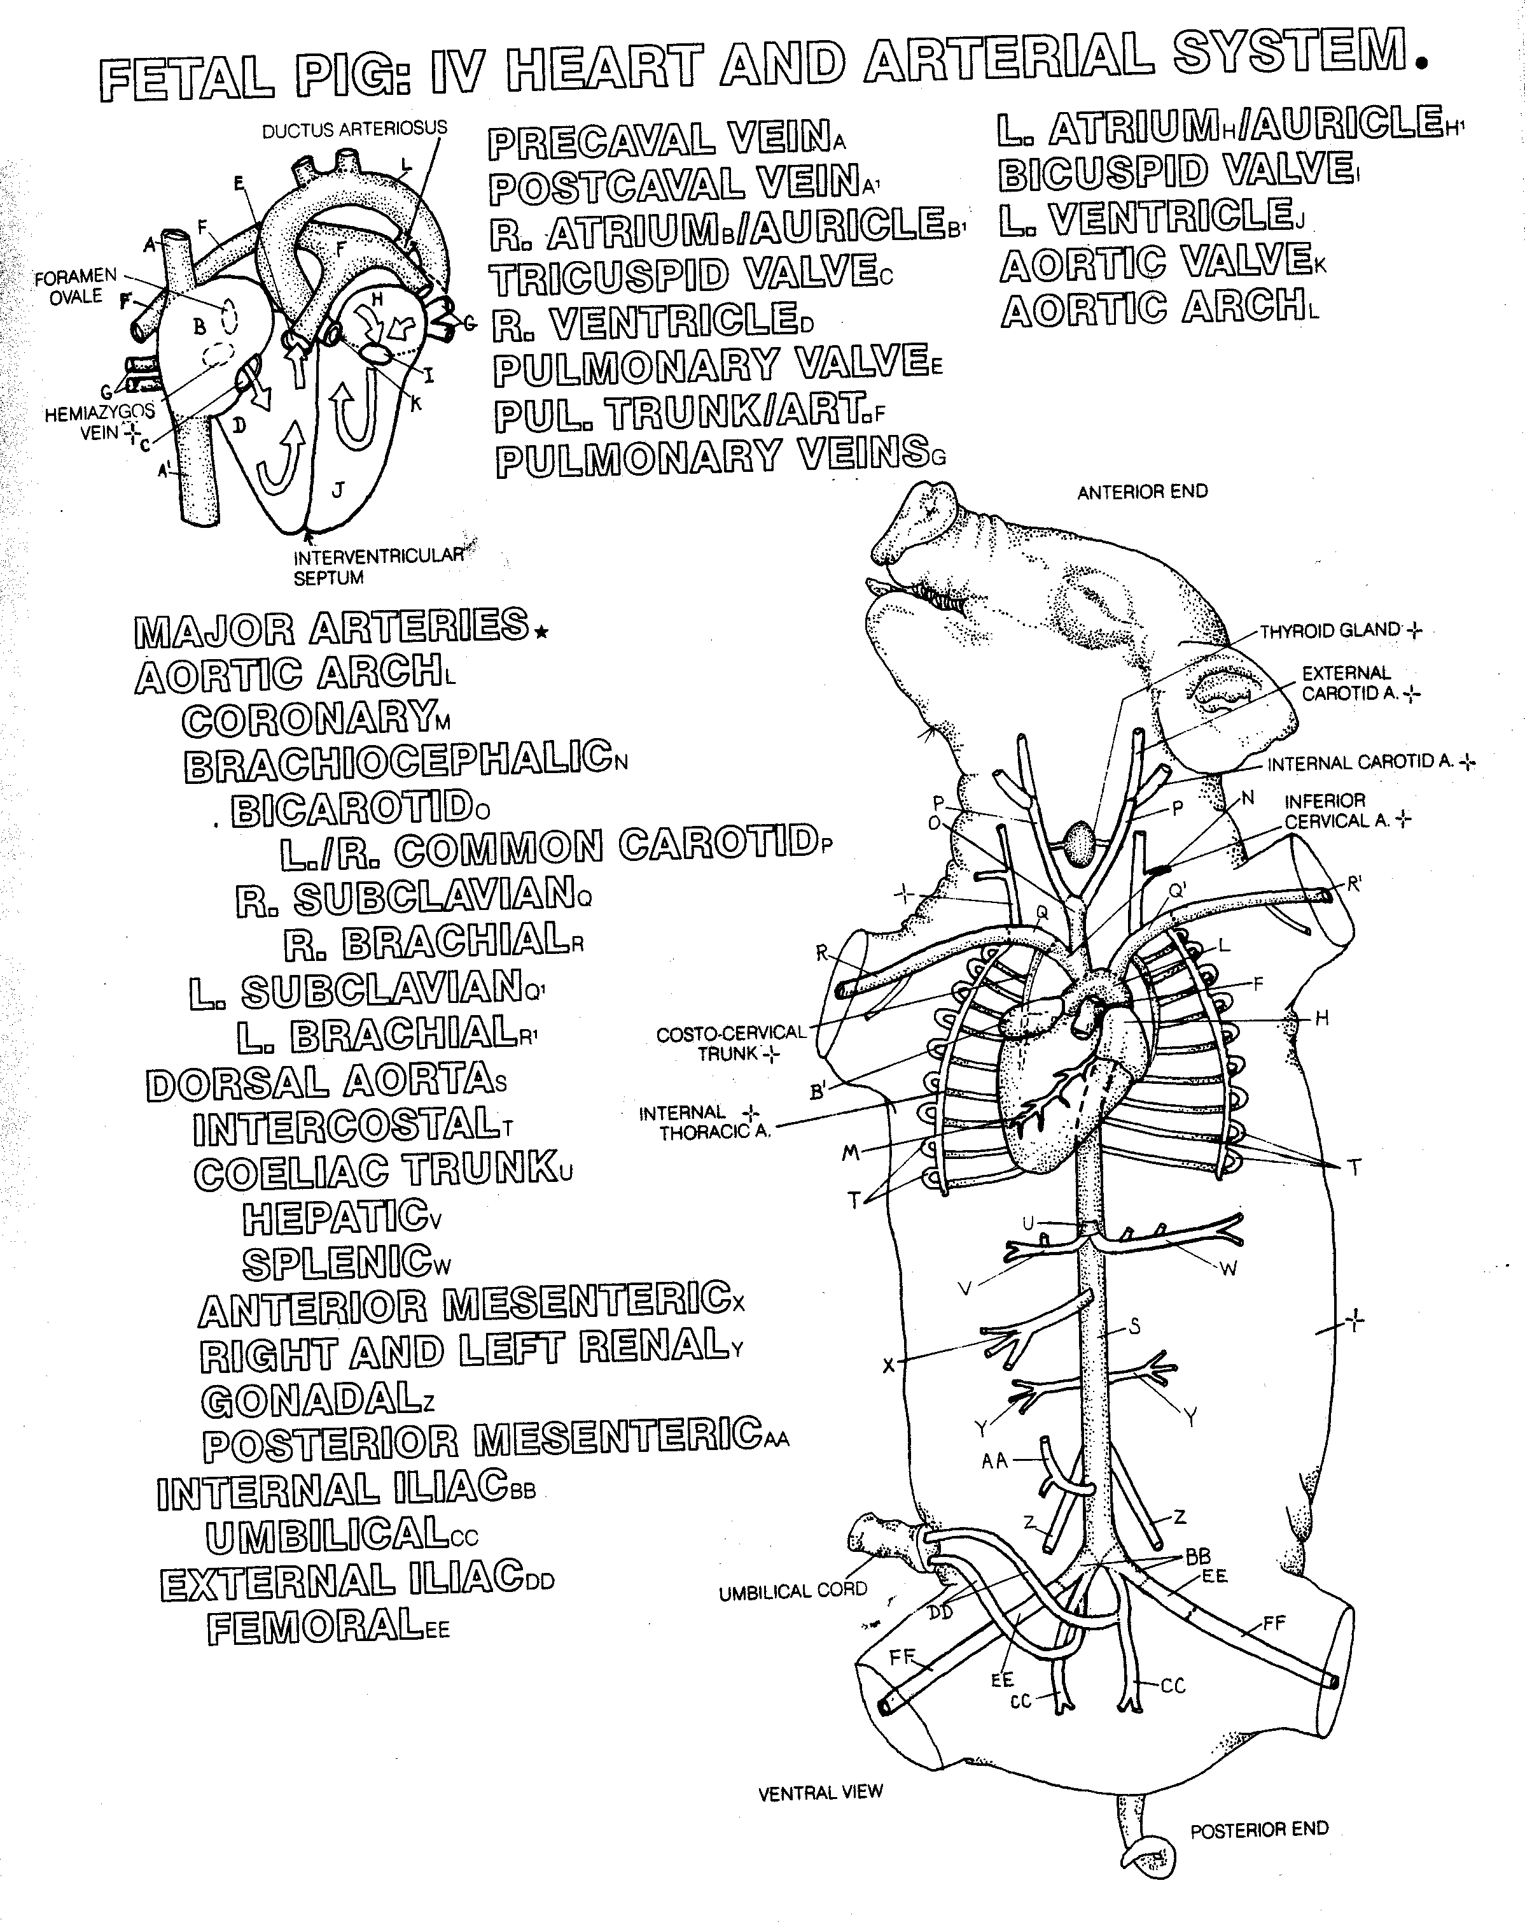
Elson, Lawrence M., The Zoology Coloring Book, Barnes and Noble Books: New York, New York, 1982

Individual Name: ______________________
Fetal Pig’s Name: _______________________
Group Members: __________________________________________________________________
Group Name: ___________________________

Section 3: Respiratory/Circulatory systems

Assignments/Questions:

- What is the function of the nasal septum?

- Would the trachea collapse when you were inhaling or exhaling if there were no rings of cartilage in its walls?

- What is the role of the surfactant in the alveoli? Why, furthermore, do the alveoli need moist endothelium?

- What must happen in order for the lungs to expand so that you can inhale?

- Why does the rib cage have cartilage where the ribs and sternum attach?

- Why is it necessary to close the opening of a puncture wound in the chest?

- On which side of the body is the heart located? It is nestled into the lungs that are not of the same size, nor do they have the same amount of lobes. Why?

- What keeps blood from pooling in the legs of humans and pigs?

- Blood is prevented from flowing backward in the veins by these one-way valves. Why do these structures not exist in arteries or capillaries?

- Which has more muscles: the atria or the ventricles; the aorta, pulmonary veins or the vena cava?

- Why is it an advantage for arteries to have elasticity?

- What blood vessels provide oxygen to the heart muscles? to the brain?

- What is the disease in which fatty deposits collect on the walls of the arteries? What does it cause?

- What are the roles of the thyroid? And the thymus?

- Why is it important for the fetal heart to have both the ductus arteriosus and the foramen ovale, but life threating for the adult heart to have these?

Section 4: The Nervous System
The survival of an organism depends on its ability to respond to changes in its environment in a coordinated and effective way, To do this, sensory structures have evolved which detect various environmental stimuli which are then relayed to the brain where they can be integrated and interpreted so that the appropriate action can be taken.

Directions:
You may not have enough class time to dissect eye, ear, brain/ spinal cord. Discuss within your group what you want to accomplish and then do it! Whatever you decide to do, do not butcher for a quick superficial glance – do what you do well. However, you may be able to save the eye (? the ear?) for last – be aware that removal of the eye entails cutting through the optic cord and severing it from the brain.
The Eye: see directions below.
The Ear: see directions below.

The Brain/Spinal Cord: Make a longitudinal incision with a scalpel starting from the base of the neck and continuing rostrally. Gently separate the skin from the skull and peel it back anteriorly until the skull is fully exposed. The bone is not yet calcified, but still cartilaginous. With the scalpel, make a circle design on the top of the skull, then, with little pressure, cut the skull. This may take a few times going over the same line. Take care not to press down and damage the meninges covering the brain. Remove the disk you have cut. Now start “chipping” away pieces of the skull until you have exposed the whole brain. Be sure to remove the back of the skull where it joins the vertebral column. If possible, use the scissors to cut away a few of the vertebrae without damaging the spinal cord. Ventrally and anteriorly nerves come off the brain and go through holes in the skull to the outside. Investigate the pig’s head to see where they are. In particular look for the prominent oral and olfactory nerve passages.
Now carefully separate the brain from the skull and investigate it.

The Eye: To clearly expose the eyeball, carefully dissect away the eyelids, some of the bone of the orbit and the surrounding connective tissue and lacrimal (tear) glands. Narrow, band like muscles (extrinsic ocular muscles) connect the eyeball to the orbit and control the eye’s movements. Emerging from the back of the eyeball is the optic nerve which carries visual information to the brain. After the eyeball has been removed make sagittal section and identify the following structures.
- fibrous tunic. This first (outermost) layer is composed of a posterior-lateral opaque schlera and an anterior transparent (in non-preserved specimens) cornea.
- vascular tunic. This second layer is composed of the dark, pigmented choroids coat. The part in front of the lens is the iris. Circular and radial muscle fibers within the iris control the diameter of the pupil and thus the amount of light passing through the lens. Locate the ciliary body which adheres to the periphery of lens. It is responsible for changing the shape of the lens and thus permits sharp focusing.
- Humors. The vitreous humor is the viscous material between the retina and the lens. The aqueous humor is the watery substance filling the posterior chamber (between the iris and lens) and the anterior chamber (between the iris and cornea).
- Retina. The retina lies on the inside surface posterior chamber. It is the eye’s third tunic and is made up of rods and cones, the actual photoreceptive cells.
- Gently push the retina aside and notice tht is appears to be attached to the choroids layer at one spot. This is where all the eye’s sensory nerves combine to form the optic nerve. The optic nerve runs through an opening in the skull to the brain.

The Ear: The mammalian ear has a dual function- maintaining equilibrium and detecting sound. It consists of three parts: the inner ear, the middle ear and the external ear.
- The external ear. Remove the pinna (ear flap) and cut away muscle to expose the external acoustic meatus (the inward extending passage). Follow this until you expose the eardrum (tympanic membrane).
- The middle ear. The rest of the dissection should be done with a dissecting microscope. Just beyond the eardrum is the tympanic membrane containing three auditory ossicles: the malleus, uncus, and stapes. Carefully remove the ossicles and identify them. The stapes (innermost) fits into a small hole in the fenestra vestibule or ovul window). Slightly ventral to this is the round window or fenestra cochlea.
- The inner ear. The cochlea which is responsible for the sense of equilibrium, is found in the inner ear. Since this is a very difficult dissection and may not be successful for all students, make sure you examine the models on demonstration. Also read your text to learn the functions of each of the components of these sensory structures.

The Brain: Remove the brain by skinning the head and carefully picking away the top and sides of the skull. The heavy membrane covering the brain should be left intact as long as possible until you have laid the brain bare.
- Meninges. The mammalian brain is surrounded by several layers of connective tissue or meninges. A tough, protective dura mater covers the other membrane. (dura - hard, mater – mother). The arachnoid membrane comes next. A vascular pia mater lies against the surface of the brain (pia- tender).. Between the arachnoid and the pia circulates cerebrospinal fluid serving both as a protective cushion and as a supply of nutrients.
- Cerebrum. The most conspicuous parts of the brain are the pair of cerebral hemisphere, the primary integration centers. The surface of each is convulated, forming many ridges (gyri) and grooves (sucli). Notice that the surface is composed of grey matter (cell bodies of neurons). Below this lies the white matter which is due to myelination of the neuron processes. It is possible that this process has not yet occurred in your fetal pig, in which case, everything will look grey.
- Rhinencephalon. This structure is situated below the cerebrum and is primarily concerned with olfaction smell. The olfactory bulb forms the anterior part of the rhinencephalon and receives branches of the olfactory nerve endings from the nasal cavities. Posterior to the olfactory bulbs on the ventral surface you can see the optiv chiasma where the optic nerves cross. Posterior to this is the oval hypothalamus which is concerned with the integration of many autonomic functions: sleep, body temperature, water balance, appetite and carbohydrate and fat metabolism.
- Posterior to the hypothalamus lies the pons (ventral) and the cerebellum (dorsal). These are concerned with muscular coordination.
- Medulla oblongata. This structure is the most posterior part of the brain, merging with the spinal cord. Its function is to regulate many visceral activities such as rate of heart beat, blood pressure, breathing movements, etc.
- After you have examined the external features of the brain, make a sagittal section and try to identify the structures shown in the diagram.

The Spinal Cord.
- Investigate the spinal cord next. It is covered with the same membranes as the brain. Look for the spinal nerves leaving the spinal cord – there are 31 of them!
- Look at the cross section and notice two areas, an area of grey matter and an area of with matter. As in the brain, the grey matter is composed of cell bodies and unmyelinated nerve fibers, whereas the white matter is composed of myelinated fibers. Myelination, with nodes of Ranvier, allow impulses to be carried much faster than in unmyelinated neurons.

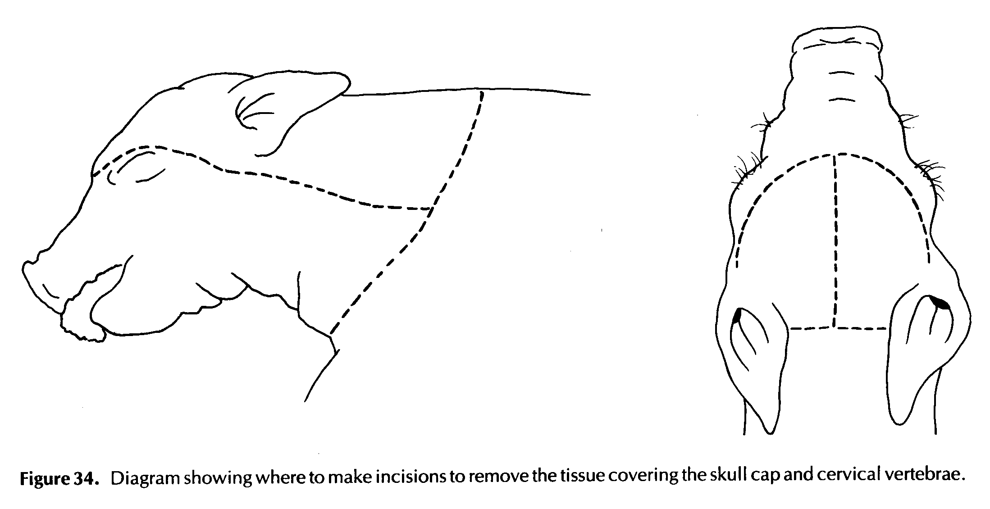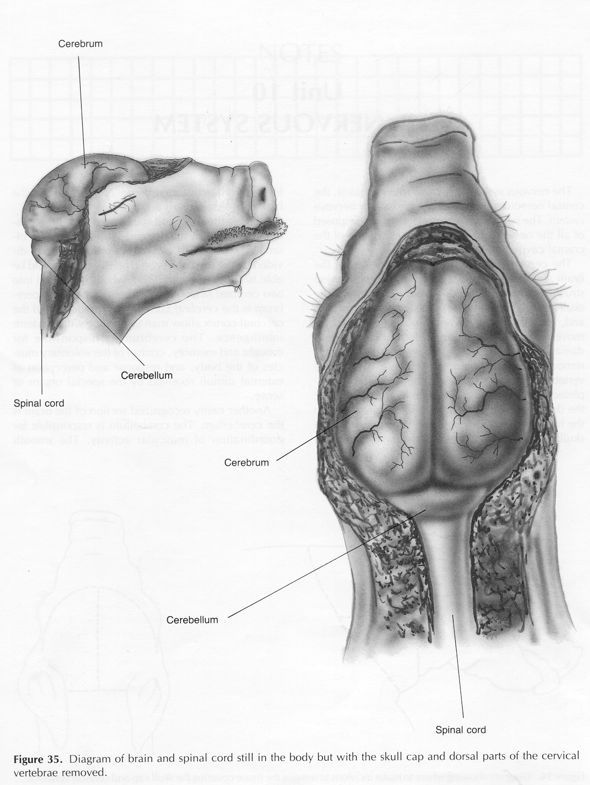
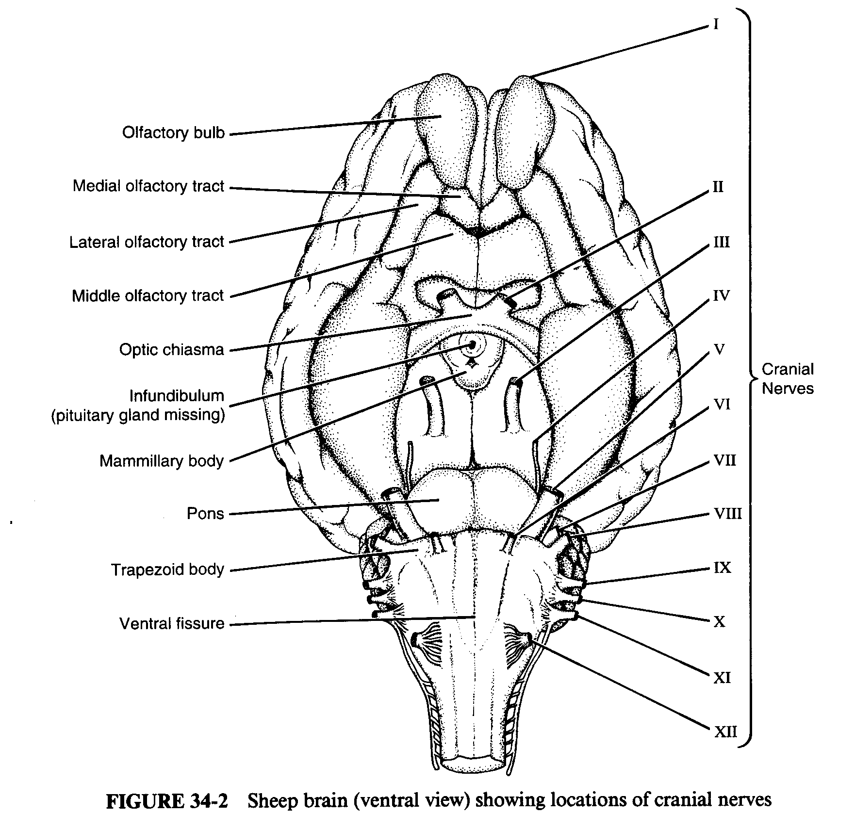

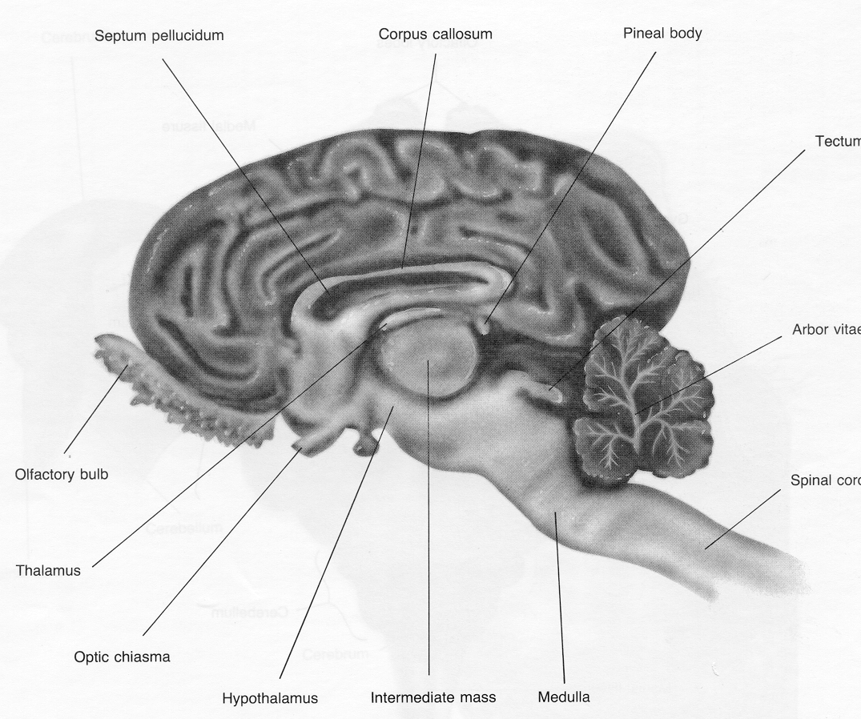 | 

