Muscle Contraction Note Guide:
Exam Question: Why does hyperextension (of a muscle) hurt?

Powering the Muscle
 | Oxidative | Glycolytic
What
Pro
Con

MM Contraction Basics
Muscles are attached to bones by ___________________________
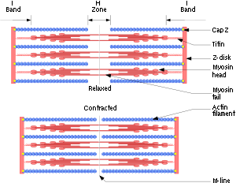
Tendons grab onto _______________________ on bones
Muscles work in antagonistic pairs
Ex. Biceps and triceps
One muscle contracts while the other relaxes

Functional Unit: _______________________ (Video)
Actin and Myosin do the actual contracting
The Neuromuscular Junction
- Is the location of ___________________________________
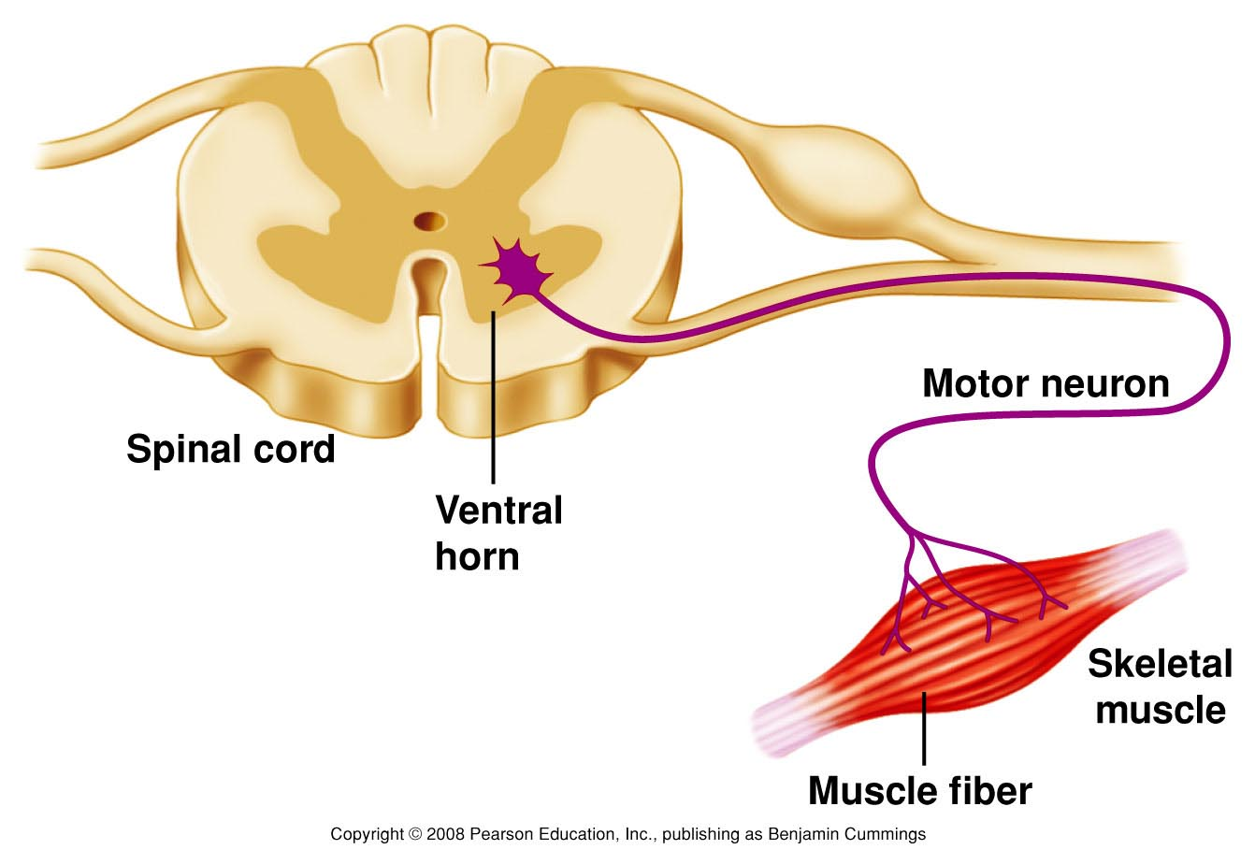
- _____________________ (electrical signal):
  - Travels along nerve axon
  - Ends at __________________________________
- Releases _____________________________ (ACh)
- Into the ________________________ cleft (gap between synaptic terminal and motor end plate)

The Mechanism of Force Generation in Muscle
- Neuron dumps a bunch of ___________ on the motor plate (mm)
- Action potential
- Ca⁺⁺ _____________________
- Ca⁺⁺ bonds to ___________________
  - _____________ binding sites are _______________
- __________________ Cycle begins
- Ca⁺⁺ _________________
- Tropomyosin _________________ biding sites
