Animal Distribution Notes (Page 780)
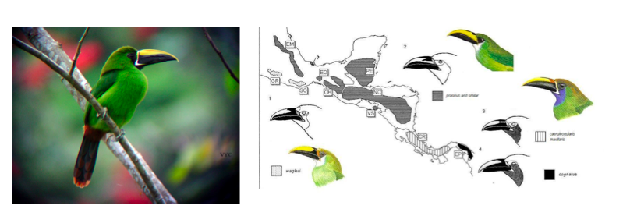 | Disjunct Distributions
 | - What:
 | - Results in: _______________________ Because:
 | Speciation
 | - What:
 | - Why: They no longer _____________________ and the ______________ become so different they become their own __________________
Cause of Disjunct Distributions
Reasons for Vicariance:
1.The _________ moved and separated a once continuous population.
•EX: _____________________ ___________________ IE Pangaea
2.The ___________________ _________________ and caused the separation
•Ex: A _____________ ___________ down, or a mountain sprung up
3.Middle territory is _____________ ____________________so they stop going there

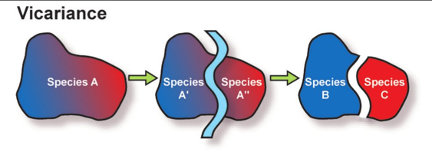
Continental Drift
Evidence:
1) Fits like a ____________________
2) _____________ are the same on different continents
3) Living __________________ in widely separated lands are _________________.
Ex: India and Madagascar have similar mammals, which are quite different from those in Africa, even though it is now near to Madagascar.

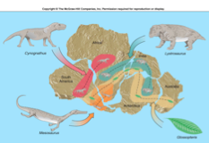
4) There are numerous __________________ similarities between eastern South America and western Africa.
EX: Continuous mountain range

Practice Exam Question: Pangaea, the continents moving apart could contribute to vicariance. How?

Types of Speciation
____________ speciation: | ______________ speciation:
When a species splits into 2+ because the populations are ______________ isolated. | Species diverge while inhabiting the __________ ____________

Practice Exam Question: What type of speciation is this? And Why?

