Macroscopic Muscle
How do Muscles Work? - Macroscopic anatomy of muscles
- Muscles are attached to bones. All skeletal muscles cross at least one joint.
- Each muscle pulls from an ____________________ to an ________________________.
- Each muscle produces a specific movement – “_______________________”
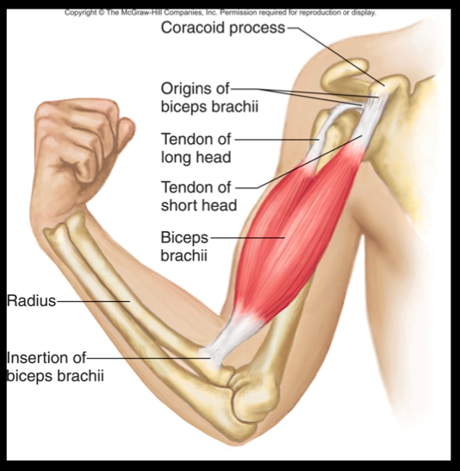
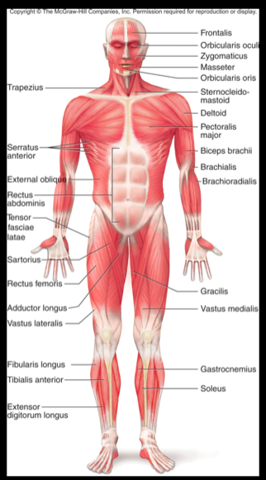 | Naming Muscles  - Named for its ____________________ and __________________  - Ex: SternoClido Mastoid
Skeletal Muscles: Functional Groups
Muscles work in pairs located on opposite sides of a joint
- Muscles ____________________ – NEVER PUSH
  - Work together to do the opposite of each other
- _____________________ = _____________________ - Provides the major force for producing a specific movement
- ______________________ - Opposes or reverses a particular movement
- _________________________ – Works together with a prime mover to add force or control

Activity: Pick a Muscle and Find:
- Identify the movement
  - Demonstrate to class
- Prime Mover | Synergist | - Antagonist

