Antibody Antigen Game
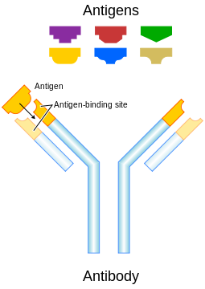
Immune Basics: When antigens (foreign substances that invade the body) are detected, several types of cells work together to recognize them and respond. These cells trigger the B cells to produce antibodies, specialized proteins that lock onto specific antigens.

Your Mission:
- Find a partner
- Make an antigen and antibody that fit together
- Antigen should be evil and demonic
  - The creator of the Antigen will be a Virus or Invader

    - Virus Name: ______________________________________
- Antibody should be wholesome and angelic
  - The creator of the Antibody will be a B Cell

    - B Cell Name: ______________________________________

Antibody | Antigen
- Good Guy  - Recognize the bad guy  - Used to launch attack of the immune system on the bad guy | - Bad Guy  - How the bad guy is recognized

