Blood Vessel-Notes TOC#2
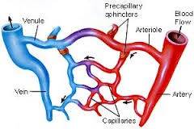 | Pnemonic for:  Arteries Arterioles Veins Venules Capillaries
- Arteries–

- Arterioles-

- Veins-

- Venules-

- Capillaries-

- Atherosclerosis-

Label the following structures of this capillary network.

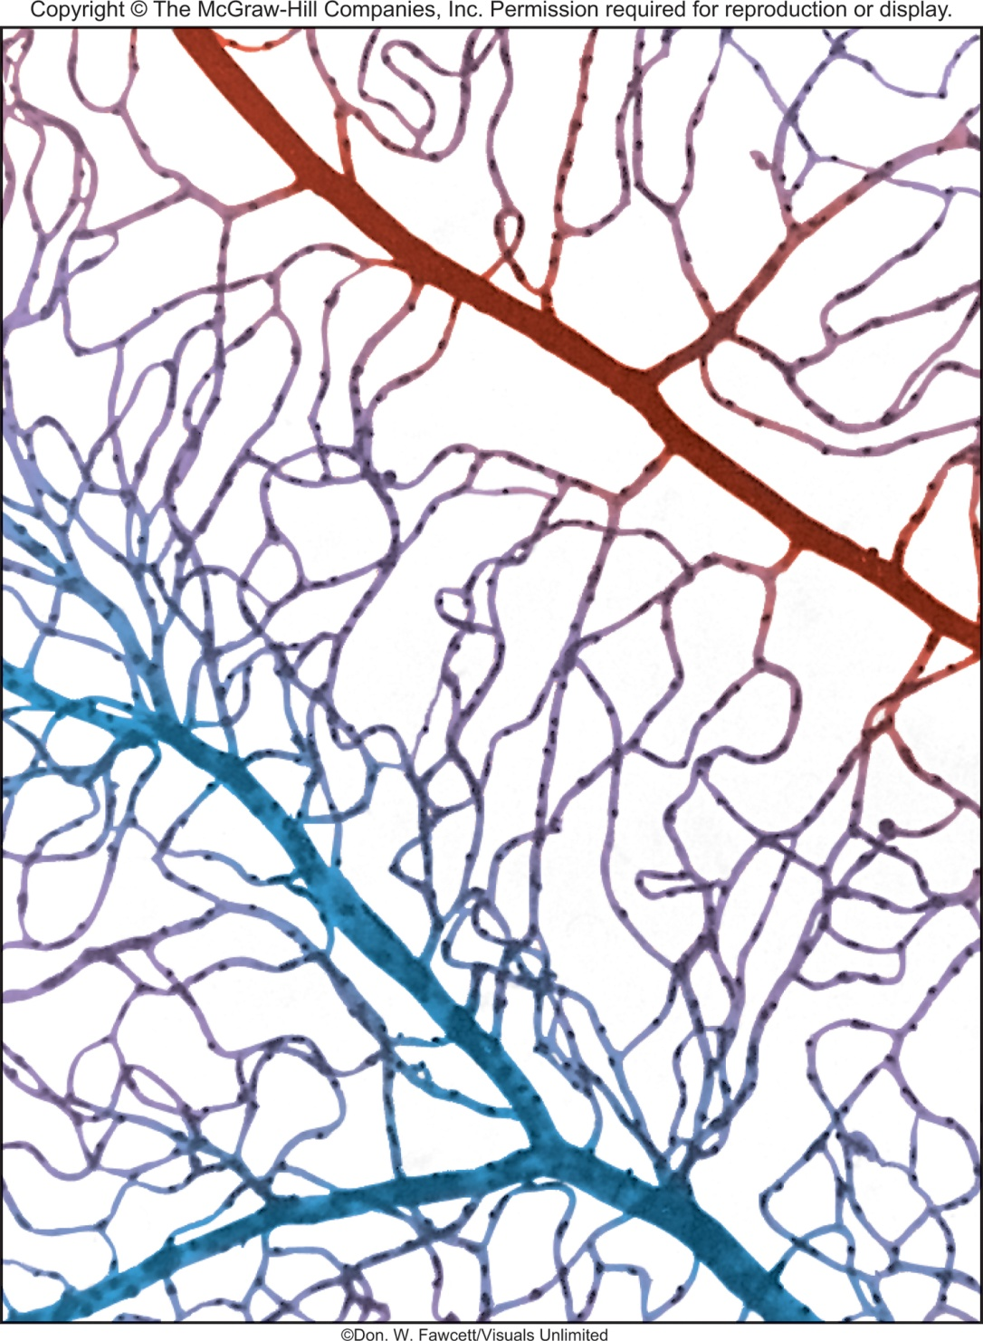

Compare an artery to a vein.
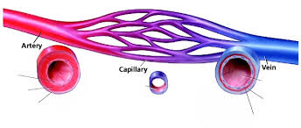
Artery | Vein
Structure: | Structure:
Function: | Function:
Free Choice: | Free Choice:
Why are they different? | Why are they different?

