Unit2: How Plants Gain Mass
- Write the Equation of Photosynthesis from memory:

CB (Compact Bean) Demo Lab
Video to Summarize: https://www.youtube.com/watch?v=2KZb2_vcNTg
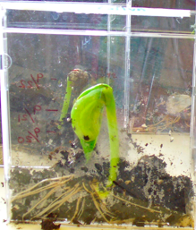
Goal
The purpose of this experiment is to introduce students to the concept of how plants grow and gain mass.

Question
Where did the mass come from as the plant grew?

