Gymnosperms (Pine Trees) Angiosperm (Flowering Plant) Lab

Gymnosperm Life Cycle | Angiosperm Life Cycle
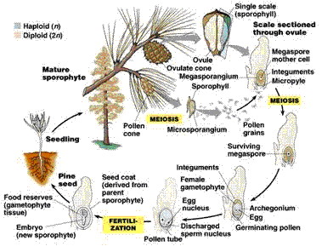 | 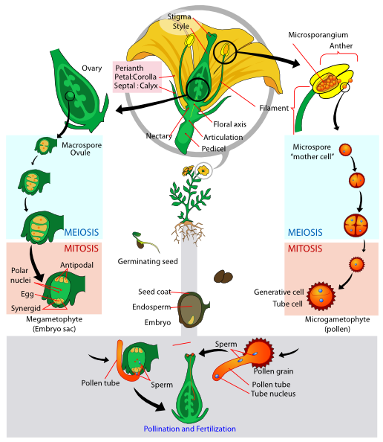
The 4th group is the Gymnosperms -- plants that produce seeds, but lack true flowers or fruits. Their most familiar members are the conifers, including pines, spruces and firs, but they also include many more obscure and beautiful plants unfamiliar to most people from North America. Gymnosperms include the tallest, most massive, oldest, and possibly the most beautiful organisms known to humankind.  Gymno- means naked and –sperm means seed. "Naked" here refers to the lack of a fruit surrounding the seed; a fruit is a structure derived from the ovary of a flower, so fruits are found only in the flowering plants (the Angiosperms), which we will study next week. | The 5th group is the Angiosperms - no older than 135 million years, the angiosperms probably arose much earlier.  How did angiosperms evolve?  1. Any discussion of how angiosperms evolved must include a topic we’ve touched upon briefly before in our discussion of flowers: the role of insects.  2. Early in seed-plant evolution, insects became pollen carriers as they searched for food. In turn, plants evolved floral nectar and odors for attracting insects to carry pollen.  3. The rise to dominance of angiosperms in the Tertiary seems to have been greatly influenced by adaptations for pollination by increasing diversity of flying insects.

- Pre-Lab:
  - What are gymnosperms?

    - Why are they called naked seeds?

    - How do they protect their seeds then?

  - What evidence is there that angiosperms are the most derived plant?
II) How are flowers like cones?
  - How did pinecones evolve into flowers?
Fern | Gymnosperm |  | Angiosperm
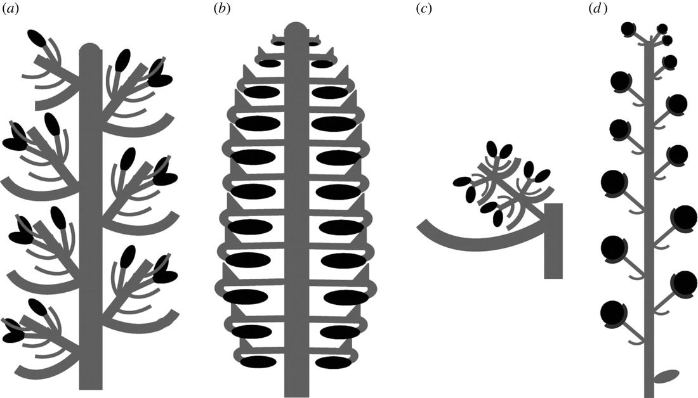
How did it change from  Fern TO Gymnosperm? |  | How did it change from  Gymnosperm TO Angiosperm?
Main Structure:  Purpose: | Main Structure:  Purpose: |  | Main Structure:  Purpose:

- Reproductive anatomy of flowers
  - Obtain a flower and cut it in half longitudinally. Identify its main structures using your in class book. At left below, draw the flower and label.
Flower Parts
See Figure 13.33 In green Biology Textbook | Label  - Sepals  - Petals  - Stamens  - Anther  - Filament  - Carpel  - Stigma  - Style  - Ovary.  Color Code with a highlighter which are male and which are female structures  Key: (Color Code)  - Male  - Female

