Unit2: Plant Unit Review
Be able to explain this:
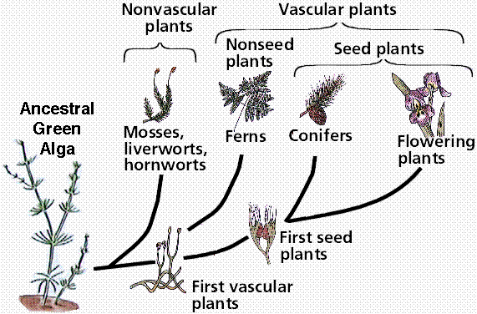
What is a phylogenetic tree?

Tell an Evolution story:
Discuss each plant group | Add the steps one at a time | Explain each step
Tell the story of THE EVOLUTION OF REPRODUCTIVE TISSUE
Algea:  Reproduction method: | Limitations:
Moss:  Reproduction method: | Limitations: | Advancements:
Fern:  Reproduction method: | Limitations: | Advancements:
Pine Tree :  Reproduction method: | Limitations: | Advancements:
Angiosperm:  Reproduction method: | Limitations: | Advancements:
What is the difference between ancestral and derived?

- How is a prokaryote like a charophyte?

How does gymnosperms vascular tissue that doesn’t collapse?

How is evolution related to natural selection?

Moving to land: (TOC13)
Why did plants bother?

What is the main problem with plants moving to land?

What does desiccation mean?

What 2 ways did plants use to deal with this main problem?
Way they accomplished this: | Way they accomplished this: | Way they accomplished this: | Way they accomplished this:
Photosynthesis Equation:
Reactants (what goes in) | Products (what comes out)
Explain in a sentence:

How are these the same thing and what are they showing?
How the same?

What are they showing?

Light Reaction  Why called Light Reaction? | Dark Reaction  Why called Dark Reaction?  Why is that not entirely correct?
Where does it occur? | Where does it occur?

ATP
What is ATP? | Why Have it?
What is the difference between ADP and ATP?

What is the purpose of glucose?

What is the connection between plants and animals? (3 - Explain) (think of the food web)

What is a symbiotic relationship, and how are lichen an example of this?

Lab Review:
What is the format of a hypothesis? Be able to generate one.

In the Plant Types Labs –
Why does the angiosperm not need a cone?

What is the purpose of a flower?

List 3 adaptations that gymnosperms have that allow them to live on land:

How does having vascular tissue affect your shape? | 2 types of vascular tissue
 | Type 1: ______________ | 2: _____________________
 | Function:
In the light intensity’s affect on Photosynthesis Lab –
What did counting bubbles actually measure?

How does it measure that?

How did light affect the rate of photosynthesis and why?

In the Spore to Fern Demo – Where does the fern get its mass? – https://www.youtube.com/watch?v=2KZb2_vcNTg
How does the Fern gain mass? –Explain as specifically as you can.

What did that have to do with photosynthesis?

Create your Finals Study Packet:
Quiz 1
Exam 1
Gummy Bear Lab Conclusion
Jell-O Lab Conclusion

