Rainbow Flower Lab
Celebrate your complete plant evolution essay with creating a rainbow flower!
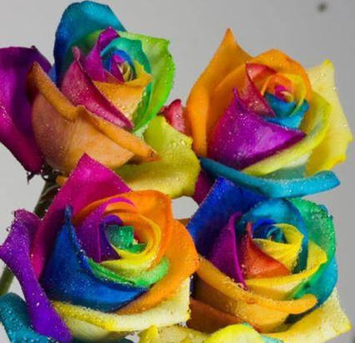
Protocol – use your knowledge of vascular tissue to create a rainbow flower.

Materials:
- Food coloring
- Razor
- Cups

Make a Plan for what your group needs:

Hypothesis:

