Unit2: Plant Review – This will account for 60-70% of your final exam, the last 40-30% comes from unit 1 – please review the last unit quizzes, exams and labs.
Be able to explain this:
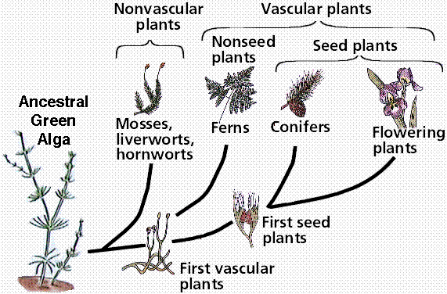
Move to Land

Vascular

Seeds

Flowers

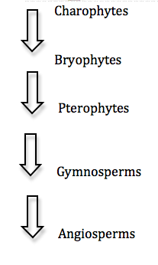
What is the difference between ancestral and derived?

How is evolution related to natural selection?
Photosynthesis Equation:
Reactants (what goes in) | Products (what comes out)
Explain in a sentence:

Light Reaction  Why called Light Reaction? | Dark Reaction  Why called Dark Reaction?  Why is that not entirely correct?
Where does it occur? | Where does it occur?

What is ATP?

Why Have it?

What is the difference between ADP and ATP?

What is the purpose of glucose?

What is the connection between plants and animals? (3 - Explain)
How are these the same thing and what are they showing?
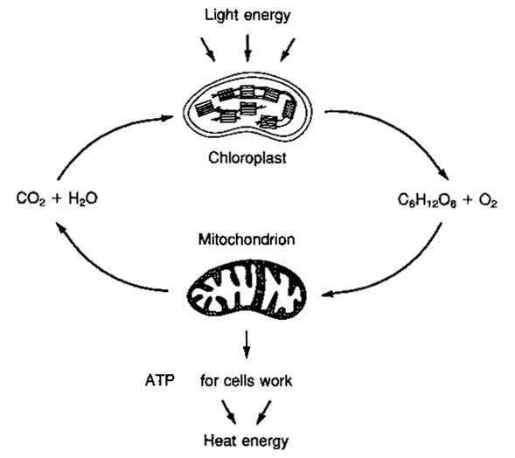 |  | How the same?  What are they showing?
Lab Review:
What is the format of a hypothesis? Be able to generate one.

In the Plant Types Labs –
Why does the angiosperm not need a cone?

What is the purpose of a flower?

Why have vascular tissue?

How does gymnosperms vascular tissue that doesn’t collapse?

How can you tell that mosses are ancestral to gymnosperms?

In the light intensity’s affect on Photosynthesis Lab –
What was the purpose of the lab?

Why did we measure bubbles when we were really measuring photosynthesis?

How did light affect the rate of photosynthesis and why?

In the CD Bean Lab –
What was the purpose of the lab?

How did the bean gain mass? –Explain as specifically as you can.

What did that have to do with photosynthesis?

