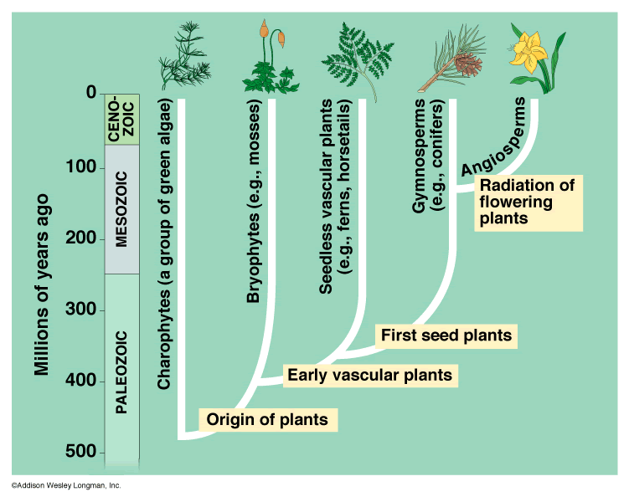
The above is a Phylogenetic Tree of Plants – What does this mean?:

Define/Explain:
Adaption:

Evolution:

Origin:

Photosynthesis:

Vascular (in plants):

Charophytes:

Bryophytes:

Pterophytes:

Gymnosperms:

Angiosperms:

Summary:

What does this tell us about the evolution of plants?

