The Characteristics of Life LAB

Biology is the study of life. In this activity you will observe and discuss a group of living and non-living things and come up with a list of characteristics that you think define life.  We will use the scientific method to explore and determine if these items are living or non-living.  Instructions  - Have a discussion about what characteristics all living things share.  Think – Pair – Share  - Think on your own  - Pair up with a partner  - Share your ideas together  - In your lab groups (2-3):  - Brainstorm 7 characteristics of living things.  - Observe each specimen.  - Decide whether or not each specimen has each of the characteristics of life.  - If the specimen has that characteristic write yes in the data table, if it does not write no.  - Make a conclusion, is it living?  - Do a little research… Teacher will help give some background. | 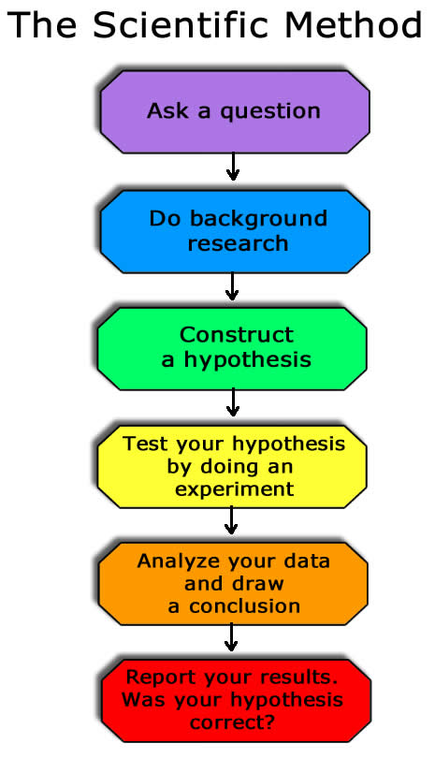

Student Hypothesis:
Characteristic of All Living Things | Bone | Bamboo | Yeast | Candle | Shell | Salt | Seed | Soil | Insect
1)

2)

3)

4)

5)

6)

7)

Summary:

Characteristics of Life: With research!
Characteristic of All Living Things | Bone | Bamboo | Yeast | Candle | Shell | Salt | Seed | Soil | Insect
1) Composed of Cells:

2) Different Levels of Organization

3) Living Things Use Energy:

4) Living Things Respond To Their Environment

5) Living Things Grow

6) Living Things Reproduce

7) Living Things Adapt To Their Environment

Is it living?
Summary:

Analysis Questions: (Answer clearly, in complete sentences on the back of this paper.)

- Were any of your hypothesized characteristics of life right?

- Which of the characteristics of life were difficult to observe just by looking at the specimens?

- For one of the specimens and one of the characteristic that were difficult to observe directly describe how you could observe that characteristic if you had enough time and equipment. Design an experiment!

- Do you think scientists have a set of characteristics of life that they all agree on? Why or why not?

