Bio 10: Final Exam Review – Home
BBQ#1: Do you have to have all 7 characteristics of life to be considered alive? Explain.

BBQ#2: An uncharged atom of zinc has an atomic number of 30 and an atomic mass of 65.
This atom has:
•______ protons
•______ neutrons
•______ electrons.
**BBQ3: Draw two water molecules, and label any parts or interactions.

BBQ4: –When you “lose” weight due to exercise, how do most of the atoms that made up that weight leave your body?  •A. In your breath  •B. In your urine  •C. In your feces  •D. In your sweat  •Explain why and how | 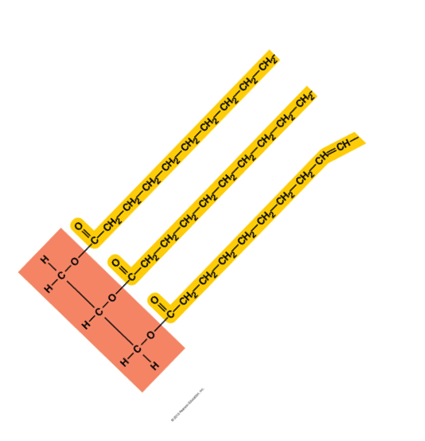
BBQ5: 1.Draw a saturated and non saturated fat.  2.Explain why are saturated fats considered worse for your health?  –Talk about double bonds | 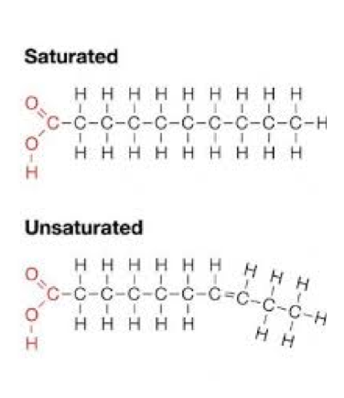
**BBQ7: What is the cellular currency of energy?
- Draw it
- How and where does it store energy?
- Plants use what organelle to make energy?
Why is it important to me – a predator what plants do, in regards to energy?

*BBQ8: Explain osmosis and how it affects a salty (hypertonic) cell.  - Is the movement of water passive or active transport? Explain. | 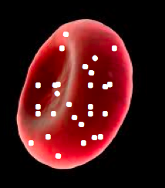

BBQ9: Complete the table on Cellular Respiration
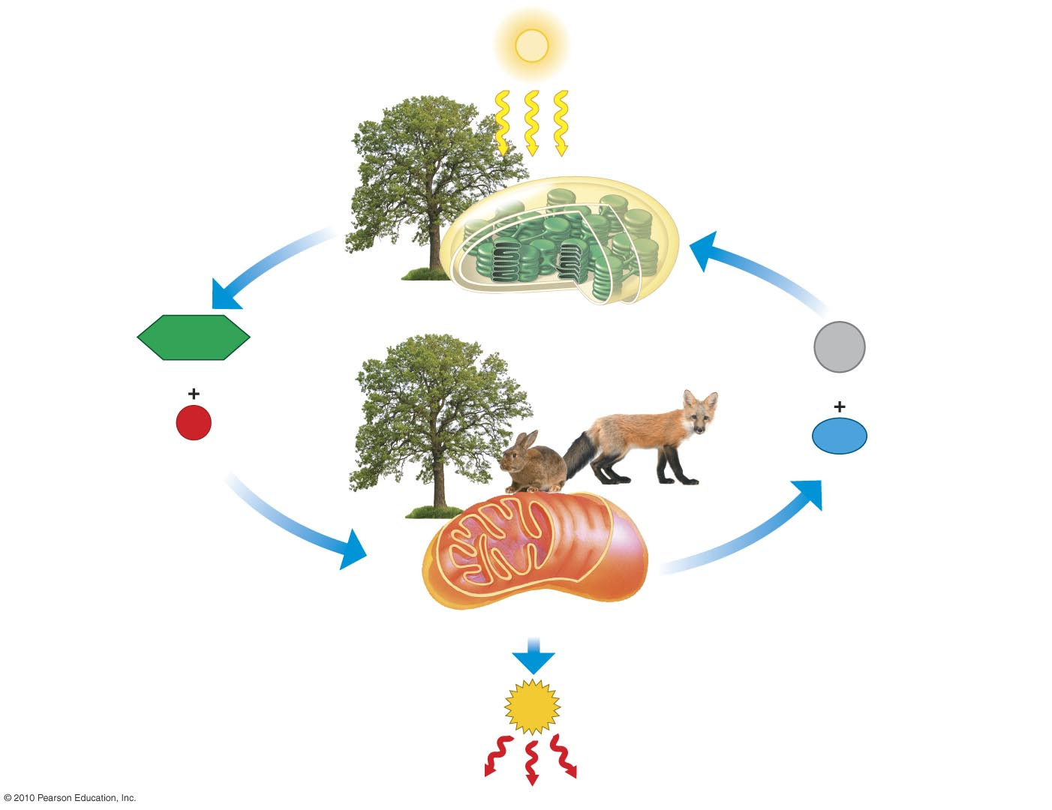
Explain the exchange between plants and animals shown in this picture.

Be sure to discuss cellular respiration, photosynthesis, mitochondria, chloroplasts and the gasses involved.

BBQ11: Complete the table on Photosynthesis
BBQ12: Complete the table on DNA Structure
Draw a Chromosome: | Why is DNA stored in Chromosomes?
Overall Structure of DNA: | What is the purpose of that shape?
What is the Monomer of DNA? | They are bound together with what type of bond (s)?
BBQ13: Which type of mutation is the most disruptive to DNA? Why?

*BBQ14: Explain the steps (and sub steps) needed to turn DNA into Protein
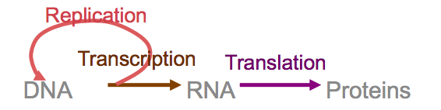

BBQ15: Draw the Cell Cycle.
*BBQ16: Your friend tells you she recently had testing done at the doctor’s office, and the doctor discovered a malignant tumor in one of her breasts that has metastasized. She is too upset to listen what the doctor has to say, and asks you to help her make sense of it all.
- Based on your understanding of malignancy, what treatment option do you recommend to her and why?

*BBQ17: Compare and contrast the PURPOSE, STEPS and CELLS of Mitosis vs. Meiosis 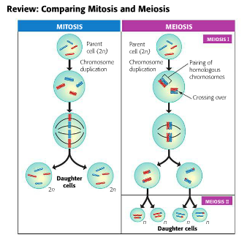
- BBQ18: Describe the advantages and disadvantages of asexual and sexual reproduction.

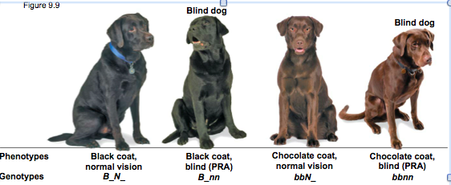

**BBQ19: A black lab who is blind, had a mother who was chocolate brown. This black lab mates with a chocolate brown lab with normal vision, whose mother was blind.
  - Draw the punnett square

  - What is the phenotypic ratio of their offspring?

**BBQ20: Explain how pesticide resistance in mosquitoes (or rubber duckys) is actually an example of natural selection

**Tell me about sexual selection and how it reduces survivorship but still causes natural selection?

: 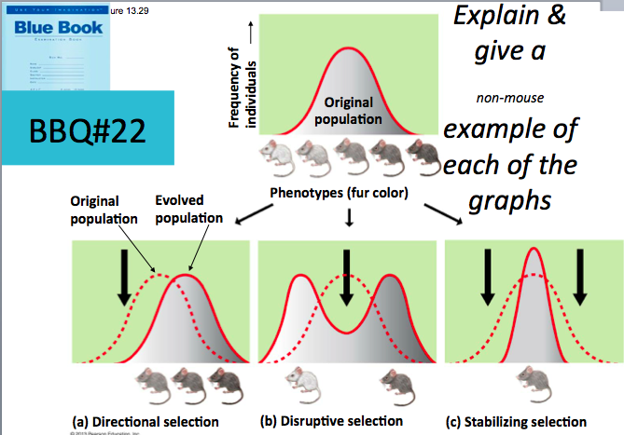
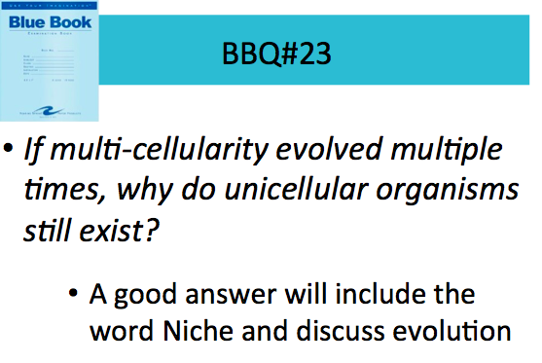
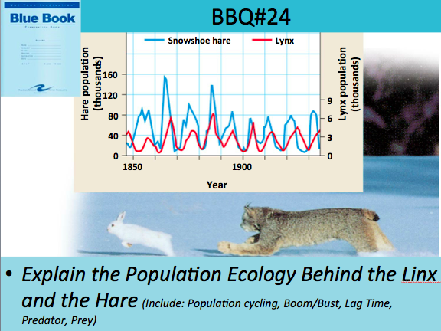
Be Able to distinguish between the two of these:
Ecological Succession Vs. Eutrophication
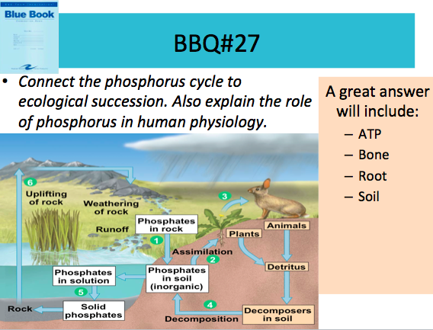 | 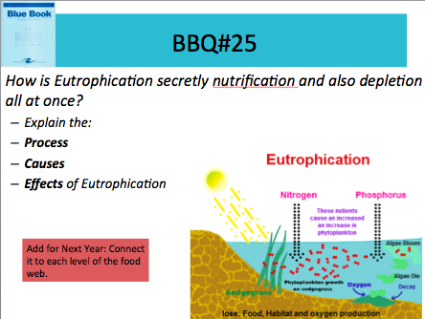

*
**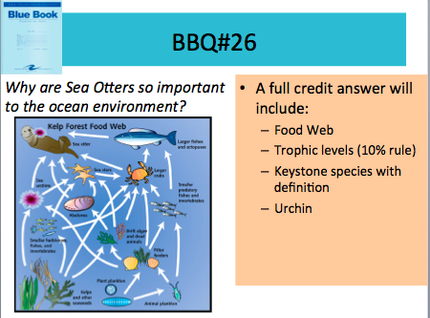

**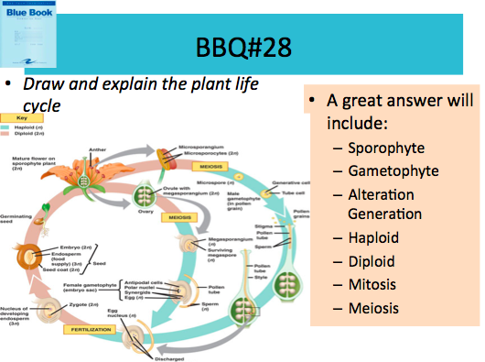
Endosperm | Flower | Why is advantageous for flowers to be able to reproduce sexually and asexually?
Purpose:  How is it made: | Purpose:  Pro:  Con:
**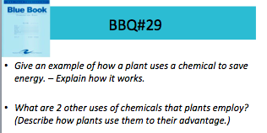
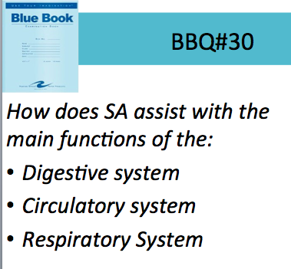
Big Themes: Tie it all together:
**How does SA improve the function?
Cells | Molecules | Ecology | Plants | Animals
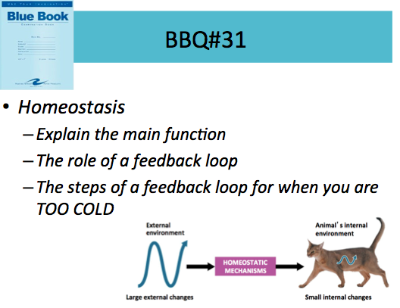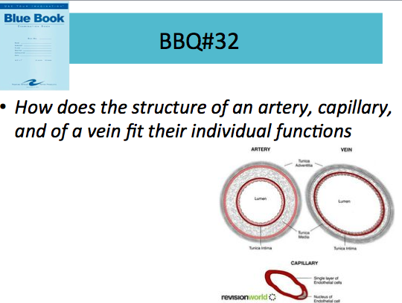
How does the structure of a ____________ fit its function?
DNA | Enzyme | Water | Root Hair | Animal Blood Vessel
Structure:  Function:  How does structure fit function: | Structure:  Function:  How does structure fit function: | Structure:  Function:  How does structure fit function: | Structure:  Function:  How does structure fit function: | Structure:  Function:  How does structure fit function:

