Bio 10: Final Exam Review in Class
Big Themes: Tie it all together:
**How does SA improve the function?
Cells | Molecules | Ecology | Plants | Animals

How does the structure of a ____________ fit its function?
DNA | Enzyme | Water | Root Hair | Animal Blood Vessel
Structure:  Function:  How does structure fit function: | Structure:  Function:  How does structure fit function: | Structure:  Function:  How does structure fit function: | Structure:  Function:  How does structure fit function: | Structure:  Function:  How does structure fit function:
*Prokaryotic cells/organisms Vs Eukaryotic cells/organisms
- Which came first?
- How can you tell?

- If one evolved from the other, why do they both still exist?

**BBQ3: Draw two water molecules, and label any parts or interactions.

**BBQ7: What is the cellular currency of energy?
- Draw it
- How and where does it store energy?
- Plants use what organelle to make energy?
Why is it important to me – a predator what plants do, in regards to energy?

*BBQ8: Explain osmosis and how it affects a salty (hypertonic) cell.  - Is the movement of water passive or active transport? Explain. | 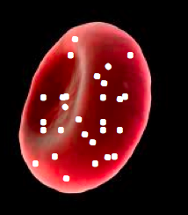
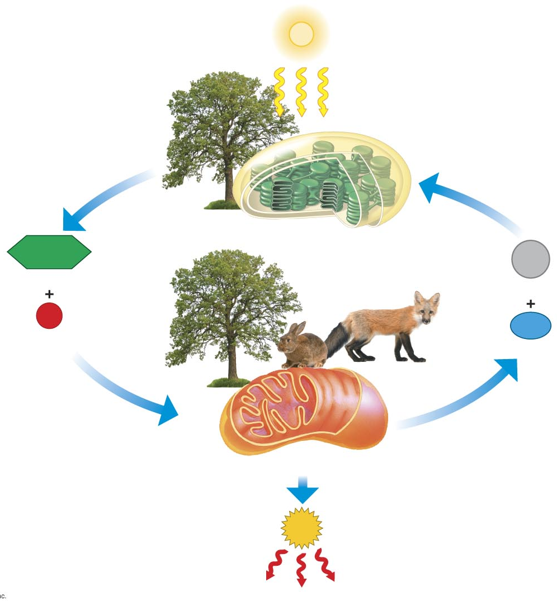
BBQ9: Explain the exchange between plants and animals shown in this picture.
- Be sure to discuss cellular respiration, photosynthesis, mitochondria, chloroplasts and the gasses involved.

*BBQ14: Explain the steps (and sub steps) needed to turn DNA into Protein
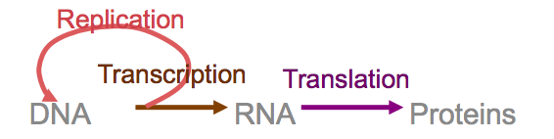

*BBQ16: Your friend tells you she recently had testing done at the doctor’s office, and the doctor discovered a malignant tumor in one of her breasts that has metastasized. She is too upset to listen what the doctor has to say, and asks you to help her make sense of it all.
- Based on your understanding of malignancy, what treatment option do you recommend to her and why?

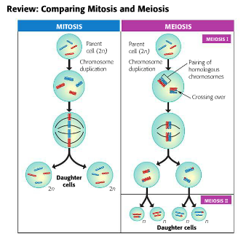
*BBQ17: Compare and contrast the PURPOSE, STEPS and CELLS of Mitosis vs. Meiosis

- BBQ18: Describe the advantages and disadvantages of asexual and sexual reproduction.

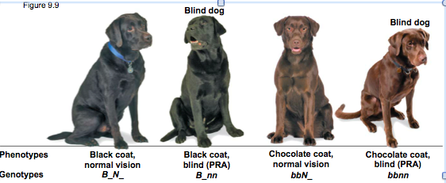

**BBQ19: A black lab who is blind, had a mother who was chocolate brown. This black lab mates with a chocolate brown lab with normal vision, whose mother was blind.
  - Draw the punnett square

  - What is the phenotypic ratio of their offspring?

**BBQ20: Explain how pesticide resistance in mosquitoes (or rubber duckys) is actually an example of natural selection

**Tell me about sexual selection and how it reduces survivorship but still causes natural selection?

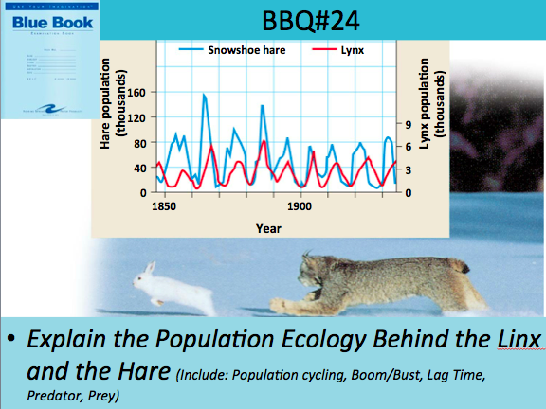
Be Able to distinguish between the two of these:
Ecological Succession Vs. Eutrophication
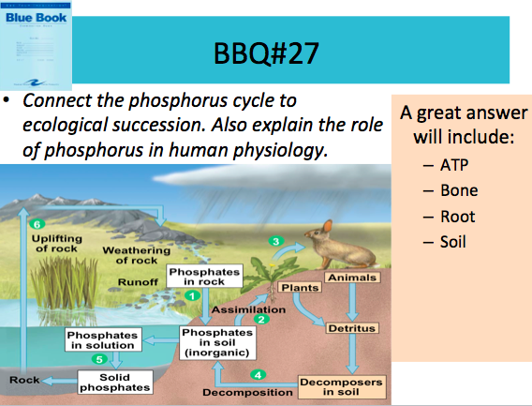 | 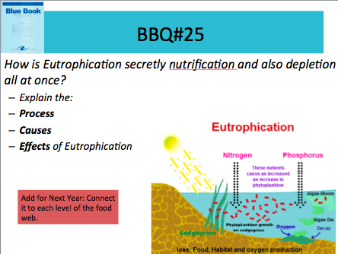
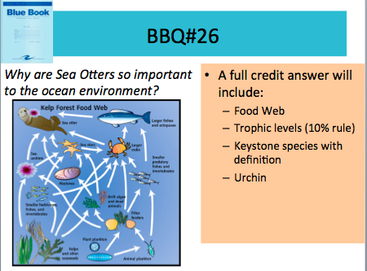
**What is a keystone species? Give an example that exemplifies their importance.

**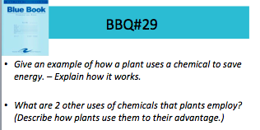 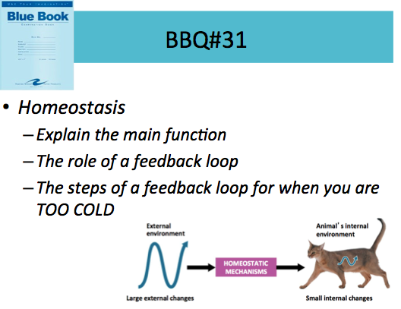
*
Endosperm | Flower | Why is advantageous for flowers to be able to reproduce sexually and asexually?
Purpose:  How is it made: | Purpose:  Pro:  Con:

