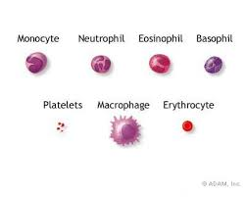
Blood Components Essential Questions
How does the structure of blood cells relate to their function? | What factors influence who you can receive blood from through a transfusion?
What information can be determined through blood analysis? | Come up with a question you have about blood:
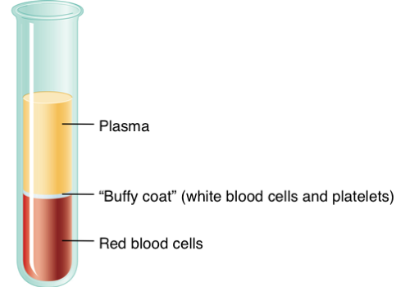
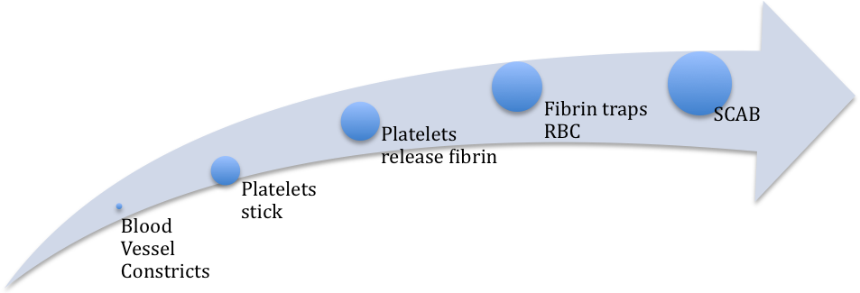 | 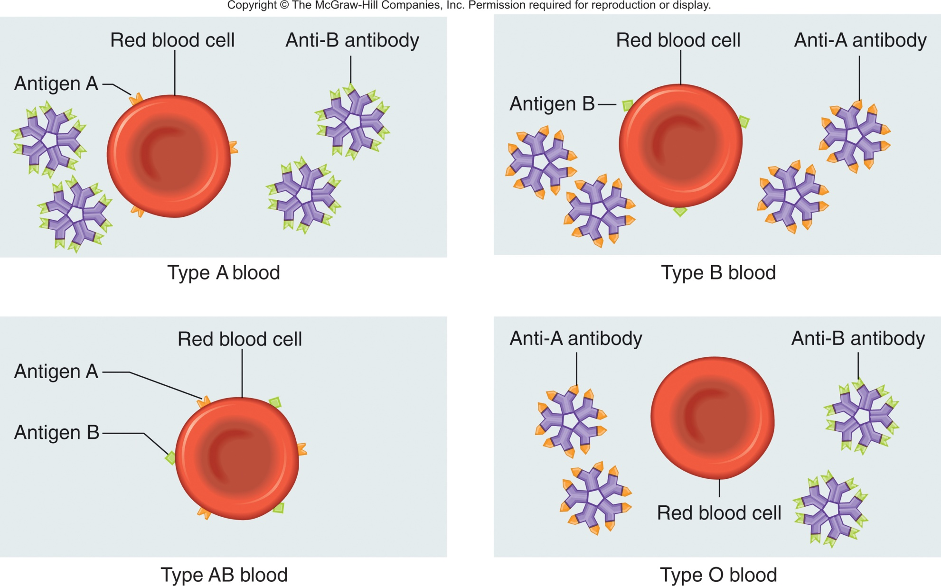

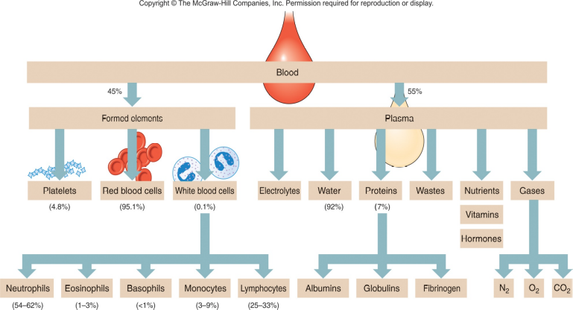
THE BLOOD COMPONENTS
Blood component  (Sketch) |  | Function
Platelets  AKA ______________________ |  | Main Job:
Blood Clot Formation | 1.Vessel _____________  2.Vessel ______________  3.___________ ____________ to blood vessel walls |  | 4.Platelets release ____________ (protein)  5.Fibrin traps ________________  6.Clotting cascade started
Red blood cells  AKA ______________________ |  | Main Job:  Shape:  How does their shape support their function?
White Blood cells
______________ | ______________ | ______________ | ______________ | ______________
_____________, engulf smaller particles and contain many lysosomes that help breakdown organic molecules. | Moderate _________ reactions as well as defend against parasitic infections. | Migrate to damaged tissues and release histamine to promote ___________ and heparin to ____________  ____________ | Largest blood cells, and are ___________ engulfing larger particles, have variably-shaped nuclei.) | Major players in specific __________ ____________ and some produce ____________.  Long lived!
(54-62% of leukocytes) | (1-3% of leukocytes) | (1% of leukocytes) | (3-9% of leukocytes | (25-35% of leukocytes)

Plasma (components)

