Terrestrial Biome Note Guide - Cornell Notes
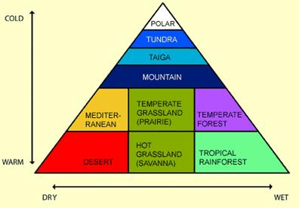 | Biomes:
 | What:
 | Adaptations:
 | What: (in our own words)
Using your notes give a 1 sentence description of each
1.Temperate deciduous forests | 2. Coniferous forests | 3. Tropical Forests
4. Grasslands | 5. Tundra | 6. Deserts

Terrestrial Biomes:
1. Temperate Deciduous Forests: Trees that show seasonal changes
•Fall, leaves fall off
Adapted to: Dormancy
 | Woodchucks: Go dormant in Winter to deal with the lack of food – lower heart rate and sleep to save calories
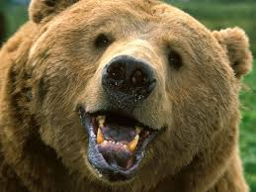 | Bears:
Practice Exam Question: The Temperate Deciduous Forest is known for dormancy, how do animals show adaptation to dormancy, give an example, including animal name?

2. Coniferous Forest: Evergreen Trees: Cold
- Adapted to _________________________________________________________.
–The animals of this area must do the same
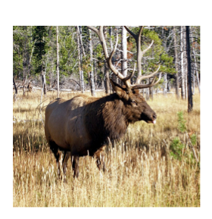 | Caribou
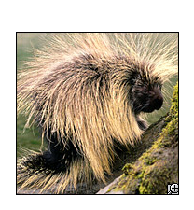 | North American Porcupine
Practice Exam Question: What 2 adaptations do the N. American porcupine have the Coniferous Forest and how does it serve them in this environment?
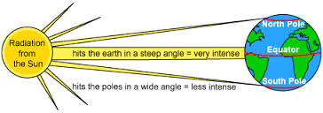
3. Tropical/Rain Forests: On Equator: _____________________________________________.

 | Frog:
 | Siamang:
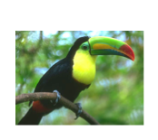 | Toucan:
4. Grasslands: Flat and Grassy
- Adaptation: ___________________________________________________
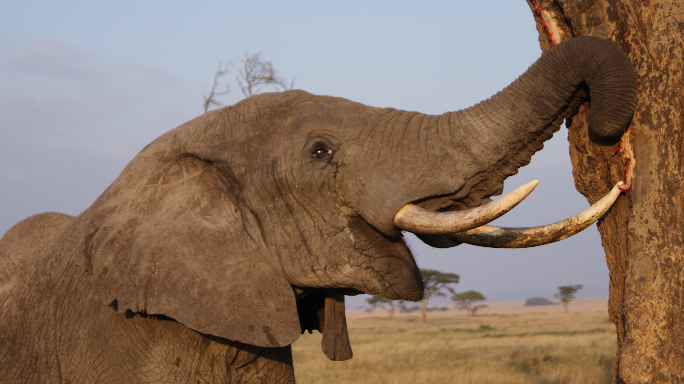 | Dental Adaptations: In response to _____________________________________
 | Elephant:  1.  Draw: |  |  | 2.  Draw:
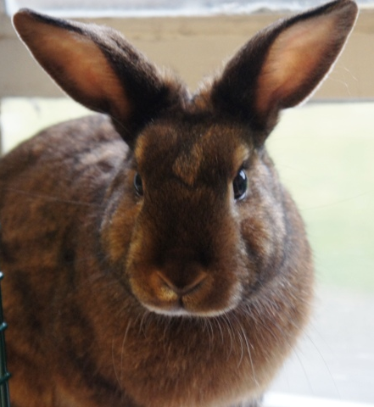 | Rabbit/Hare:  1)  Draw: |  |  | 2)
Practice Exam Question: Why do rabbits/elephants need multiple tooth adaptations to deal with grass?

5. Tundra: Cold & short growing season
- Adaptations: ___________________________________________________________________
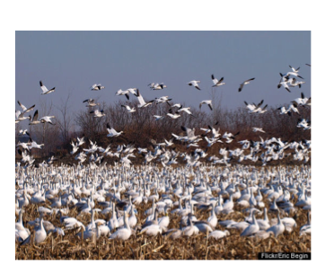 |  | Snow Geese:
 |  | Lemming:
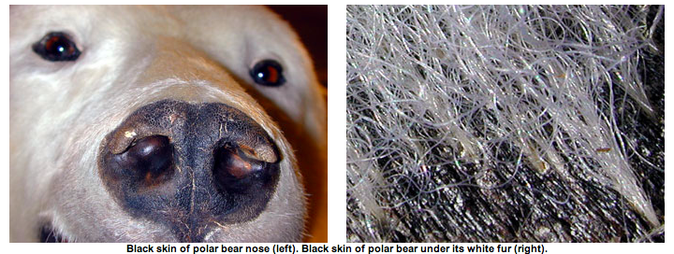
Polar Bear:
6. Deserts: Hot and Dry
- Adaptations: ___________________________________________________________________
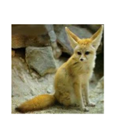 |  |  | Fennec Fox/Hare:  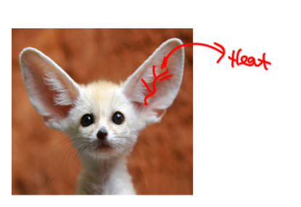
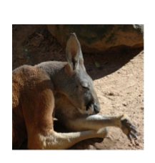 |  |  | Kangaroo:
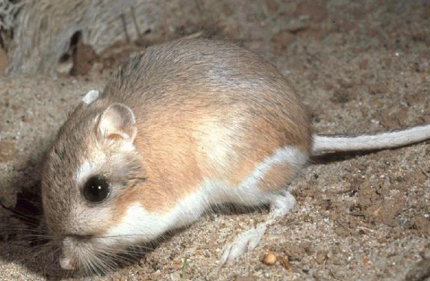 |  |  | Kangaroo Rat:
 |  |  | 1) |  | 2)  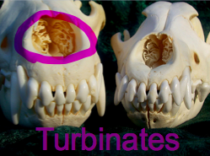
Summary:

