Mendelian Genetics II – Dihybrid Crosses
Environmental Impact on Phenotype

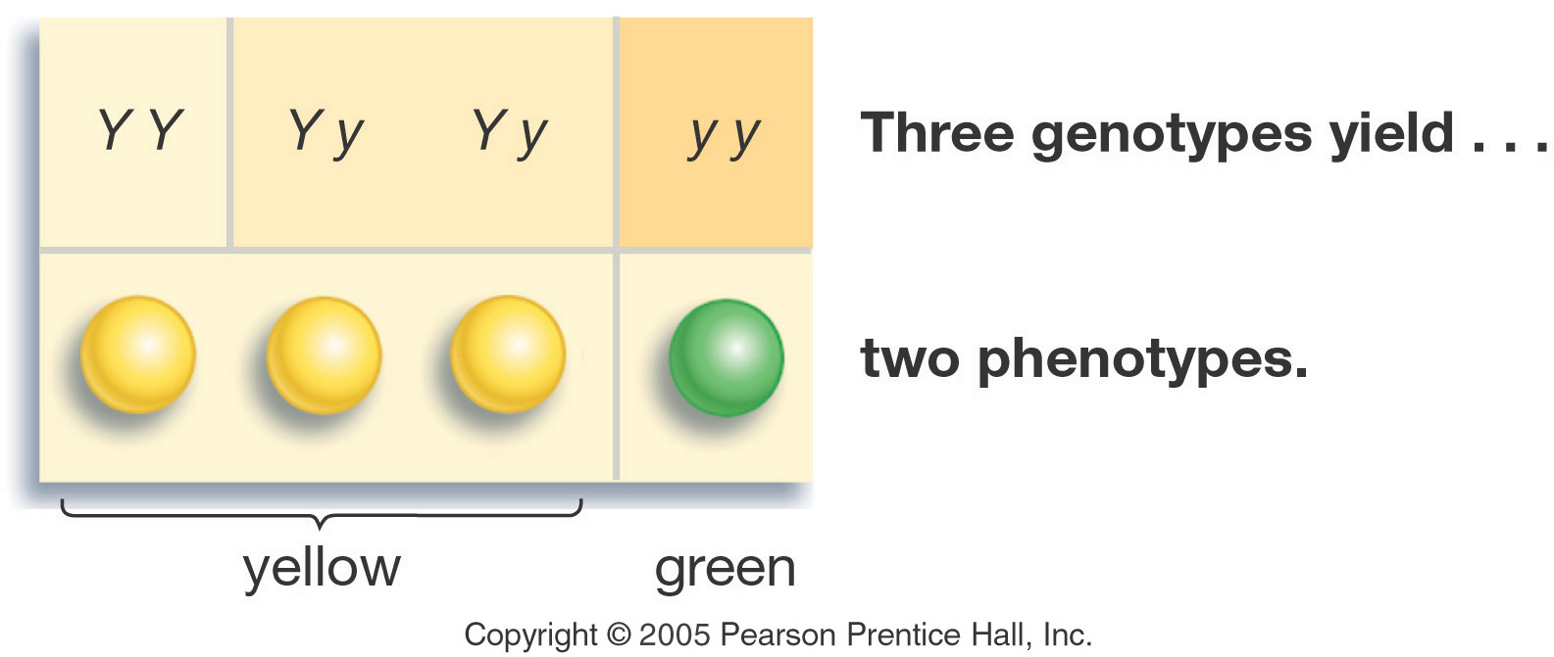

- pH: of the soil will change the color of hydrangea flowers from blue to pink
- Temperature:
Generation “Gap”
- Parental P₁ Generation = the parental generation in a breeding experiment.
- F₁ generation = the first-generation offspring in a breeding experiment. (1st filial generation)
  - From breeding individuals from the P₁ generation
- F₂ generation = the second-generation offspring in a breeding experiment.
(2nd filial generation)
  - From breeding individuals from the F₁ generation
Mendel’s Laws - Laws of Inheretance
- Law of Segregation: When gametes (sperm egg etc…) are formed each gamete will receive one allele or the other.
- Law of independent assortment: Two or more alleles will separate independently of each other when gametes are formed
Results of Monohybrid Crosses
- Inheritable factors or genes are responsible for all heritable characteristics
- Phenotype is based on Genotype
  - Which of these does natural selection act on?
  - Each trait is based on two genes, one from the mother and the other from the father
  - True-breeding individuals are homozygous ( both alleles) are the same
Law of Dominance
- In a cross of parents that are pure for contrasting traits, only one form of the trait will appear in the next generation.
- All the offspring will be heterozygous and express only the dominant trait.
- RR x rr yields all Rr (round seeds)
Law of Segregation
- During the formation of gametes (eggs or sperm), the two alleles responsible for a trait separate from each other.
- Alleles for a trait are then "recombined" at fertilization, producing the genotype for the traits of the offspring.
Applying the Law of Segregation

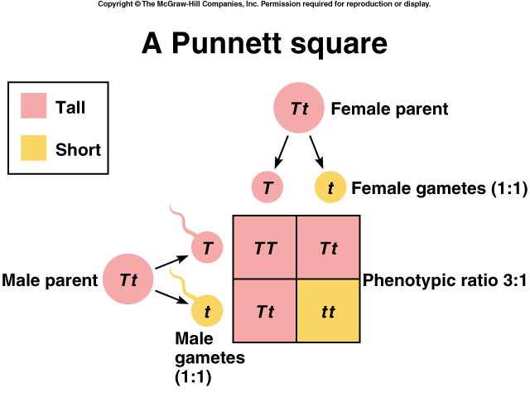

Use the Foil Method:
First
Outside
Inside
Last

Law of Independent Assortment
- Alleles for different traits are distributed to sex cells (& offspring) independently of one another.
- This law can be illustrated using dihybrid crosses.
Dihybrid Cross
- A breeding experiment that tracks the inheritance of two traits.
- Mendel’s “Law of Independent Assortment”
- Each pair of alleles segregates independently during gamete formation
- Formula: 2^{n} (n = # of heterozygotes)
- Question:
How many gametes will be produced for the following allele arrangements?
Remember: 2^{n} (n = # of heterozygotes)

1. RrYy =

2. AaBbCCDd =

3. MmNnOoPPQQRrssTtQq =
Dihybrid Cross
Traits: Seed shape & Seed color
Alleles:
R round
r wrinkled
Y yellow
y green

Dihybrid Cross | Summary of Mendel’s laws

