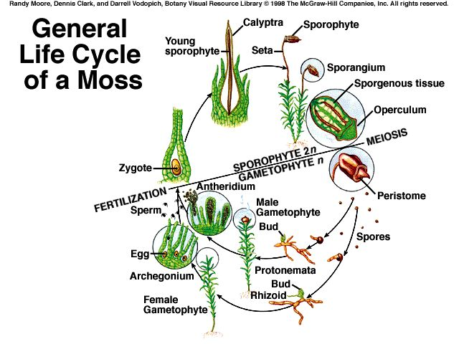
LAB: Nonvascular Plants (Bryophytes) & Charophytes
►Overview
The alga-like plant Spirogyra (Phylum Charophyta) was once lumped in a supergroup known as green algae, along with the Chlorophytes (Ulva, Volvox, Chlamydomonas, etc.,). However, recent molecular data show that Charophytes are more closely related to land plants.
- Charophytes are not LAND PLANTS
Bryophytes include the familiar mosses (Phylum Bryophyta) plus two other phyla: the liverworts (P. Hepatophyta) and hornworts (P. Anthocerophyta).
- These plants lack any clearly differentiated tissues to transport water, nutrients and metabolites around the plant body. Although this severely limits their size, nonvascular plants still dominate some habitats, particularly moist temperate or cold environments. Root-like rhizoids provide anchorage but do not conduct water. Mosses absorb water like sponges, but can also dry out and become dormant.
Marchantia (mar-KANT-ia) is a representative genus in phylum Hepatophyta (liverworts). It grows by producing a horizontal thallus (flattened body). Umbrella-shaped antheridia and palm tree-like archegonia are borne on stalks. | 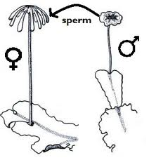
Sphagnum, in phylum Bryophyta, is an ecologically important wetland moss. It grows in peat bogs, which are very acidic, so organic matter decays slowly. Sphagnum phyllids contain both photosynthetic cells and water storage cells; the latter retain their water storage capacity even when dead. | 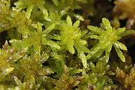
1 Four traits shared by Charophytes and land plants are
- Phragmoplasts (vesicles involved in forming new cell walls between recently divided cells)
- photorespiratory enzymes in organelles called peroxisomes,
- Similar structure in flagellated sperm and
- Circular arrays of proteins in their plasma membranes.
Pre Lab:
Define
Rhizoids:

Similar to: ________________ in other plants
Phyllids

Similar to: ________________ in other plants
Seta

Similar to: ________________ in other plants
Sporangium capsule.

Similar to: ________________ in other plants

Question: Why can we not just call them roots, leaves, and stems?

Lab:
►Station 1: Draw a single piece of moss
1. Obtain a clump of moss, isolate a single individual from the clump using forceps, and examine it under the dissecting scope.
2. Carefully draw the plant, labeling the following structures: rhizoids, phyllids, seta and sporangium capsule.
- Draw at 1X
►Station 2: Water storage in Sphagnum, a moss
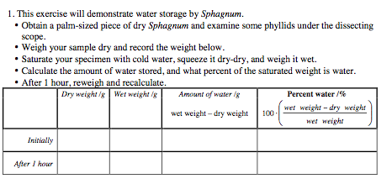

► Station 3: Phylum Charophyta
- The filamentous green alga Spirogyra probably evolved from a unicellular organism. Filaments consist of many cells. Asexual reproduction in Spirogyra is by mitosis. Sexual reproduction is achieved through conjugation, in which nuclei fuse to form a zygote after nuclei are exchanged between cells of adjacent filaments connected by a tube. Observe fresh material of Spirogyra under the compound microscope at 40X, 100X and 400X. Draw a specimen undergoing conjugation. Marvel at its beauty!
- Draw at 400X

► Post Lab Questions
Charophyta:
What are the name and function of the green structures inside the cells?
Name | Function
Why is the genus named Spirogyra?

Why aren’t charophytes considered “true plants”?

What does it mean to be an ancestral plant?

How can they get away with not being vascular?
Where they live | Shape
Bryophyta:
What are these commonly known as?

Where do they live?

How can they get away with not being vascular?
Where they live | Shape
How do they hold water?

How do they reproduce?

