Cardiovascular System
- Function of system:

- What is the function of each circuit:
Pulmonary Circuit | Systemic Circuit
DIFFERENCES | DIFFERENCES
- Valves
- Function

- Label the Pieces:
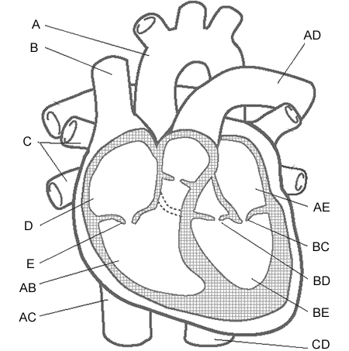 | A:  D:  AB:

- SA Node: What is the Purpose?

- How and why are arteries and veins different?

Respiratory System:
_____1. Which is the primary gas exchanged on Exhalation?
A) CO
B) CO₂
C) O₂
D) Both B and C
_____2. What is the purpose of alveoli?

How does there structure fit their function?

_____3. Name 3 functions of the nasal cavity:

______4. Where is the diaphragm located and what is its purpose?

Draw it:

Digestive System:
_____1. What type of digestion occurs in the mouth?
A) Enzymatic activity
B) Chemical
C) Mechanical
D) B and C
_____2. What is the function of the villi in the small intestine?
A) Slow the progress of food through the intestine.
B) Increase blood flow to the liver.
C) Decrease the diffusion of nutrients.
D) Increase surface area for more nutrient absorption.
E) They help to further break up the food.
_____3. Draw a picture of Villi:

_____4. Draw and label the basic path through the digestive system from Mouth to Anus on a different piece of paper.
Summary Question:
_______1. How does surface area relate to function in each of the body systems?
System | Circulatory | Respiratory | Digestive
⇑ Surface Area found where in this system?
Function of ⇑ SA

