DDT Debate
Debate Format:

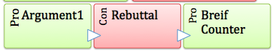
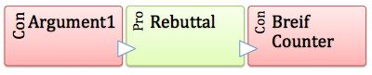
Due Dates
- Benchmark#1 - Monday 11/4 - in class:
  - Split class into pro and con teams
  - Divide work
Section | Student
Opening statement
Argument 1, Rebuttal 1
Argument 2, Rebuttal 2
Argument 3, Rebuttal 3
Closing statement

- Benchmark#2 - Tuesday 11/5:
Due at start of class | By end of class
- Reading DDT Info sheet + Margin notes  - Outline of argument | - Flush out argument

- Benchmark#3 - Thursday 11/7:
Due at start of class | By end of class
- Written arguments  - Outlined rebuttals | Meet with opposing team on rebuttals

- Benchmark#4 - Friday 11/8:
Due at start of class | By end of class
- Fine tuned written arguments  - Written rebuttals | Practiced for Debate

- Benchmark#5 - Monday 11/11:
Due at start of class | By end of class
- Whole teams arguments on google doc, accessible to whole team and counter team | Ready for debate tomorrow.

- Benchmark#6 - Tuesday 11/12: Debate
Due at start of class | By end of class
- Ready for debate | - Complete debate  - Peer evaluations
DDT Debate Outline
Opening Argument:

Argument 1:
Rebuttal 1:

Argument 2:
Rebuttal 2:

Argument 3:
Rebuttal 3:

Closing Statement:

