Respiratory Volumes and Capacities Lab

Lab Background:
Physicians and respiratory therapists use a number of lung volume measurements to diagnose respiratory disease and assess the effects of respiratory therapy on persons who suffer from lung ailments. You may be familiar with such common lung problems as asthma, emphysema, and lung cancer. In fact, if you have asthma, you may have already experienced some of the same tests of lung health and function that are included in this activity. Whether or not you have measured your lung volume before, finding out how much air your lungs can hold requires some familiarity with respiratory vocabulary. Use your notes and the Figure 1 below to guide your understanding of respiratory volumes.

Figure 1

Lung Volume Measurements
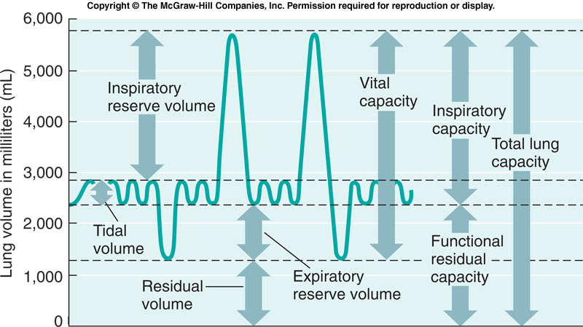

When lung volumes are measured air is collected outside the body. Since the volume of a gas is affected by temperature, pressure, and humidity levels, in order to obtain accurate measurements of lung volumes the differences in how a gas reacts inside and outside the body
must be taken into account. Both temperature and pressure levels are lower outside the body than inside. As a result, air takes up less volume once it leaves the body. Measurements of lung volume taken outside the body indicate a lower volume than the lungs actually hold. A simple conversion table that translates ATPS to BTPS can be used to adjust the volumes to account for body temperature and pressure. All of the lung volumes you measure and record in this activity will be converted to BTPS.
Materials: (per group)
• Lung Volume Bag or spirometer  • Disposable mouthpiece — one for each group member  • Calculator  • Thermometer | • BTPS conversion table (Appendix A of this activity)  • Student Activity Page and Student Data Sheet – one for each group member  • Stopwatch

Activity Instructions: Read each step and check off as it is completed.
1. Review the procedures for making lung measurements and then gather the materials required. Accurate lung volume measurements require that the procedures for collecting the expired air be followed carefully and consistently so be sure to thoroughly familiarize yourself with the techniques used.

2. While reading the procedures, have your partner observe you carefully and count the number of times you breathe in and out in a 30 second period. Multiply this number by 2 and record this figure in Data Table 1 in the column marked Resting Respiration Rate (RR). Write this same measurement in the column of all three trials and the average.

3. Change roles and repeat step 2 to obtain the RR for your partner.

4. Next, using the thermometer find the room temperature in ºC and record this temperature on Data Table 1. This is the temperature you will use on the BTPS chart to convert your collected amounts.

5. The first volume measurement you will make is Tidal Volume (TV). Remember that TV is the amount of air moved in and out of the lungs in one normal breath. Thus, in order to get an accurate reading of TV you will need to be careful not to exhale maximally into the bag.
- You only want to collect an amount of air from a normal breath.

6. First mark a disposable mouthpiece with your name. Your partner should do the same. Place your mouthpiece in the lung volume bag or spirometer. Place the nose clip on your nose. Holding the lung volume bag, take three normal breaths breathing through your mouth. On the fourth breath inhale normally and exhale a normal breath into the bag.

7. While the mouthpiece is still in your mouth, grab the bag with your free hand to insure that no air escapes. Slowly and carefully wrap the bag around your hand so that you are pushing the collected air to the bottom of the bag. Using the liter markings on the side of the bag, read the amount of air collected .

8. On the BTPS chart in your materials, find the room temperature you recorded earlier.
Multiply the TV you measured by the BTPS Factor on the chart that corresponds to the room
temperature. The resulting measurement should be slightly higher than the measurement from
the lung volume bag. Record this amount on Data Table 1 in the column marked TV.

EXAMPLE: If the room temperature is 20º C the BTPS factor, according to the chart, is 1.102. The measured tidal volume is 0.5L so the converted tidal volume is 0.5L X 1.102 = 0.55L

9. Using the calculator, if needed, multiply the RR by the TV to obtain the measurement for Minute Ventilation (MV). Record this amount on Data Table 1 in the column marked MV.

10. Empty the collected air out of the bag by laying it across your thigh and pulling it from the bottom end with one hand while pushing the bag against your thigh with the other hand. Check the bag once more to be sure all the air is out before beginning another measurement.

11. Repeat steps 6 through 10 two more times for a total of three trials. Compare your three amounts. They should be within 0.5L of each other. If not, you should repeat and replace any measurements that do not fall within this range.

12. Using the calculator, if needed, find the average of the three trials for TV and MV and
record these amounts in the appropriate column on Data Table 1.

13. Remove your mouthpiece and have your partner insert his or hers. Repeat steps 5
through 12 to obtain your partner’s RR, T, and MV.

14. The next volume measurement you will make is Vital Capacity (VC). In order to get
the most accurate measurement for VC you must exhale slowly and steadily. If you cough, laugh or hesitate before or during the exhalation you will need to start the measurement over again.

15. Reinsert your disposable mouthpiece into the lung volume bag. Place the nose clip
on your nose. Holding the lung volume bag ready, take three normal breaths breathing through your mouth. On the fourth breath inspire maximally (take as large a breath in as possible) and then exhale into the bag slowly and steadily. Continue exhaling until you simply cannot exhale any further.

16. While the mouthpiece is still in your mouth, grab the bag with your free hand to insure that no air escapes. Using the same technique as you did for TV, push the air you collected to the bottom of the lung volume bag. Using the liter markings on the side of the bag read the amount of air collected.

17. Use the same BTPS conversion factor that you used for TV to convert the VC measurement (see Step 8) and record this figure on Data Table 2 in the column marked VC.

18. Remove the exhaled air from the bag using the same method described in step 10,
then repeat steps 14 through 17 two more times for a total of three trials. Compare your three amounts. They should be within 0.5L of each other. If not, you should repeat and replace any measurements that do not fall within this range.

19. Remove your mouthpiece and have your partner insert his or hers. Repeat steps 14 through 17 to obtain your partner’s VC measurement.

20. Next you will measure Expiratory Reserve Volume (ERV). As with the VC measurement you must exhale slowly and steadily to get an accurate measurement. Any hesitation or break in your exhalation requires that you disregard that measurement and start over.

21. Reinsert your disposable mouthpiece into the lung volume bag. Place the nose clip on your nose. Holding the lung volume bag ready, take three normal breaths breathing through your mouth. On the fourth breath inspire normally (take a normal breath) as you did for TV and then exhale into the bag slowly and steadily. Unlike TV, however, you will not stop the exhalation at a normal breath but continue exhaling until you simply cannot exhale any further.

22. While the mouthpiece is still in your mouth, grab the bag with your free hand to insure that no air escapes. Using the technique described previously, determine the amount of air you collected and record it on Data Table 2 in the column marked ERV. Be sure to convert the measurement to BTPS before you record it.

23. Using the calculator, if needed, subtract ERV from VC to obtain the measurement for Inspiratory Capacity (IC).

24. Empty the air from the bag and repeat steps 20 through 23 two more times for a total
of three trials. Compare your three amounts. They should be within 0.5L of each other. If not, you should repeat and replace any measurements that do not fall
within this range.

25. Using the calculator, if needed, find the average of the three trials for VC, ERV, and
IC and record these amounts in the appropriate columns on Data Table 2.

26. Remove your mouthpiece and have your partner insert his or hers. Repeat steps 19
through 24 to obtain your partner’s ERV and IC measurements.

27. The final volume measurement, Total Lung Capacity (TLC) can be calculated from
measurements you have already made. TLC is the combination of VC and Reserve
Volume (RV), the amount of air that never leaves the lungs. The average RV is about
1 L so this is the estimated amount we will use in this calculation. Complete Data
Table 3 to obtain your TLC.

28. Follow your teacher’s instructions for calculating and recording the class data on
Data Table 4 and then answer the Analysis Questions on your Data Sheet.

