Plant Essay: Charophytes Paragraph Outline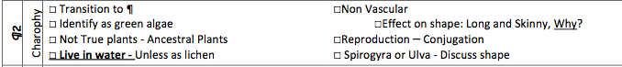
Charophtes ¶2 - Outline | ☐ TRANSITION

