From DNA to Protein
The Process:
DNA RNA AUG Codons Amino Acids to stop Protein
or
- Take DNA sequence
- Turn to RNA (change all T’s to U’s)
- Find AUG
- Split the rest of the sequence into codons from there
- Turn codons into amino acids until you hit STOP
- The protein is the string of amino acids from MET to the amino acid before STOP

Practice Test Answers:
DNA: ACCATGCCCCGTTGATTT  RNA: ACCAUGCCCCGUUGAUUU  START CODON: ACCAUGCCCCGUUGAUUU  CODONS: AUG-CCC-CGU-UGA-UUU  Amino Acids MET-PRO-ARG-STOP  Protein: MET-PRO-ARG | 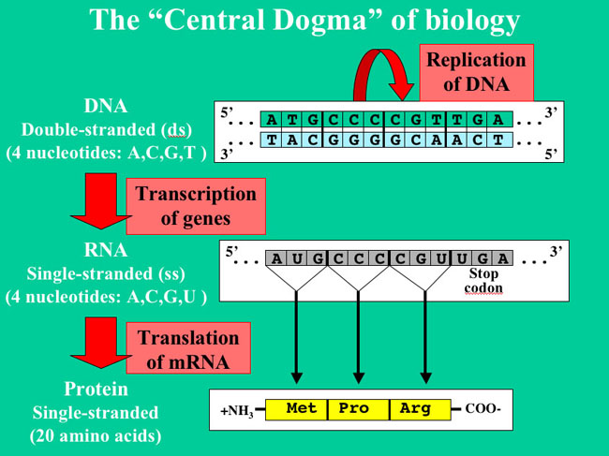

Practice Strands
1)  DNA: AATGTCAGAGGTGAAATGCTATTGAGGT  RNA: AAUGUCAGAGGUGAAAUGCUAUUGAGGU  Start Codon: AAUGUCAGAGGUGAAAUGCUAUUGAGGU  Codons: AUG-UCA-GAG-GUG-AAA-UGC-UAU-UGA-GGU  Amino Acids: Met-Ser-Glu-Val-Lys-Cys-Tyr-STOP-Gly  Protein: Met-Ser-Glu-Val-Lys-Cys-Tyr  (Since GLY comes after stop, it is not included) | 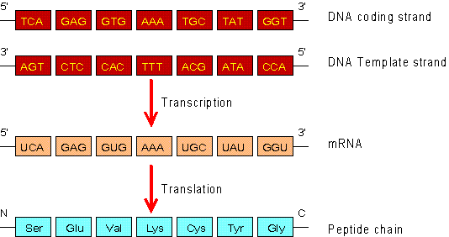
2)  DNA: TTTATATGGCAAGAGATAATTGTTGA  RNA: UUUAUAUGGCAAGAGAUAAUUGUUGA  Start Codon: UUUAUAUGGCAAGAGAUAAUUGUUGA  Codons: AUG-GCA-AGA-GAU-AAU-UGU-UGA  Amino Acids: Met-Ala-Arg-Asp-Asn-Cys-STOP  Protein: Met-Ala-Arg-Asp-Asn-Cys | 