Organelle Function Notes

Recap on Cells:
Questions/Pictures/ Key Words

“…” means something the teacher said
Cell Structure & Function
Cell theory:
•All living things are made up of cells.
•Cells are the smallest working units of all living things.
•All cells come from preexisting cells through cell division.
Definition of a cell:
•A cell is the smallest unit that is capable of performing life functions.
Prokaryotic Recap
•Do not have structures surrounded by membranes  •Few internal structures  •One-celled organisms, Bacteria | 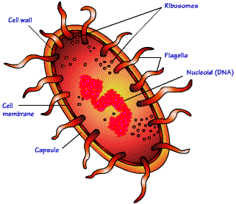Bacteria!
Eukaryotic Recap
•Contain organelles surrounded by membranes  •Most living organisms | Animal Cell 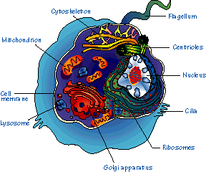 | Plant Cell  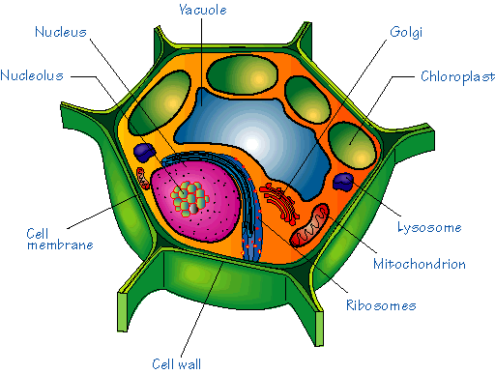

“…” means something the teacher said
Cell Parts: Organelles
A) Surrounding the Cell
Cell __________________________
•Outer membrane of cell
•Double layer of fats called ______________ “they look like two tailed sperm”
•Function: controls movement in and out of the cell
Cell Wall
•Most commonly found in plant cells & bacteria
•Function: ______________ & ____________ cells
B) Organelle Inside the Cell
Nucleus
•Function: ___________ cell activities
•Separated from cytoplasm by nuclear membrane
•Contains genetic material – DNA

Cytoplasm
•___________-like mixture
•Surrounded by cell membrane

Ribosomes
•Each cell contains thousands
•Function: Make ____________________
B) Organelle Inside the Cell (Continued)
Questions/Pictures/ Key Words

“the powerplant”

Mitochondria
•Function: Produces ___________________ through chemical reactions – breaking down fats & carbohydrates

Chromosomes
•In nucleus
•Made of _________
•Function: Contain instructions for traits & characteristics

Lysosome
•Function: ___________________ 'plant' for proteins, fats, and carbohydrates
–Transports undigested material to cell membrane for removal
–Cell breaks down if lysosome explodes

Vacuoles
•Function: Membrane-bound sacs for _________________, digestion, and waste removal
•Contains water solution
•Help plants maintain ________________

Chloroplast
•Usually found in plant cells
•Contains green ___________________________
•Function: Where _______________________ takes place
Summary:

Who has organelle?

What would happen if a Lysosome exploded in the cell?

