Pro/Euk - Cell Biology COMPLETE Notes
Questions/Pictures/ Key Words

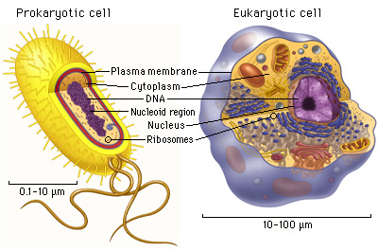

“…” means something the teacher said

Two types of cells:
- _________________ Cells
- _________________ Cells
Every thing we know about cells we call
“cell theory”.
- Cell Theory says that….
- All living things are made of ________________.
- Cells are the basic units of _______________ and f___________ in all living things. In other words, cells are like the building blocks of all living things.
- New cells are only made from ___________ __________.
Cells come in all shapes and sizes!
- There are two types of cells:
1) Prokaryotic Cells
2) Eukaryotic Cells

- Big differences between cell types:
STRUCTURAL differences.

Prokaryote Cell: A single celled organism that does not have a nucleus. – “PRO-NO! “
Traits of Prokaryotes: (pro-care-ee-ohts)
1. They do not have a , and their genetic material
2. They have some organelles, but not many.
3. They are less _________________ that eukaryotes.
4. All _______________ are prokaryotes.
•Bacteria is good, who knew?!
    - Decomposers
    - In digestive system
    - 10x as many bacterial cells as human cells in the human body!
    - Needed for cheese & yogurt
Summary:
Questions/Pictures/ Key Words

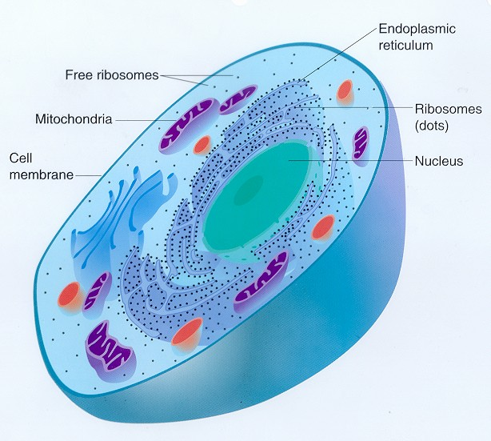

Eukaryote Cell: A more complex cell with a nucleus and many organelles. – “Eu-DO!”
Traits of Eukaryotes: (you-care-ee-othts)
1. They all have a where the genetic material of the cell is stored.
2. They have ______________ _____________ that work together to help the cell function.
3.Eukaryotic cells are much more _____________ then prokaryotic cells.
4. They can be just one cell or can make up more complex multi-cellular organisms.
5. ___________ plants, animals, fungi, and protists are eukaryotic cells.

Summary: Prokaryotic cells do not have a nucleus
& Eukaryotic cells do have a nucleus.
This allows eukaryotic cells to make multi-cellular organisms and perform more complex functions.

