Body Systems 4,5,6 Review
Skeleton Review:
- Main functions of the system:

- What is ossification?

- What can be said about baby’s skulls and why is that?

- What is the anatomy of a bone?
Include where they are on the bone and there function:
Label | Function
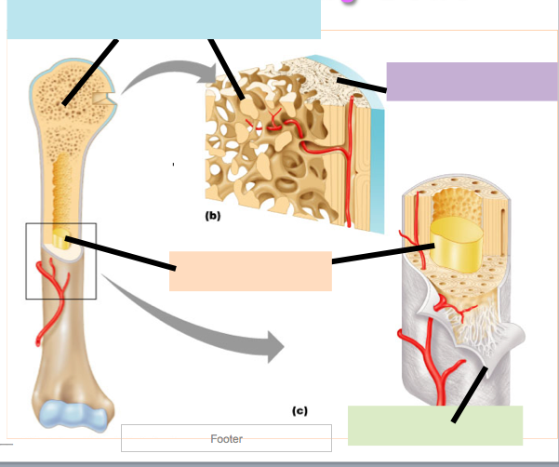 | Spongy bone:  Periosteum:  Havasian canals:  Bone marrow

- 2 types of joints, main type of movement produced
_______________________ Joint | _______________________ Joint
Type of movement produced: | Type of movement produced:

Muscular System:
- Main function of the system:

- 3 types of muscle and there functions
- Draw and explain the function of actin and myosin:

- Explain why muscles have to be paired:

Nervous System:
- What is the main function of the nervous system?

- Central Nervous System:
  - What body parts/sections does it include:

- Peripheral Nervous System:
  - What body parts/sections does it include:

- Label:
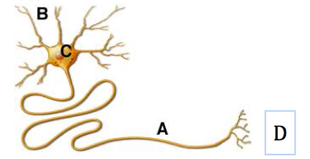 | - What is A covered in?  Why?  - What is passed down the neuron?

- How is surface area related to Neuron function?

