Study Guide:
Photosynthesis and Cellular Respiration
Resources for Studying:
- PowerPoint on Photosynthesis  - Homework | - Reading Activity on Photosynthesis  - Textbook | - Videos on my webpage  - Rate of Photosynthesis Lab

Energy:

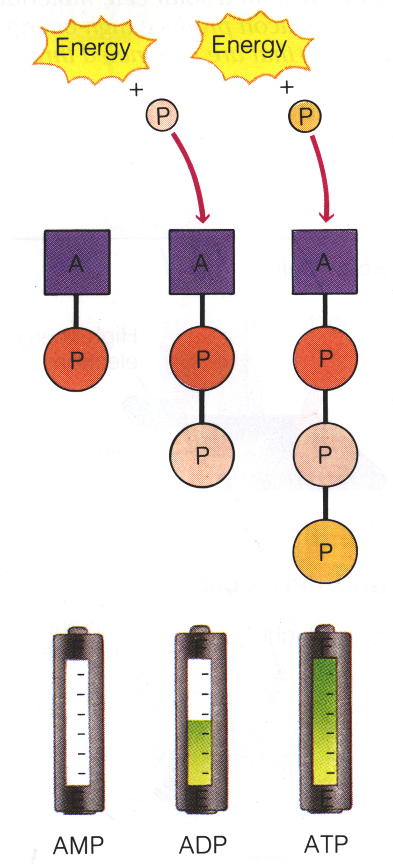 | - What is ATP? And how do you make it into ADP? 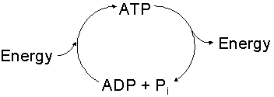  - 2. Where is energy stored in ATP?  - Which stores more energy?  ATP, AMP, ADP  Why:

Photosynthesis:
- Purpose:

- Location: (organismal level (plant or animal) and at a organelle level)

- Equation: Know products and reactants

- How does the electron transport chain work and what is its function? (Use: Concentration gradient, semipermeable membrane, and charged particle in your answer)

- Light and Dark reactions
Process | Location | Reactants  (What Goes In) | End Products  (What Comes Out)
Light Dependent Reactions
Light Independent Reactions
- Label the process of photosynthesis in the space below. Include the following structures and processes in your diagram: chloroplast, chlorophyll, light reaction, dark reaction, reactants, products, light, ATP

