Plant Evolution Guide
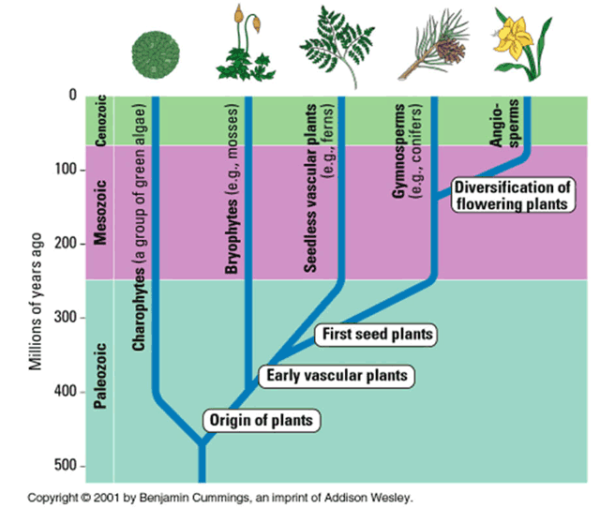
Charophytes

Bryophytes

Pterophytes (seedless vascular)

Gymnosperms

Angiosperms

