Respiratory and Circulatory System
Form And Function - Write Up
 | Artery | Vein
Function | Artery = Carry blood Away from the heat | Vein = Carry blood to your heart
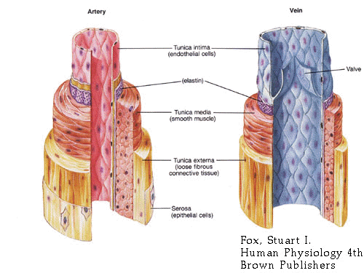
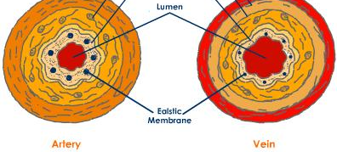
Compare the form to the function:

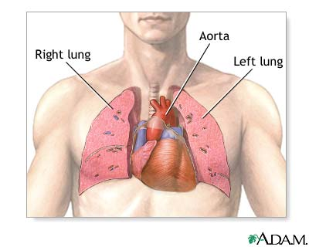
Relate the location of the heart and lungs to their function:

