DNA STUDY GUIDE
Genetics – DNA STRUCTURE
- What is the function of DNA?

- What is a chromosome?

- What is the structure of DNA?

- Why does it take that structure?

- What makes up each piece of this nucleotide? (Be able to label)
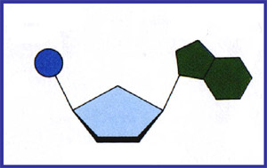
- What is base pairing?
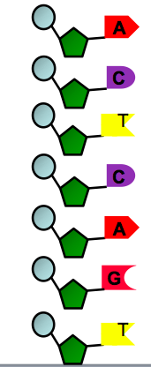

- What nucleotide pairs to what?

- Can you make the complementary strand?

