Cell Biology – Germ Theory (#5)
Comments/Questions

Notes from Video:

II.

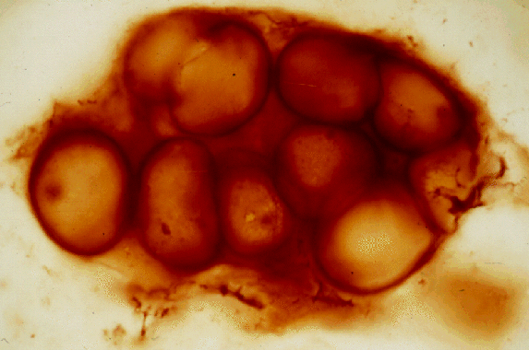

- We used to think
IV. Lazzaro Spallanzani
1.Meat broth boiled & sealed never spoils!
2.Broth boiled & left open to air develops microorganisms
3.… but critics claimed that a “vital principle” in air is needed for spontaneous generation, and was “destroyed” by boiling.
V. 1860 – Louis Pasteur settles the matter! (you will too!)
- How did life on Earth begin?
I. We know today that ALL life shares one Precambrian ancestor (all life uses the same genetic code.)
1. If life never starts spontaneously, how could it begin the first time??
2. Divine creation? Extraterrestrial origin? From non-living chemicals? (we don’t know…)
III. 1953: Stanley Miller & Harold

TOC #5
Summary

