***Photosynthesis Notes***

Comments/Questions

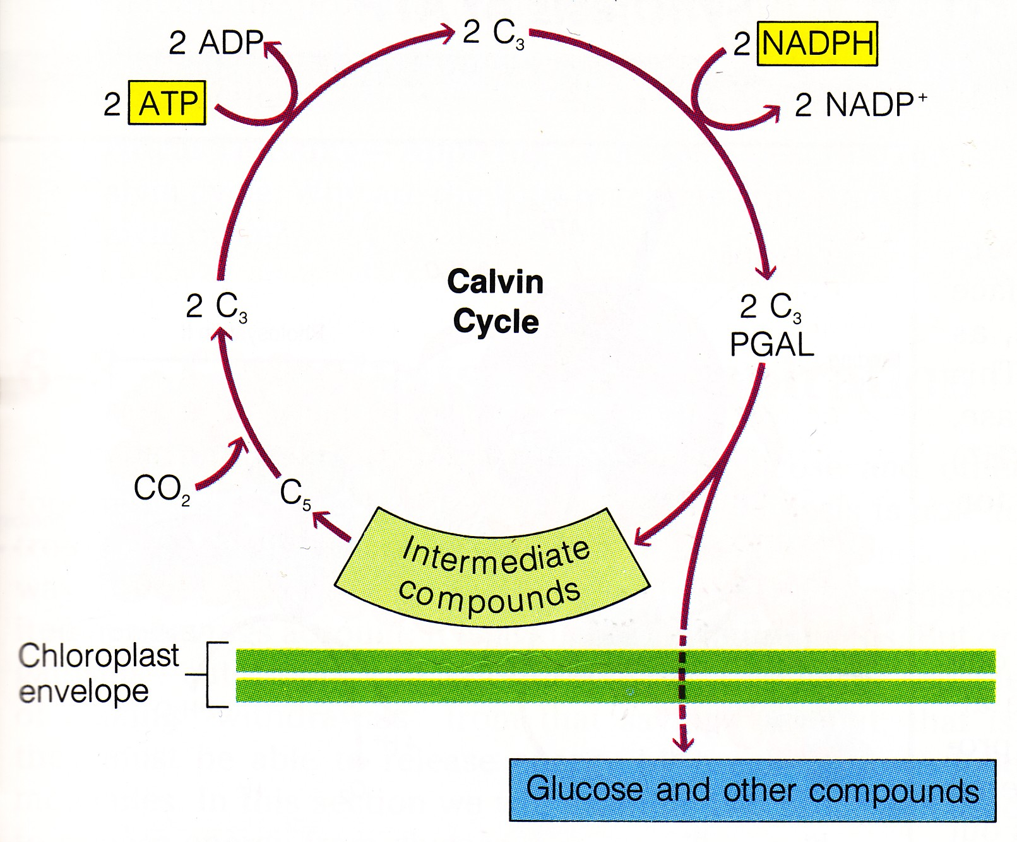

***F. Dark Reaction.***

I. The ___________________ converts the energy stored in the light reaction and carbon dioxide into carbohydrates (_________________).

* Through a series of reactions, energy from ATP and NADPH, carbon compounds and CO2 are used to form glucose, storing energy!
* The first reaction in this cycle is catalyzed by the most abundant protein (enzyme) in the world called __________________.

***G. A Closer Look at Photosynthesis***

I. Light Reactions (*Light __________________*)

* Light energy and the splitting of water store chemical energy (ATP & NADPH) and release oxygen.

II. Dark Reactions (*Light _________________*)

* The energy stored in the light reaction is used to convert _____________ _____________ into glucose.

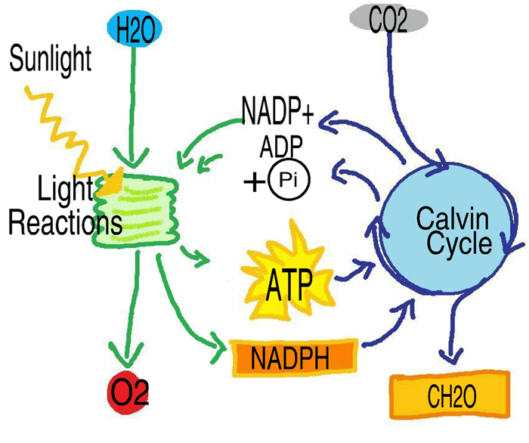

Summary