Activity1: Textbook Lifting – Feel the burn of knowledge!

- Hold your arms out in front of you  - Parallel to the floor  - Use both hands to hold a textbook  - Keep this until you feel fatigued  - Try for 60 seconds. | 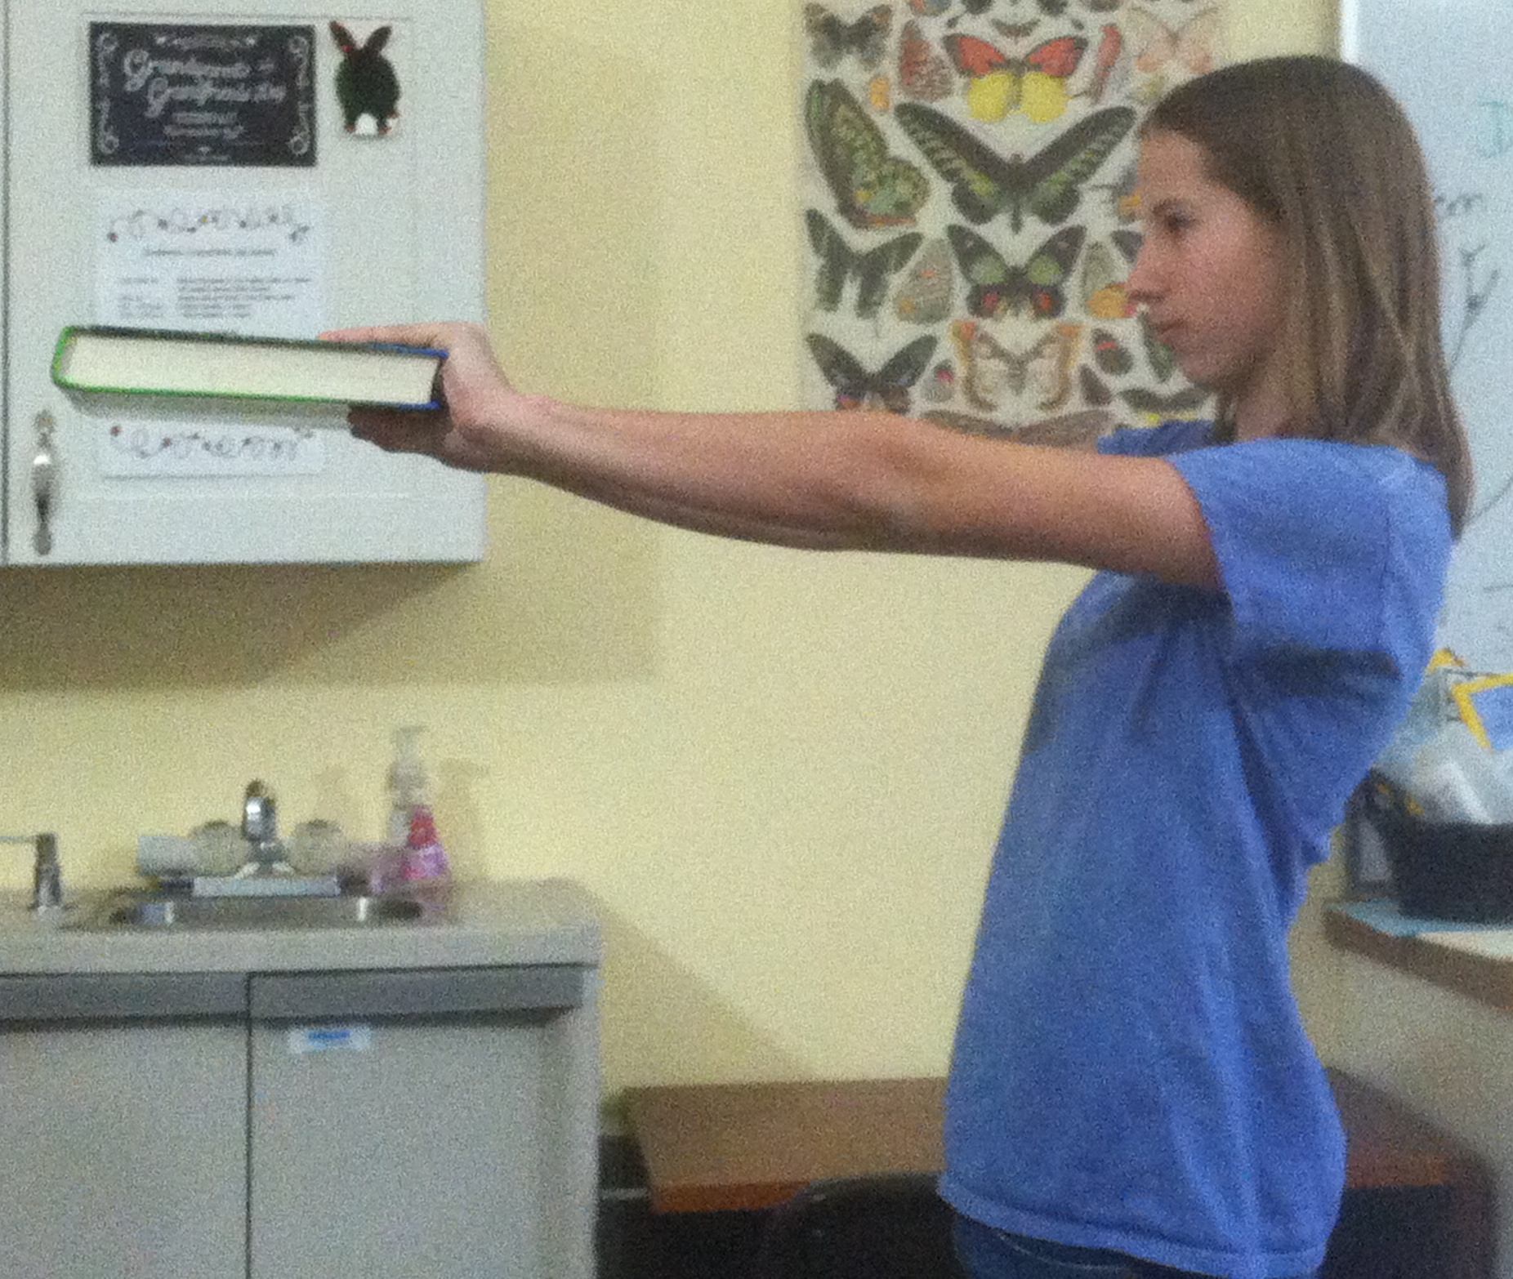

Why do you start to shake?

Which muscles experienced the most fatigue?

Biceps | Triceps | Deltoids | Pectoralis major
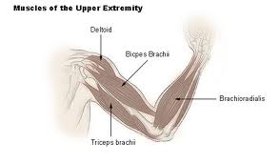
Pectoralis Major
Activity1: Textbook Lifting

Why do you start to shake?
Part 1: After just 7 seconds of use the muscle begins producing lactic acid as glycogen is broken down to provide energy. To help delay muscle fatigue, the muscle fibers are constantly switching on an off to allow individual fibers a moment to rest. This activity will demonstrate the effects of action of muscle fibers.
Part 2: Muscles are paired, one is usually stronger.
Skeletal muscles only pull in one direction. For this reason they always come in pairs. When one muscle in a pair contracts, to bend a joint for example, its counterpart then contracts and pulls in the opposite direction to straighten the joint out again. Without this arrangement you wouldn't be able to straighten your legs when you walk or bend your fingers to grip something.
Example: When your biceps muscle in your upper arm contracts, it pulls your lower arm in towards your shoulder. However, when it relaxes, your biceps cannot push your arm back out. To do this, your triceps muscle, on the underside of your upper arm, contracts and straightens your arm out. If your triceps muscle wasn't there, your arm would stay drawn in permanently.

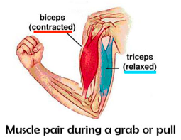 | 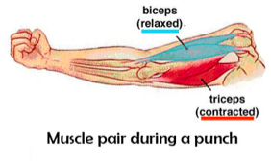
Activity2: Wall Sit

- Sit against the wall with your knees bent at a 90˚angle. (You will look like a chair)  - Hold this position for as long as it takes to feel muscle fatigue.  If it’s been more than 3 minutes you are not doing it right | 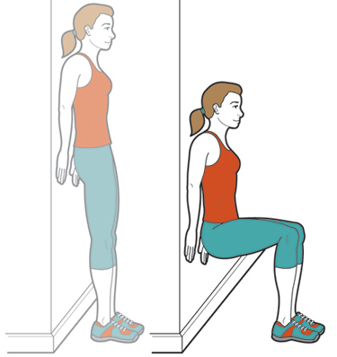

Why do my muscles burn during a good workout?

Why do my muscles burn the day after a good workout?

Activity2: Wall Sit
Why does it burn the next day?
Simple answer: Your muscles need Glycogen (muscle sugar) in order to function. When the glycogen is broken down into energy for the muscles a waste product called lactic acid is produced. A buildup of lactic acid decreases the muscles ability to contract, causing muscle fatigue.
Science Answer: Contrary to popular opinion, lactate or, as it is often called, lactic acid buildup is not responsible for the muscle soreness felt in the days following strenuous exercise. Rather, the production of lactate and other metabolites during extreme exertion results in the burning sensation often felt in active muscles, though which exact metabolites are involved remains unclear. This often painful sensation also gets us to stop overworking the body, thus forcing a recovery period in which the body clears the lactate and other metabolites
- Lactic acid can increase intracellular acidity of muscles and burn the muscle.
OR
- This idea is recently debated, and it is thought that lactic acid could serve as muscle fuel.

Why do muscles burn the day after a good workout?
The cause of delayed-onset muscle soreness, or DOMS as it is called by exercise physiologists, is still unknown.
- Most research points to actual muscle cell damage.
- These responses to extreme exercise result in an inflammatory-repair response, leading to swelling and soreness that peaks a day or two after the event and resolves a few days later, depending on the severity of the damage.
Activity3: Tennis Ball

- Extend your arm out in front of you.  - Using your hand, squeeze the tennis ball hard one time each second.  - This is how hard your heart works. | 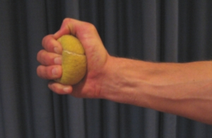

What would happen if your heart tired as fast as your hand?

Why doesn’t it?

- So, about how long did you “live”, anyway?? _____ minutes
Activity3: Tennis Ball

What would happen if your heart tired as fast as your hand?
You would die, quickly!

Why doesn’t it?
Short Answer: Evolution
Your hand uses skeletal muscles and your heart is made of cardiac muscle.
- Cardiac muscle does not experience muscle fatigue
- Skeletal muscles do experience muscle fatigue

Science Answer:
Skeletal Muscle | Cardiac Muscle
⇓ Less Mitochondria to provide energy | ⇑ More Mitochondria to provide energy
- The total volume of skeletal muscle contains an average of only 1 to 2% mitochondria.  - This is an entirely sufficient energy source for such intermittent muscular tasks as walking or running. | - The total volume of the heart, by contrast, is between 30 and 35% mitochondria.  - That massive amount of energy-generating Mitochondria means cardiac muscle, in a healthy state, need never rest.  - There is always some energy being transferred to the muscle at the same time that more energy is being used.
- Cannot stay long in a flexed position without depleting their energy reserves.
- It has not been necessary in the course of evolution for humans to be able to flex our skeletal muscles for prolonged periods of time.

Activity4: Clothespin Calisthenics
Do this:  1. Hold a clothespin between your thumb and index finger and see how many times you can squeeze it in one minute. Record  2. Now, without resting, squeeze it as fast as you can for a second minute. | 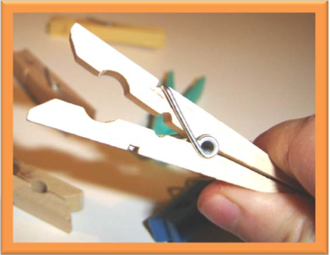

Muscle Fatigue ... Clothespin Calisthenics

How many times did you squeeze the clothespin the first minute? _______
How m any times did you squeeze the clothespin the second minute? ______
The soreness in your and arm is called muscle fatigue. Fatigue is caused by a

buildup of ________ _________ in your muscles. Hint: read the introduction

Why did you feel fatigue in your forearm rather than your fingers?

Activity4: Clothespin Calisthenics

