**Region of Plasmid DNA with Glowing Gene and Ampicillin Resistance**

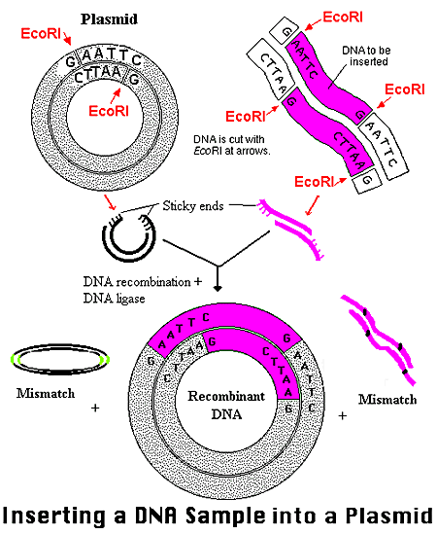

**Warm up 5/18**

What are the Characteristics of the bacteria now? (Hint each of the 2 genes affect the bacteria)

Ampicillin Resistance

Ampicillin Resistance

Glowing Gene

Glowing Gene

**Bacterial (e. Coli) Plasmid**

e. Coli

