Review Questions
- Why do you shake when your arms get tired (muscle fatigue)?

- Muscle Filaments
Muscle Filaments: | __________________ | __________________
Draw
(Label)
Function
What is the difference between the two?
- What are the different levels of muscle?

- Be able to Label:

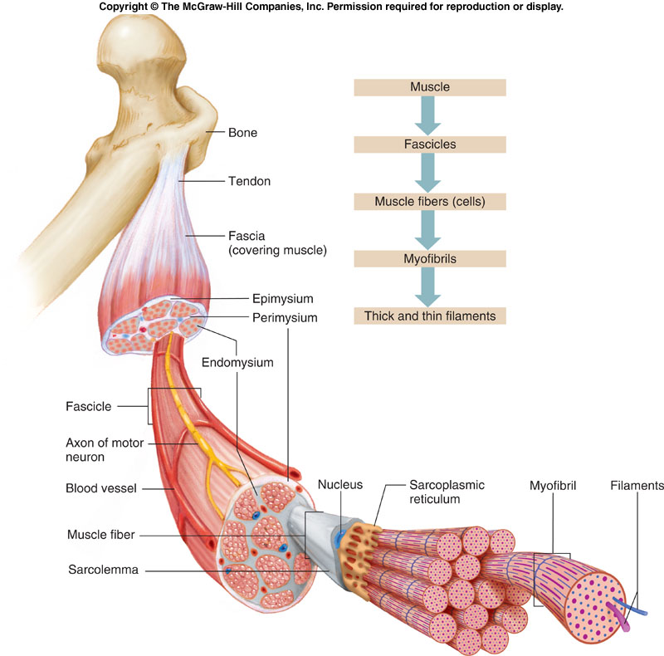

- Muscle Contraction:
Role of Ca⁺⁺
Steps | 1)  2)  3)  4)
What is needed for the cycle to repeat?

- 2 Ways to Power a Muscle:
Name:_______________ | Name:_________________
Pro: | Pro
Con | Con
Being chased by a bear, which would you likely use and why?

- Why do muscles only pull?

- Why do muscles need to be paired?

- Muscle connection:
How are muscle connected to bone?
What is the origin?
What is the insertion of a muscle?
What is the action of a muscle?
Role of the Prime mover | Ex: _____
Role of the Synergist | Ex: _____
Role of the Antagonist? | Ex: _____

- Identify the 3 muscles types
Cardiac | Name:_______________ | Name:______________
Form | 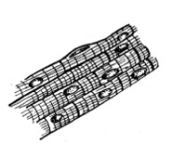 | Form
Function | Function: | Function
Circle 1 or both  Voluntary Involuntary | Circle 1 or both  Voluntary Involuntary | Circle 1 or both  Voluntary Involuntary
Location: | Location: | Lines organs and digestive system
- Why doesn't your heart get tired over time?

- Sphincter:
Muscle Type:
Draw:
Function:
How does form connect to function?
- Peristalsis?
What is it?
What muscle is it?
What is its function?
- What role does electricity have in natural muscle contraction?

- What role does electricity have in artificially induced muscle contraction?

- Galvani's experiment (frog)
Explain Experiment:
What did it establish?
- What are the 5 key milestones in human evolution?
1
2
3
4
5
- How does tooth changes ultimately affect symbolic thought?

