Review Generated in class
5-10 main-themes
Group#1:
Chap 7 – Skeletal System | Bone Structure and Function Overview | Appendicular and Axial
1) Types of Bones and their placement (long, short, flat, irreg)
2) Bone Function --movement, protection, support, red blood cell formation, salt storage
3) Anatomy of a Long Bone
4) Difference of Axial and Appendicular, parts in each
5) What does spongy bone mean to you? How does it affect your daily life? (parts of spongy bones)
6) What does compact bone mean to you? How does it affect your daily life?
7) Order of vertebrae of the spine and their main functions.
Group#2:
6. NOTES: Joint Types (Form and Function H/O, Joint Self Test and Movement Types)
Skull Structure
LAB: Male Vs Female Skeletal Anatomy
1) 3 main joint types: cartilaginous (spinal), fibrous (skull), synovial (movement)
2) Skull is made up of 22 bones, 8 cranial, 14 facial
3) Know all of the movement types! What movements are only possible in your ankle? What about the wrist? Why don't we have that movement anywhere else?
4) Identify 3 differences between male and female pelvises
5)What joint allows the most movement? How does form fit function? Which allows the least? How does form fit function?
6) Name 5 cranial bones
7) What is the only facial/cranial bone that can move?
Group#3:
- Muscle Fatigue
- · Macro Muscle Notes (PPT)
1) What muscle does is “Action”
2) lactic acid (muscle fatigue) WDLAD?
3) hurting(hyper extending)muscles
4) Origins and Insertion
5) Prime mover/synergist/Antagonist
6) How muscles are named
7) muscles pull never push
Group#4:
- Muscle Structure - Muscle types & Mnemonic Device
- Crossbridge Steps (DOC)
- 13. NOTES: Muscle Contraction
1) Three muscle types: Skeletal, Smooth, Cardiac
2) Made up of tubes in tubes
3) Cardiac Muscles:
- Intercalated discs connect the group of fibers
-Group of fibers contract as a whole
4) Skeletal Muscles:
- under voluntary control
- attached to bones
- allow movement of the limbs
5) Smooth Muscle:
- non-Striated
- makes up the digestive system, blood vessels
- forms the layers of the organs
7) Mnemonic Device:
- Men (Muscle)
- Fear (Fascicles)
- Muscled Females (Muscle Fiber)
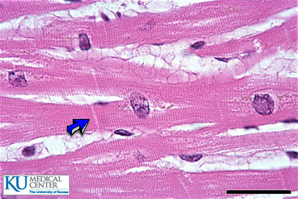
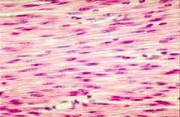
- Mysteriously (Myofibrils)
- Seeking (Sarcomeres)
- Mythical (Myosin)
- Accuracy (Actin)
Group#5:(Haiden and Bob)
· The Riddle of the Sphincter
· Electrical Muscle Stimulation (PPT)
· Human Evolution Response (DOC)
1) Identify the 3 muscles types
2) Which is responsible for lining your digestive system?
3) What is peristalsis?
4) What role does electricity have in natural muscle contraction?
5) What role does electricity have in artificially induced muscle contraction?
6) What are the 5 key milestones in human evolution.
7) How does tooth changes ultimately affect symbolic thought?

